

For further information
The Giving Team at Southwark Diocese are here to support you. Please do contact us with any questions, or for any resources.
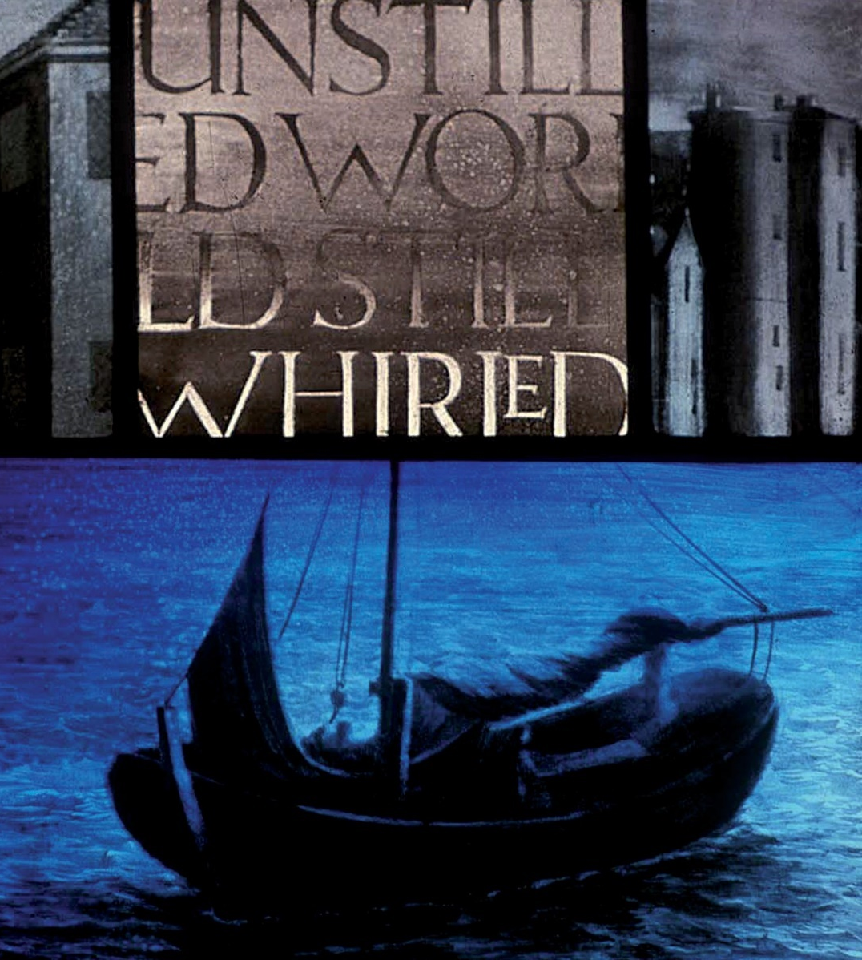
Tel: 020 7939 9400

Email: gabby.parikh@southwark.anglican.org
Resources to help PCCs
- A leaflet for PCCs including a sample Legacy Policy.
- A leaflet for individuals about making a will and leaving a legacy.
- Posters, Email Footers, and many more materials available.

www.churchofengland.com/legacy
www.farewill.com/southwarkdiocese
https://solicitors.lawsociety.org.uk/
www.southwark.anglican.org/legacies

At St Mary’s Merton, the Parish Legacy Coordinator ensures information about legacies is consistently available and provides a confidential listening ear for any questions. He works with the vicar to ensure names are remembered (in line with family wishes) in a liturgy of remembrance each November.
Ian says: “Making a will ensures a person’s wishes are respected after their death and gives peace of mind for their loved ones. My church has benefitted from gifts in wills, enabling us to meet the cost of a public address system in church and helping to pay for significant improvements to the church hall, a great asset enjoyed by people in our part of London.” Legacies have also enabled St Mary’s to support organ scholars, provide a new churchyard gate and install a modern kitchen in their hall.
This leaflet is produced by the Diocese of Southwark and is based on material produced by Parish Resources from the Church of England.
Images reproduced with kind permission of the Dear and Chapter of Southwark.

The Diocese of
Southwark
The Diocese of
Southwark
The Diocese of
Southwark


Your role

The role of a Parish Legacy Co-ordinator is to act as the main point of contact for legacies (also known as gifts in wills) within a church. This involves encouraging church members to keep their wills up to date and informing them of how legacies can and have been used to make a difference in their local church.
You will provide a friendly, supportive and confidential ear to church members who want to talk about writing their wills or leaving legacies.

Main objectives:

To help the parish community:
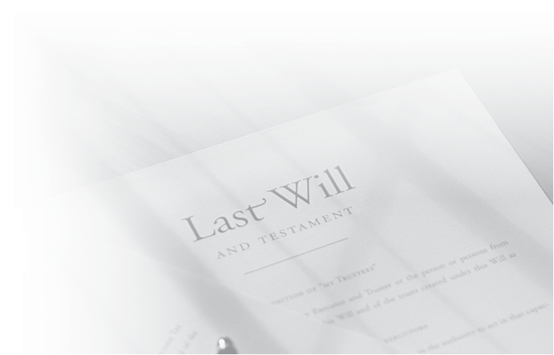
- Understand the importance of writing a will as an act of Christian stewardship;
- To rejoice and share thanks, in the ministry and mission of the church, thanks to legacy gifts.

Core tasks include:

Encourage the PCC to make and communicate a PCC Legacy Policy (see our PCC leaflet about legacies).

Work with clergy to launch and communicate the policy with the congregation. This could include clergy preaching on the theme.

Act as the main point of contact in the parish for all legacy enquiries.

Ensuring the church honours and thanks families when legacies are received. This could include an annual service of thanksgiving.

Being available for individuals who want to talk about legacies.

Many people know it’s a good idea to write a will, but never get around to it!
The Code of Fundraising Practice 2025 states at least two providers should be given, without recommendation. Local solicitors can be found using: https://solicitors.lawsociety.org.uk. The Church of England has partnered with Farewill, to will’s to be written online, for free. Visit: www.farewill.com/southwarkdiocese
Contact giving@southwark.anglican.org for further support.

Personal Specification

- Sensitive to people and able to maintain personal confidentiality.
- A good listener.
- Well organised, used to dealing with paperwork.
- Well respected, liked and trusted within the church community.
- Enthusiastic about giving to resource God’s mission.
- Preferably has made their own will including a charitable legacy.
- Desirable but not essential: knowledge of financial and legal affairs.

Your role is not to give advice but to signpost to further information and appropriate professionals, so you don’t need specialist knowledge.

Approach

- Remind people the importance of caring and providing for family first, and communicating all their wishes with their loved ones.
- Don’t be afraid to talk about the impact of gifts in wills; they can transform a church’s ministry and mission!
- Never disclose confidential information to a third party, including the clergy.
- Make information about legacies and wills available in a low key, sensitive way over the long term.
- Pray, listen and speak with love, hope and understanding.

