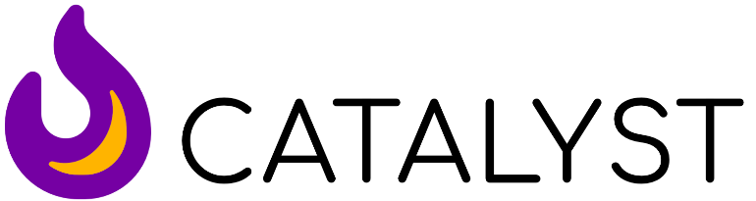

Take up the challenge to deepen your knowledge, hone your skills and follow God’s call for ministry and mission with children and young people. Catalyst is a dynamic training course which aims to equip and inspire you. This course will help you if you are a volunteer in a toddler group, helping at a youth club, doing a few Sunday morning sessions a month or running an outreach programme as a paid worker. You will learn from experts in the fields of children and youth ministry, whilst being supported by your Diocese. And did we mention that every aspect of the Catalyst is fully funded by the Church of England, so you won’t need to pay a thing.
Who is it for?
The course will benefit you if you are new to children and youth ministry by providing a solid foundation on which you can build. It will also benefit those who have been around a little longer, to renew, refresh and revitalise their existing knowledge and experience. For some it will also provide a pathway into further training. So, whether you are a volunteer or an existing paid church worker, we encourage you to prayerfully discern whether Catalyst is right for you.
What will I learn?
At its heart, Catalyst will help you develop approaches with children and young people that fosters a holistic and lively relationship with Jesus.
Weaved through the sessions and the conference are the core topics of: safeguarding, cultural awareness, working in groups, discipleship, self-knowledge, self-reflection, theology, biblical studies, play, informal learning, mission and evangelism.
What is involved?
Induction: You will be invited to an induction day in Bristol (Saturday 21st September), York or Cambridge (Saturday 28th September).
Five Group Sessions: There are five monthly group sessions where you will meet, for about 2 hours, with other Catalyst participants from your Diocese. Prior to each group session, you will engage with topic content through the Catalyst platform from the comfort of your own home. This means that you will be familiar with the topic before you meet as a group, then you will be able to engage with the topic themes by drawing on your own experience.
Conference: At the end of January (Friday 31st to Sunday 2nd Feb.) you and all Catalyst participants from other Dioceses are invited to the three-day Catalyst conference at the Hayes Conference Centre in Derbyshire. All meals and accommodation will be provided, and during the day you will hear from experts in the fields of children and youth ministry.
Graduation: You are invited to celebrate the completion of the course and all that you have achieved with your new Catalyst friends at Ridley Hall in Cambridge (Saturday 17th May).
For more information check out the Catalyst website https://catalyst30k.org and register interest with the CYP Team today The deadline to register is Friday 6th September.
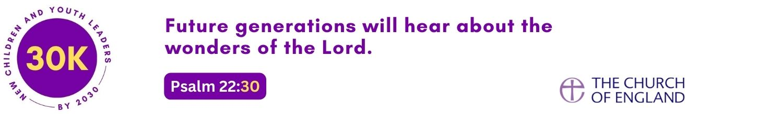

Summary of content

Induction: A Catalyst for Mission : In person Saturday 28th September 2024 at Ridley, Cambridge
Discover what it means to play your part in God’s mission to the world.
- Learn how Catalyst will equip you to serve children and young people in your context.
- Understand the value of reflection for your ministry and mission with children and young people.

Session one: Children, Young People and Culture. In person Saturday 19th October 2024 Trinity House
Ignite your passion for mission with children and young people by taking a closer look at the cultural contexts you are in.
- Develop your understanding of the relationship between mission and culture.
- Explore biblical examples of mission and culture (e.g., Paul in Athens – Acts 17).
- Recognize the characteristics of contemporary culture i.e., growing up within a digital environment.

Session Two: Children, Young People and Relationships. Online 18th Nov 2024 7-9pm
Explore the importance of developing a deeper relationship with God, your team and the children and young people you minister to.
- Explore how trust and collaborative relationships with your team are beneficial for your ministry with children and young people, particularly in relation to safeguarding.
- Learn how to develop healthy relationships with children, young people, and their families that benefit mission and discipleship.
- Understand your role as a leader with children and young people.

Session Three: Children, Young People and Discipleship. Online 9th December 2024 7-9pm
Discover what discipleship is for children and young people today and develop approaches that will be best suited to your context.
- Understand how discipleship of children and young people is influenced by their cultural context.
- Develop your understanding of children and young people’s spirituality.
- Explore a variety of discipleship approaches e.g., intergenerational church, resourcing faith at home, Forest Church, traditional small groups, camps etc.
- Understand the role of being a leader when discipling children and young people.

Conference: Children, Young People and Growth. 31st Jan 2025 -2nd Feb 2025
Take a deep dive into the theology of growth and learning in the beautiful university city of Cambridge.
- Develop your understanding of discipleship and your role within this.
- Explore theories of children and young people’s development.
- Investigate the principles and practices of play, informal education, and/or non-formal education among children and young people.
- Explore theories of how we learn e.g., Vygotsky, Freire, multiple intelligences.
- Explore a biblical understanding of children and young people.
- Develop your ability to lead a group.

Session Four: Children, Young People and Learning. Online 24th Feb 2025 7-9pm
Building from the conference, you will continue to expand your knowledge about how children and young people learn and how participatory and inclusive groups are essential for their growing relationship with Jesus.
- Develop your understanding of inclusion and participation.
- Consider how your approach engages with neurodivergent children and young people.
- Understand issues facing children and young people who have physical disabilities.

Presentation (in learning groups): Children, Young People and Me. In person 29th Mar 2025 10am-12pm
Show your learning group your key learning from the Catalyst course by giving a short presentation about an aspect of your ministry over the past year.
- Understand how your learning will enable the development of others.
- Consider how your learning can be built on and influence your sense of calling to working with children and young people in the future.
- Understand the importance of reflective practice in ministry with children and young people.

