Croydon Episcopal Area, Diocese of Southwark

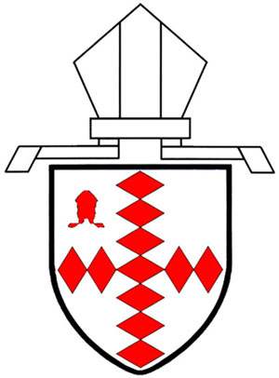

Service of
Baptism and Confirmation
at Holy Communion

[Date and time]

[Host Parish]

This evening we welcome The Bishop of Croydon, The Rt Revd Dr Rosemarie Mallett, and the families and friends of those who are to be baptised and confirmed at this service. We also welcome those from [parishes]. Please remember all those being baptised and confirmed today in your prayers throughout this coming week.

[HOST PARISH]
Candidate’s name

[PARISH 1]
Candidate’s name

[PARISH 2]
Candidates’ name

[PARISH]
Candidate’s name

*indicates candidate will be baptised as well

Welcome to [parish]

During the service
Please ensure your mobile phone is turned off.

A collection for the Bishop of Southwark’s Lent Fund
(Registered Charity Number 1075122) will be taken
during the Offertory hymn. Please give generously.

Christians of all denominations are welcome to receive Communion
if you usually do so in your own church.

Common Worship: Services and Prayers for the Church of England ,material from which is included in this service, is copyright © The Archbishops’ Council 2000

CCLI

