WHAT SHALL I DO NOW?  Please REVIEW your giving prayerfully.  What is the one step you could take in response? [suggested responses may vary according to the current options at your church].  If you currently give via the collection, could you move to REGULAR GIVING with the Parish Giving Scheme (PGS)?  Scan here:  QR code here  If you are already a regular giver could you increase your gift by [5 or 10]%?  Our Parish PGS code is:  Each of you should give what you have decided in your heart to give, not reluctantly or under compulsion, for God loves a cheerful giver. 2 Corinthians 9.11 |  |  |  | THANK YOU  Thanks to the generosity of our congregation, we have been able to:  - [personalise these with key aspects of your church’s mission and ministry, for example:]  - provide a warm, welcoming and spiritual home for our community, including hosting school events for [xx] children  - welcome [xx] families to our Messy Church  - provide home communion and care for our elderly.  Do contact [name] [vicar, parish stewardship officer, treasurer, churchwarden] with any questions.  Insert church website and/or a link to the giving page on your website.  Quote from someone in your congregation about what [name of your church] means to them |  | Generosity Campaign |  | Name of church  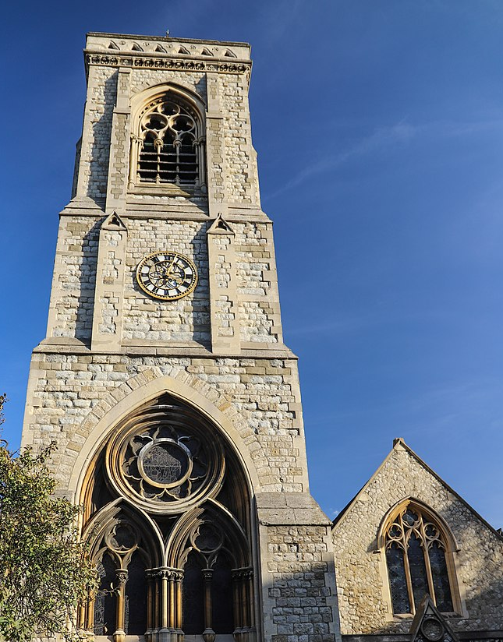  Loving God  Loving Anytown  church vision key words
 | OUR VISION  [Church vision – replace with your own.  We love God and we love Anytown. We long for every generation to know God’s love in Christ. We pray for God’s kingdom to come in Anytown and seek to serve our community, bringing hope, sharing peace, welcoming all.]  [Insert images from your mission and ministry activities here]  In the coming year we hope to:  Insert your own specific plans and hopes:  - Upgrade our meeting rooms so that they are accessible to all;  - Relaunch our toddler group;  - Continue to serve our community at the Foodbank. |  |  |  | OUR CHALLENGE  To fulfil our vision, we spend [£x] a week.  [£xxxx] on outreach and mission [including….].  [£xxxx] on worship and ministry, including heating our spaces, to welcome all.  [£xxxx] on expressing generosity by giving to  other charities.  [£xxxx] on our share of clergy costs for our parish pledge.  We currently receive [£x a week].  Fundraising income [£xxxxx]  Gift Aid recovered [£xxxxx]  Hall/ other income [£xxxxx]  Planned giving income [£xxxxx]  So we have a challenge!  We need an extra [£xxxx] a week to sustain our life together.  Among our regular congregation of [xxxx], this means an average of an extra [£xxxx] per person per week.  [St Agatha’s] doesn’t receive national funding or government support,but is sustained by your generous giving. |  |  |  | HOW MUCH SHALL I GIVE?  We worship a generous God. Out of overflowing love for us, God sent Jesus His Son, who gave His life for ours.  Trusting in God’s provision, we are called to reflect His love with open hands and hearts. Cheerful, intentional, generous giving is a natural part of the Christian life.  This many people Increasing their weekly gift by Equals this much extra weekly income  5 £10 £50  10 £5 £50  15 £2 £30  20 £1 £20  This adds up to an extra £150 a week from 50 givers― £7,800 a year! [adjust numbers]  The bible teaches PROPORTIONATE GIVING – giving back to God a percentage of your income. The Church of England challenges us to give 5% to our church, and 5% to charity.  As a rough rule of thumb:  5% = £1 per week for every £1,000 of  annual income.  For example, 5% of an income of £10,000 = £10 per week

