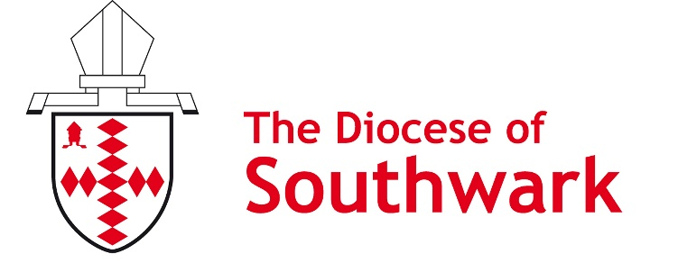
0

southwark.anglican.org/tkc

Thy Kingdom Come resource request form

Contact name:
Church name:
Postal address (for delivery):

Postcode:
Telephone: E-mail:

Free Thy Kingdom Come resources
You can order additional copies of the items listed below at no cost. We will need your order by Wednesday 4 May in order to have them printed and sent out before Ascension Day.

Description (all available in multiples of 10) | Number
Thy Kingdom Come – All God’s People A5 booklet (new for 2022)
Everyday Faith - Hidden Church - A5 booklet
Everyday Faith – Pocket Prayers– A6 booklet
Workplace prayer fold-out

Thy Kingdom Come grants
We can award £100 grants towards creating a prayer station or prayer space to celebrate Thy Kingdom Come. (We would really value any photographs of the resulting prayer stations/rooms.)
PCC bank details: Sort code: Account number:
A brief description of how the money will be used:

E-mail us at missionsupport@southwark.anglican.org or post this form to Thy Kingdom Come Orders, Mission Department, Trinity House, 4 Chapel Court, Borough High Street, London SE1 1HW.
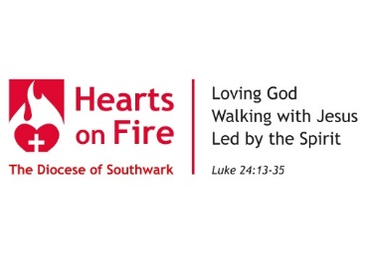

Walking
Welcoming
Growing

