From Lent to Lent:

A Year of Small Steps from March 2022

From Lent to Lent: A Year of Small Steps

Walking . . . a journey of small steps to become more environmental in our daily lives
Welcoming . . . seeking new ways of living out our faith through everyday choices
Growing . . . growing our awareness of God’s creation and how we can take steps to protect it

Small Steps
The ecological crisis is growing. As Christians, the climate emergency is an opportunity to show our love for our neighbours in the global south who are already suffering the effects of climate change. It is an opportunity to show our care for God’s creation, to reach out and connect with others in society and to show that change is possible, working together, little by little.
This booklet invites you to commit to a year of weekly actions, each month focusing on a different aspect of the environment, with one suggested lifestyle change to consider each week.
It begins in May, to follow on from the season of Lent and any personal pledges you may have undertaken in the lead-up to Easter, but of course you can start in any month you choose!

Action number one: fold this booklet to the correct page and stick it on your fridge!
March – Reduce Waste

Week 1 Put a reusable shopping bag or ‘bag for life’ in the inner pocket of every handbag/rucksack/coat/jacket that you use, so that you’re never caught out without one. ☐
Week 2 Buy loose fruit and vegetables (take your own bags) instead of pre-packaged. ☐
Week 3 Invest in a reusable coffee cup or water bottle and make a habit of carrying it everywhere you go. ☐
Week 4 Visit a market or ‘zero waste’ shop and take your own packaging. ☐

April – Nature

Week 5 Plant bee and butterfly-friendly seeds, if possible. If not, sponsor a tree planting or donate to a wildlife charity. ☐
Week 6 Go for a walk in a green space. ☐
Week 7 Compost your food waste if possible. ☐
Week 8 Join a local litter pick or just do a miniature one of your own. ☐

May - Save Water

Week 9 Fill your kettle by mug so you only boil the water that you need. ☐
Week 10 Turn the tap off when you clean your teeth – and make sure your family does too! ☐
Week 11 Put a plastic bottle filled with water in your toilet tank to reduce the amount of water used per flush, or install a ‘Hippo’ water saver. ☐
Week 12 Wash clothes less frequently – air them, and spot clean small marks instead of washing the whole garment. ☐
Week 13 Keep a jug of tap water in your fridge so that you always have cold water without having to run the tap to cool it down. ☐

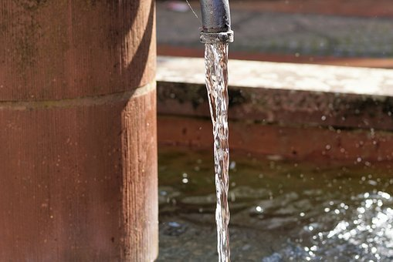
June - Travel

Week 14 If you have a car, swap at least one journey to public transport this week. ☐
Week 15 If you’re planning a summer holiday, choose a location you can reach by car or train instead of flying. ☐
Week 16 If you drive regularly somewhere (e.g. school, work), could you give a lift to someone else making a similar journey? ☐
Week 17 Get your bicycle serviced, if necessary, and go for a cycle this week. Perhaps you can use it as a mode of transport more frequently? ☐

July - Reduce/Repair/Reuse

Week 18 Mend something that’s been sitting around, or that you might otherwise throw away. Sew on a button or tighten that loose screw. ☐
Week 19 Find a local ‘repair group’ (transition town initiatives often run them) and go to their next event, to have your own item repaired or to help others and meet like-minded people. ☐
Week 20 Suggest running a clothes swap event – with a group of friends, at work, with your book club, or through the PTFA at your child’s school. ☐
Week 21 Sort out your wardrobe and take any unwanted items to the charity shop. ☐
Week 22 If you are buying clothes, explore vintage, preloved or ethically produced garments before going to the high street. ☐
August – Ethical Consumption

Week 23 Think before you buy, and don’t buy anything you know you’re going to throw away. ☐
Week 24 Boycott the top 5 least ethical companies & email to tell them why: Amazon, ASDA, Nestle, Tesco, Coca Cola. ☐
Week 25 See how much of your weekly shop can be Fairtrade. Buy storecupboard items in bulk if you can, to reduce packaging. ☐
Week 26 Whenever you buy paper, make sure it is recycled (including kitchen towel, toilet paper, stationery, printing paper, envelopes . . .) ☐

September - Campaign

Week 27 Write an email to your MP, asking what actions they are personally taking to combat the climate emergency or to reduce pollution in the area, or another environmental priority. ☐
Week 28 Sign up to the Climate Coalition mailing list to be informed about lobby days, petitions and marches: www.theclimatecoalition.org ☐
Week 29 Write an email to a local councillor, asking what environmental actions they are taking locally. ☐
Week 30 Investigate current campaigns by environmental charities like Friends of the Earth, Tearfund, Greenpeace or the Woodland Trust, and see whether you can support them, for instance by signing a petition or putting up a poster at work. ☐

October – Make Your Home An Eco Zone

Week 31 Divest your personal finances from fossil fuels by switching your current account to ethical banking (e.g. Triodos, the Co-op Bank, Ecology Building Society, Nationwide Building Society) ☐
Week 32 Contact your pension provider and ask them to divest from fossil fuels (visit the charity shareaction.org for advice). Now tackle any other savings you may have and switch those to ethical ISAs or savings accounts. ☐
Week 33 Commit to a plastic-free bathroom by replacing shower gels and facewashes with bars of soap, shampoo and conditioner with packaging-free bars, and investing in bamboo toothbrushes. ☐
Week 34 Replace your cleaning products with ecological, non-toxic brands. ☐
Week 35 Switch to an ethical phone and broadband provider. ☐
November - Spread The Word

Week 36 Inform yourself about the climate emergency and ecological crisis by reading websites such as www.campaigncc.org ☐
Week 37 Explore ways of communicating about climate change – talk about it with friends and family, observe how people react, visit websites such as theclimatecommsproject.org ☐
Week 38 Take an eco action at work – like turning off your computer at the end of the working day or bringing a reusable coffee cup – and ask your colleagues to do the same. Ask if your workplace has an eco rep or committee, join it or start one! ☐
Week 39 Talk to people in one other place you regularly go – the gym, your child’s school, a place of worship or your local supermarket. Ask them to consider what action they might be taking. ☐
December - A Green Christmas

Week 40 Buy recyclable wrapping paper. Avoid shiny metallic or foiled paper. ☐
Week 41 Give gifts that people actually want! Ask people for ideas, what they would like, and buy things they will enjoy using rather than festive novelties likely to be discarded within days, or agree to exchange ‘experiences’ instead. ☐
Week 42 Source gifts that are ethically made or Fairtrade, or give a subscription or charity gift. ☐
Week 43 Choose your tree carefully. If real, consider buying one that can be replanted, or check that your council will compost it. If artificial, treasure it and reuse it for as many years as you can. Wait until after dark to turn on your Christmas lights, and turn them off before bed. ☐

January - Save Energy

Week 44 This week, take half an hour to switch to a Green Energy supplier for your electricity and gas at home. ☐
Week 45 Turn off lights in all the rooms you are not using – including any corridors or hallways – and buy a stock of LED bulbs ready for when you need to replace a bulb. ☐
Week 46 Unplug electric appliances when you aren’t using them, or switch them off at the wall. Even turned off, many appliance keep drawing power. ☐
Week 47 Put on a jumper and turn your central heating thermostat down by a degree or two. ☐
Week 48 Wash lightly soiled clothes at 30⁰ instead of higher temperatures, and air dry instead of using the tumble dryer. ☐

February – Food

Week 49 Spend a week reducing food waste in your home; make a meal plan, shop from a list, eat leftovers, use the freezer, cook creatively with what you have. ☐
Week 50 Get rid of disposable food wrap and store food in reused takeaway containers, beeswax wraps or a bowl with a plate on top instead. Take a homemade leftovers to work for lunch, to save money and packaging. ☐
Week 51 This week, eat less meat. Try a new vegetarian meal, experiment with foods you wouldn’t normally try, and have at least one meat-free day. ☐
Week 52 Invest in reusable boxes for food storage instead of using cling-film or foil. ☐

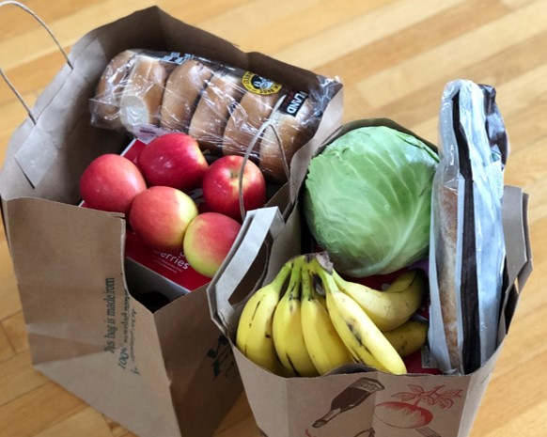

At the end of your year, whichever month this might be, reflect on the changes you’ve made.

Which have you stuck with?
Which would you like to try again?

Notes

Creator God,
the heavens declare your glory,
and the earth your generosity.
Forgive our exploitation of your gracious provision.
Through your bountiful goodness guide our efforts
to be better stewards of your creation.
Amen

