St Margaret’s Chipstead

Children and Families Leader

We are looking for an energetic, fun and enthusiastic Children and Families Leader who is passionate about knowing and sharing God’s transforming love.
We are looking to build up our children’s groups again after the difficulties of lockdowns. Numbers are growing , families are becoming engaged and new families are joining us. Messy Church continues to grow and attract old and newcomers. We are looking to restart our midweek ministry to young families and plan future mission into this diverse and interesting parish.
We have excellent facilities, in particular our Orchard building, which houses our children’s ministry and have an enthusiastic and dedicated team of volunteers who are very supportive.
We are committed to finding the right person for the Church rather than appointing to a fixed role and therefore the role can be carried out on a full or part time basis with scope for substantial flexibility.
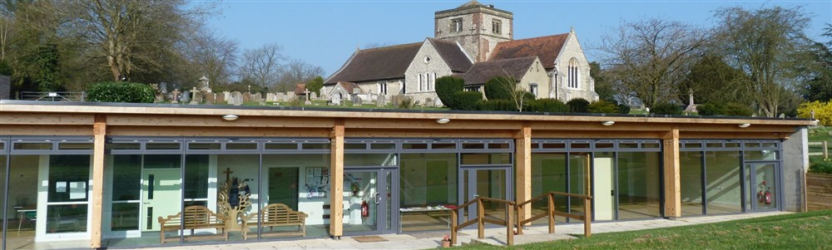

For more details about our church please visit our website at:
www.stmargaretschipstead.org
For an informal conversation or to receive an application pack please call Ray King on 07932 996563 or contact via email at: rayking@smchipstead.org

