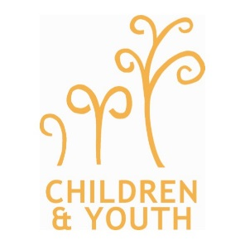
Diocese of Southwark Mission Team
Trinity House
4 Chapel Court
Borough High Street
SE1 1HW

Dear Colleague,

Thank you for your interest in a micro grant for the development of church based and inspired work with children and young people. This is usually for sums up to £300, examples of what this grant could be spent on are below, and help and advice is easily available by contacting Aike or Keli. We particularly keen to encourage children and youth led proposals, where the CYP have taken the lead and have identified where to apply to raise money.

Grant examples:
- The purchase of equipment and resources, for example:
  - equipping a room for children / youth activities – table tennis table,
  - youth bibles
- Activities, for example:
  - Pilgrimage: e.g. Taize; Soul Survivor; Greenbelt; Walsingham; L’Arche;
  - Weekend residential, e.g. Carroty wood; Fort Rocky; Youth camp at Hillfield
  - Day trips: e.g. Thorpe Park,
- Providing for additional needs of children and/ or young people in church / youth activities, for example:
  - the purchase of sensory equipment, large print bibles, specialist software / hardware
- Mission projects involving CYP, for example:
  - minibus hire; ingredients for a cake sale; purchase of plants for redoing a garden, paint
- Bursaries in cases of individual hardship for CYP church activities

Details of the Application process:
- Application is by the attached form. The form needs to be approved by a PCC or and money paid into an organisation bank account. We ask that you submit copies of receipts for items of expenditure over £10.
- The fund is now open and there is no deadline for applications. Money will be allocated on a first come, first served basis, provided the criteria outlined below are met.
- This scheme normally provides grants up to £300. We will consider some grant applications of more than this where additional significant benefit is proposed.
- In most cases we ask for the project/training be completed before releasing funds.

If you require help to develop the proposal, or find out sources of additional funding, please contact aike.kennett-brown@southwark.anglican.org. To apply, please complete an application form and post or email to Mission Team Administrator MissionSupport@southwark.anglican.org

Yours sincerely,

Aike Kennett-Brown
Mission Support Officer (Children and Young People)

Keli Bolton
Mission Support Officer (Children and Young People, Mission Action Planning)

