Calendar of Intercession
2021

1st Comfort Idowu-Fearon Diocesan President

2nd Jean Cartwright Diocesan Treasurer

3rd The Rt Revd Christopher Chessun The Lord Bishop of Southwark

4th Penny Lochead Reigate Area Vice President Jenny Kempsell Reigate Area Trustee
Susan Gibbin Reigate Area Trustee
All branches in the Reigate Area

5th Susan Gibbin Safeguarding Officer

6th Penny Lochead Faith and Policy Co-ordinator
Faith and Policy Core Group

7th All staff at Mary Sumner House

8th Cynthia Smith and Action and Outreach Core Group

9th Olu Akitoye MU@ Home correspondent
All MU@Home members (New name for Indoor Members)

10th All work in Parenting, Prisons and Hospitals in the Diocese

11th Sheran Harper Worldwide President
Kathryn Anderson Canterbury Provincial President

12th The Rt Revd Dr Richard Cheetham Bishop of Kingston

13th Wendy Moss Kingston Area Vice President
Eastlyn Douglin Kingston Area Trustee
Ursula Hodges Kingston Area Trustee
All branches in the Kingston Area

14th Val Green MU News Editor

15th Work with Women’s Refuges and Refugees in the Diocese

16th Link Diocese of Oxford
Archdeacons of Lewisham & Greenwich, and Southwark

17th Joy Morrall Finance and Administration Co-ordinator
Frankie Turner Training Officer
Ann Squirrell Gift Aid Co-ordinator
Finance and Administration Core Group

18th The Rt Revd Jonathan Clark Bishop of Croydon

19th Sally Steele Croydon Area Vice President
Olu Akitoye Croydon Area Trustee
Cathy Brown Croydon Area Trustee
All branches in the Croydon Area

20th The Revd Esther Foss Diocesan Chaplain

21st Sally Steele Away From It All (AFIA) Co-ordinator

22nd Archdeacons of Croydon and Reigate

23nd Bev Jullien Mothers’ Union Chief Executive

24th The Rt Revd Dr Woyin Karowei Dorgu Bishop of Woolwich

25th Jennifer Davis Joint Woolwich Area
Catherine Hall Vice Presidents
All branches in the Woolwich Area

26th Wave of Prayer Link Correspondents
Ijeoma Molokwu (Machakos, Kenya); Liz Pullen (Harare, Zimbabwe)
Margaret Palmer (Phulbani, India);
Mopileola Walter (Ogori-Magongo, Nigeria), Comfort (Temporary)
(Ekiti, Nigeria)

27th Anne Love Diocesan Secretary

28th All Diocesan Members
Deanery Leaders and Deanery Members

29th Margaret Simmons Fundraising and Communications
Co-ordinator
Jenny Holroyd Diocesan Literature Representative
Lesley Frankham Assistant Literature Rep

30th Archdeacons of Wandsworth and Lambeth

31st All MU Members in Southwark Diocese.

Please pray daily for our MU Link Dioceses:

Province of Kenya, Machakos and Josephine;
Province of Nigeria, Ekiti and Margaret Omotunde;
Ogori-Magongo and Angela (Provincial President) and Susan.
Province of Central Africa, Harare and Faith;
Province of North India, Phulbani and Neerja (Provincial President) and Jharana (President DWFCS);
Province of Canterbury, Southwark and Comfort
and our UK Link Diocese, Oxford and Maureen
Our Diocesan Link – Zimbabwe

The Mothers’ Union Prayer:
Loving Lord we thank you for your love so freely given to us all.
We pray for families around the world.
Bless the work of the Mothers’ Union as we seek to share your love through the encouragement, strengthening and support of marriage and family life.
Empowered by your Spirit may we be united in prayer and worship, and in love and service reach out as your hands across the world.
In Jesus’ name.
Amen.

Mary Sumner’s personal prayer:
All this day, O lord, let me touch as many lives as possible for thee;
And every life I touch, do thou by thy spirit quicken, whether through the word I speak, the prayer I breathe, or the life I live. Amen

A prayer for MU at Home (Indoor) members:
O God, our heavenly Father,
our strength and peace and joy,
bless all who are indoor Members.
Give us your grace
according to our need;
help us to know and love
and trust you more,
to pray better and always to
do your will.
Through Jesus Christ our Lord. Amen.

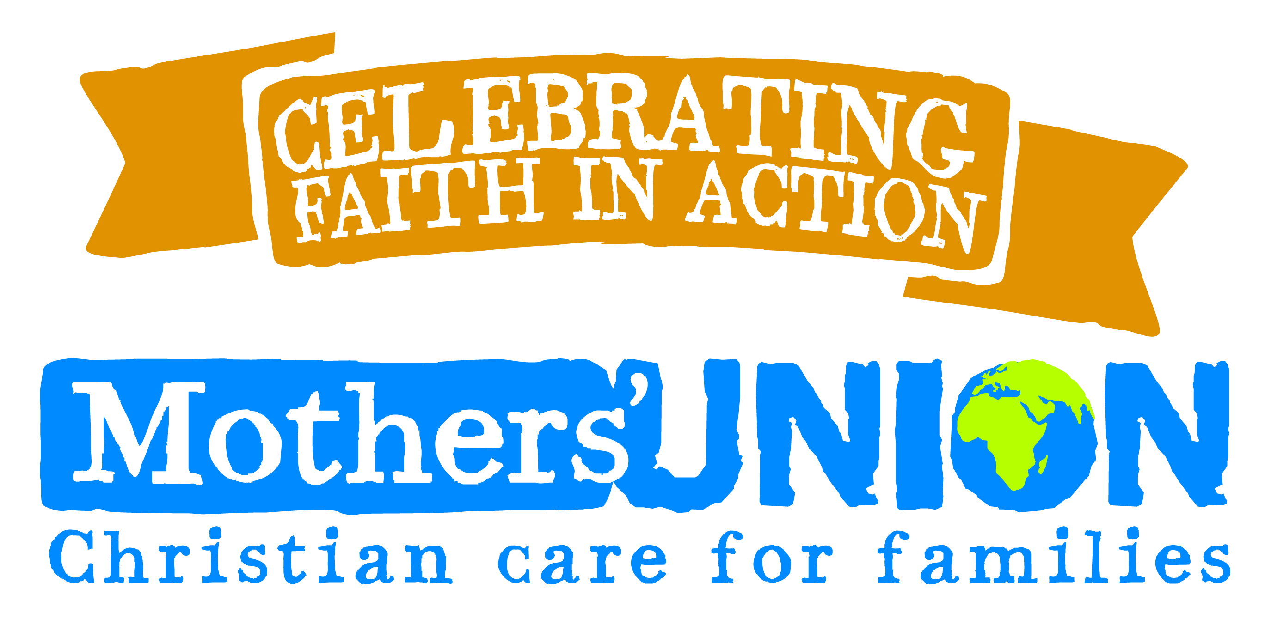

SOUTHWARK DIOCESE



Intercession Calendar
2021

Theme for 2021:
Rebuilding Hope and Confidence

