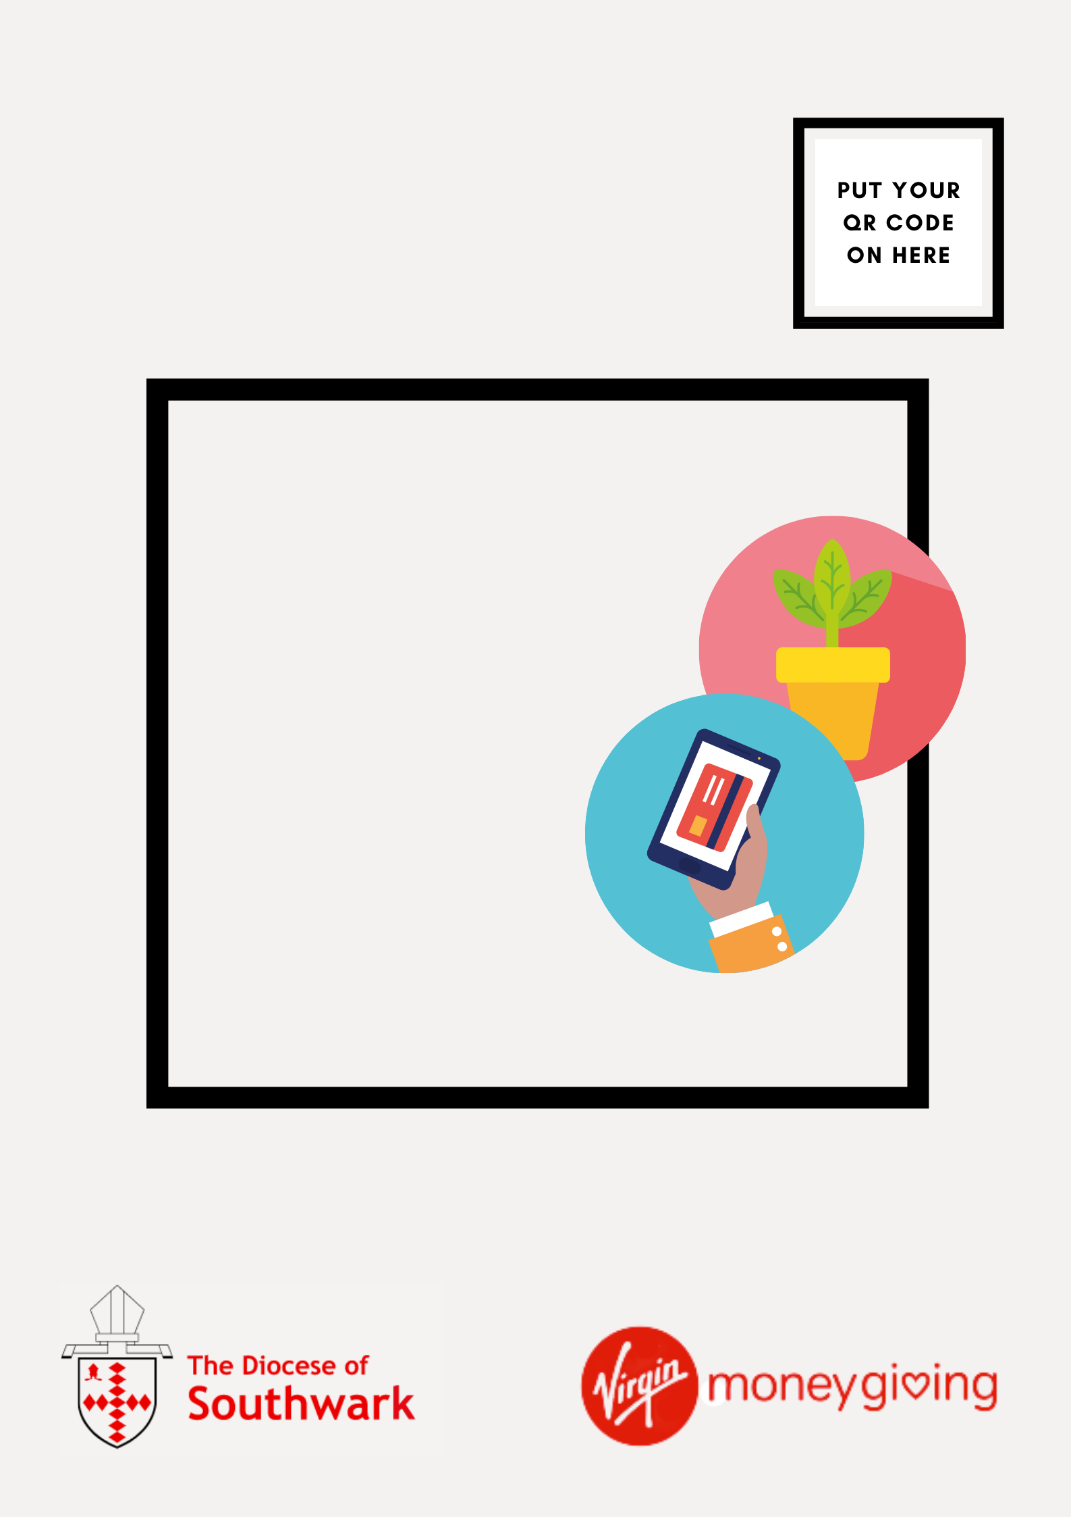

**scan to give**

SUPPORT THE WORK   
OF [CHURCH NAME]

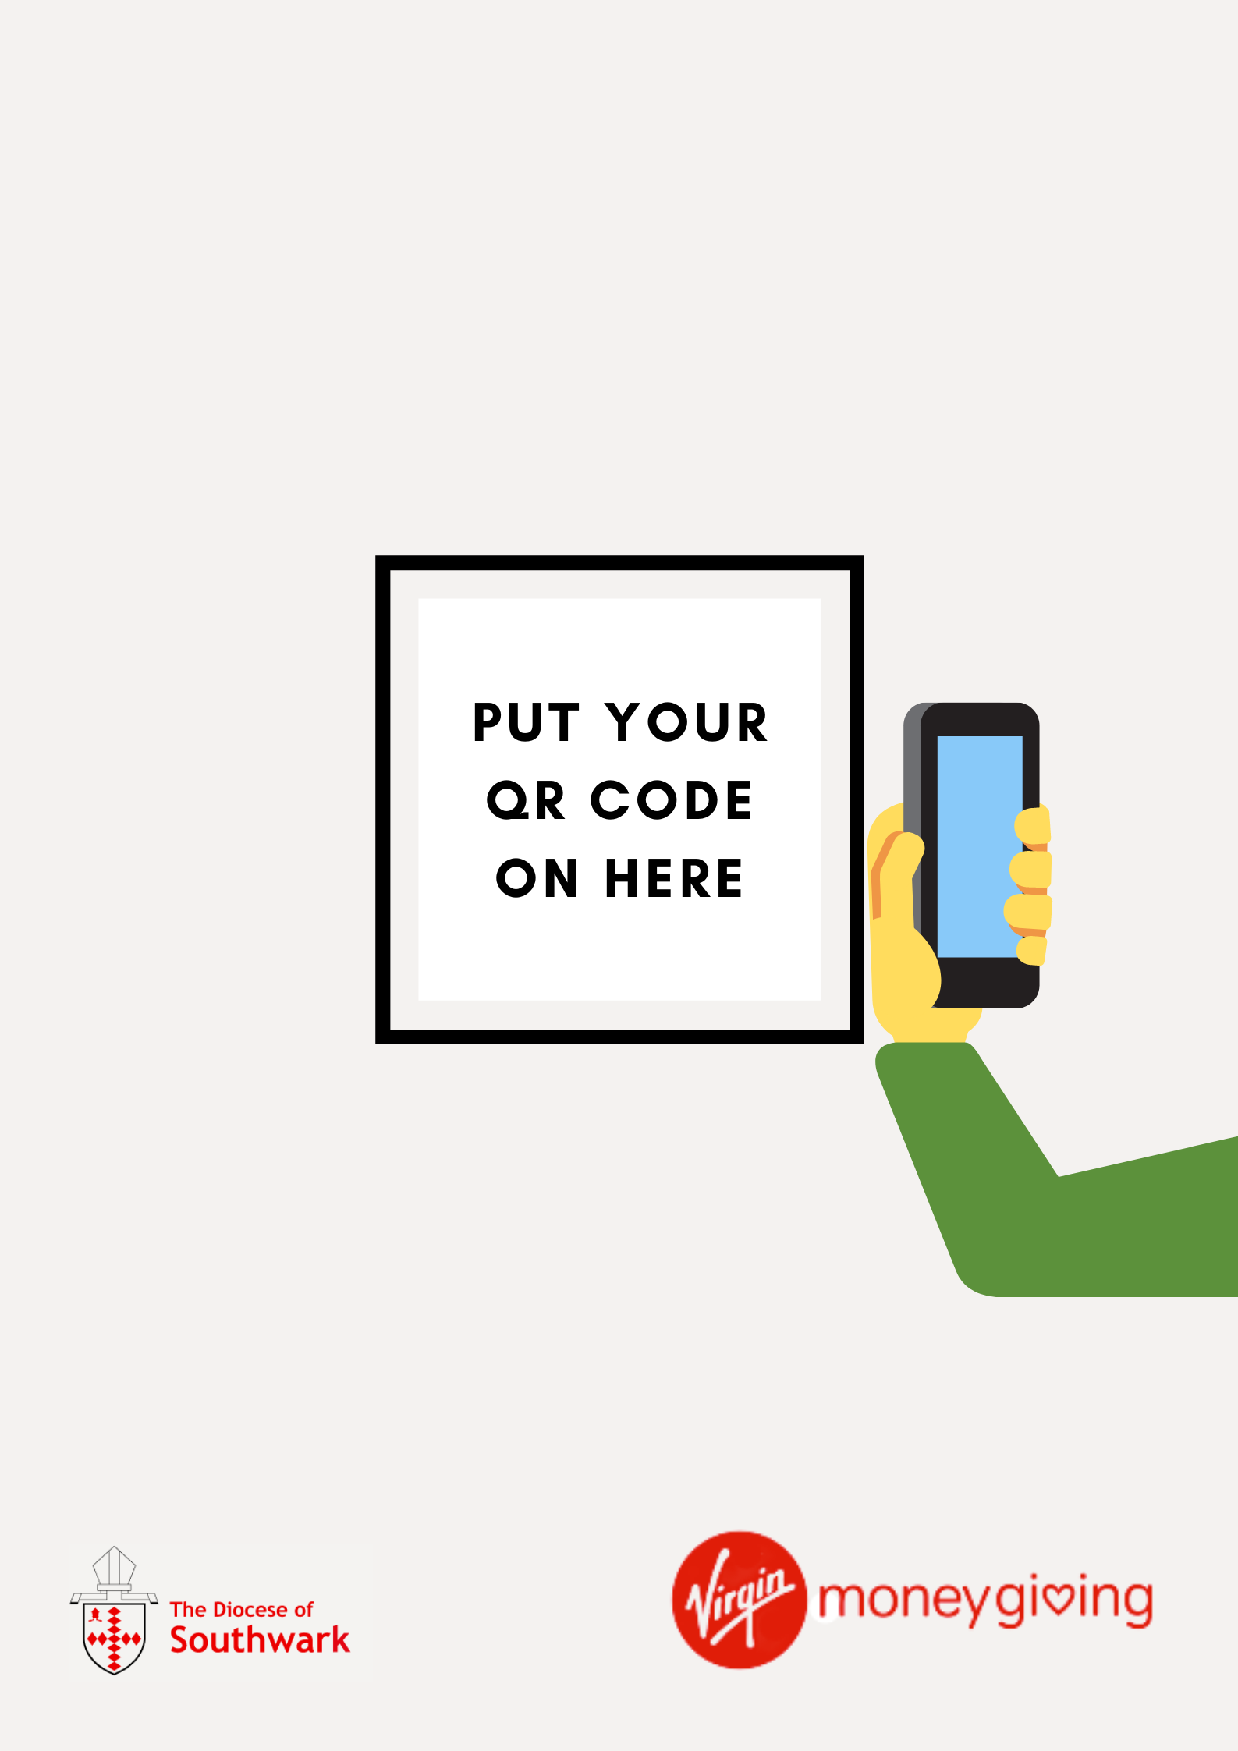

**how to give**

3. CLICK THE LINK DISPLAYED

4. DONATE

1. OPEN YOUR PHONE CAMERA  
   
2. SCAN THE QR CODE

**THANK YOU FOR YOUR DONATION**