Donate safely to [Your Church Name]
Thank you for supporting us and enabling our church to serve our community. Please
continue to share God’s gifts and give to the work of our church using these safe ways:

Standing Order |  | Give by contactless |  | Give online
Please consider setting up a regular gift via Standing Order. This method of giving makes it easiest for us to budget. Standing order forms, including Gift Aid declaration if you are able, are available [location in church]. Please speak to [Treasurer] for more details. |  | Use our [brand of] giving device located in the church [location]. You can donate with: a debit or credit card, Apple Pay, or Google Pay. |  | Scan this code with  your phone camera  and donate directly  to our church  via [name provider]. Follow the instructions – it’s simple and secure.  [Insert your  QR code here]  No phone? Please visit our page later: [insert shortened URL e.g. tinyURL.com/SupportStAgathas]

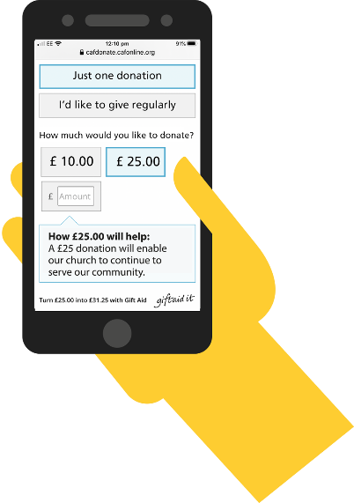
Thank you
for your gift.

Donate safely to [Your Church Name]
Thank you for supporting us and enabling our church to serve our community. Please
continue to share God’s gifts and give to the work of our church using these safe ways:

Standing Order |  | Give by contactless |  | Give online
Please consider setting up a regular gift via Standing Order. This method of giving makes it easiest for us to budget. Standing order forms, including Gift Aid declaration if you are able, are available [location in church]. Please speak to [Treasurer] for more details. |  | Use our [brand of] giving device located in the church [location]. You can donate with: a debit or credit card, Apple Pay, or Google Pay. |  | Scan this code with  your phone camera  and donate directly  to our church  via [name provider]. Follow the instructions – it’s simple and secure.  [Insert your  QR code here]  No phone? Please visit our page later: [insert shortened URL e.g. tinyURL.com/SupportStAgathas]

Thank you
for your gift.
Thank you
for your gift.
 | Donate safely to [Your Church Name]
Thank you for supporting us and enabling our church to serve our community. Please
continue to share God’s gifts and give to the work of our church using these safe ways:

Standing Order |  |  | Give by contactless |  | Give online
Please consider setting up a regular gift via Standing Order. This method of giving makes it easiest for us to budget. Standing order forms, including Gift Aid declaration if you are able, are available [location in church]. Please speak to [Treasurer] for more details. |  |  | Use our [brand of] giving device located in the church [location]. You can donate with: a debit or credit card, Apple Pay, or Google Pay. |  | Scan this code with  your phone camera  and donate directly  to our church  via [name provider]. Follow the instructions – it’s simple and secure.  [Insert your  QR code here]  No phone? Please visit our page later: [insert shortened URL e.g. tinyURL.com/SupportStAgathas]

