Donate safely to [Your Church Name]
Thank you for supporting us and enabling our church to serve our community. Please
continue to share God’s gifts and give to the work of our church using these safe ways:

Parish Giving Scheme |  | Give by contactless |  | Give online
Please consider setting up a regular gift via PGS. This Direct Debit scheme is a free and secure donation system, and our preferred method of giving for regular donations. For more information and to sign up, scan this QR code or pick up a gift form [location].  [Insert your PGS  QR code here] |  | Use our [brand of] giving device located in the church [location]. You can donate with: a debit or credit card, Apple Pay, or Google Pay. |  | Scan this code with  your phone camera  and donate directly  to our church  via [name provider]. Follow the instructions – it’s simple and secure.  [Insert your  QR code here]  No phone? Please visit our page later: [insert shortened URL e.g. tinyURL.com/SupportStAgathas]

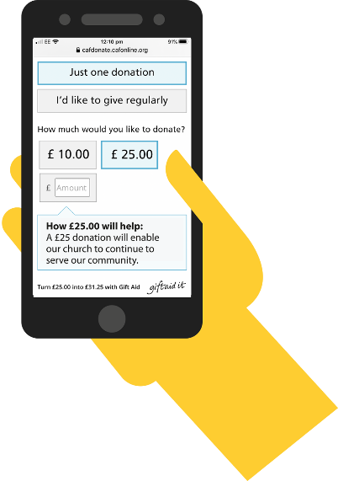
Thank you
for your gift.

Donate safely to [Your Church Name]
Thank you for supporting us and enabling our church to serve our community. Please
continue to share God’s gifts and give to the work of our church using these safe ways:

Parish Giving Scheme |  | Give by contactless |  | Give online
Please consider setting up a regular gift via PGS. This Direct Debit scheme is a free and secure donation system, and our preferred method of giving for regular donations. For more information and to sign up, scan this QR code or pick up a gift form [location].  [Insert your PGS  QR code here] |  | Use our [brand of] giving device located in the church [location]. You can donate with: a debit or credit card, Apple Pay, or Google Pay. |  | Scan this code with  your phone camera  and donate directly  to our church  via [name provider]. Follow the instructions – it’s simple and secure.  [Insert your  QR code here]  No phone? Please visit our page later: [insert shortened URL e.g. tinyURL.com/SupportStAgathas]
Thank you
for your gift.

Thank you
for your gift.
 | Donate safely to [Your Church Name]
Thank you for supporting us and enabling our church to serve our community. Please
continue to share God’s gifts and give to the work of our church using these safe ways:

Parish Giving Scheme |  |  | Give by contactless |  | Give online
Please consider setting up a regular gift via PGS. This Direct Debit scheme is a free and secure donation system, and our preferred method of giving for regular donations. For more information and to sign up, scan this QR code or pick up a gift form [location].  [Insert your PGS  QR code here] |  |  | Use our [brand of] giving device located in the church [location]. You can donate with: a debit or credit card, Apple Pay, or Google Pay. |  | Scan this code with  your phone camera  and donate directly  to our church  via [name provider]. Follow the instructions – it’s simple and secure.  [Insert your  QR code here]  No phone? Please visit our page later: [insert shortened URL e.g. tinyURL.com/SupportStAgathas]

