Welcoming Children and
Young People back to church
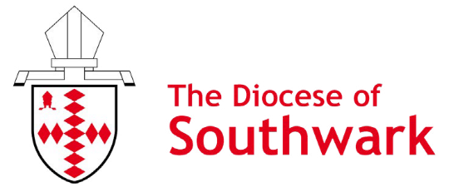
Following the Prime Minister’s announcement to reflect Step 3 of the roadmap out of lockdown, from 17 May groups for 4-18 years-old will be able to gather both indoors and outdoors. The size of your group should take into account factors such as recommended occupancy levels of the room so that social distancing is maintained, and your ability to ventilate the space. It is still advised that parents and carers should not routinely be present, due to transmission risks and where parents do attend, they should be socially distanced. Running a crèche during a service is not advised until after 21 June. Further details on guidance can be found here:
- Protective measures for holiday or after-school clubs and other out-of-school settings for children during the coronavirus (COVID-19) outbreak - GOV.UK (www.gov.uk)

- Guidance for parents and carers of children attending out-of-school settings during the coronavirus (COVID-19) outbreak - GOV.UK (www.gov.uk)

Whilst adhering to the latest guidance and getting the appropriate risk assessments is good practice, what is equally as important is to take time to reflect, pray and plan how to re-engage or reach new families and young people. As well as providing Covid-secure age-appropriate activities, it is essential our welcome includes ways to re-engage all the generations, sharing together our stories of this year of separation and where we have seen God at work in tough times.
To help you on this journey, the CYP team have launched a Welcoming Children and Young People toolkit series:
- the First Steps booklet provides a framework to help your church begin, re-start or reimagine your vision, values and form an action plan
- if you want to explore the opportunities your church has to enable children and young people encounter and deepen their relationship with God, try the Spirituality and Relationship with God booklet
- meanwhile, the Mission and Outreach booklet will help you map out opportunities and work out your next steps to reach new families or involve your existing young people in mission
- our final booklet Decision Making and Inclusion, will be published later this Spring.
The CYP team, Aike Kennett-Brown aike.kennett-brown@southwark.anglican.org and Keli Bolton keli.bolton@southwark.anglican.org are on hand should your church require additional support with the process.
Download the booklets, get in touch with our CYP team, and find out more about the help and resources we offer on the Children & Youth Ministry section of our website.

