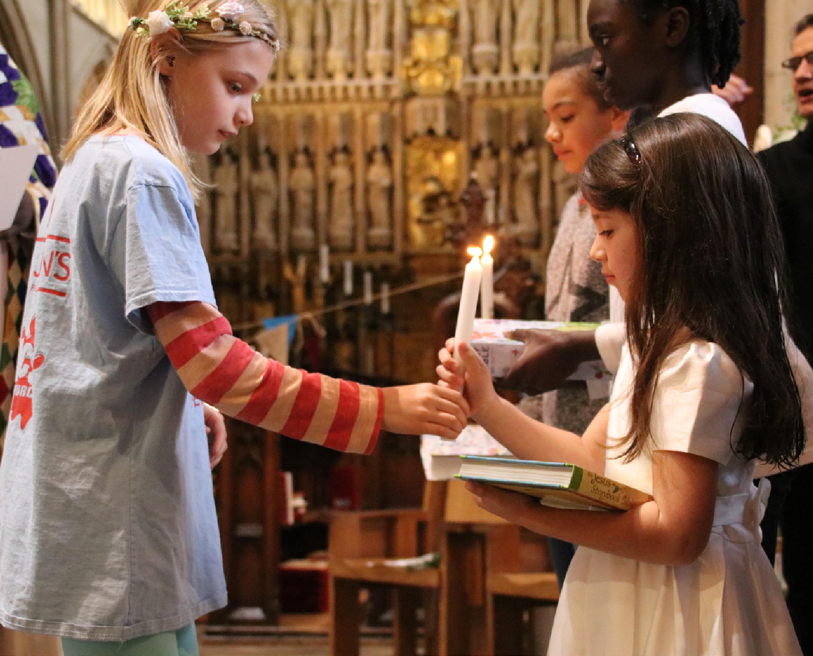

**Welcoming Children and Young People** Spirituality and

Relationship with God

***Walking Welcoming Growing***

**Welcoming Children & Young People: Spirituality and Relationship with God**

**Contents**

Preface by The Bishop of Southwark

3

Introduction

4

The Reflective Cycle

5

Section 1: Where are we now?

6

Section 2: Where do we want to be?

8

Section 3: What do we need to do?

10

Section 4: Next steps

16

Appendix 1: How we can help

18

Appendix 2: Your details

19

Appendix 3: Your notes

21

Further reading

23

2

Walking

Welcoming

Growing

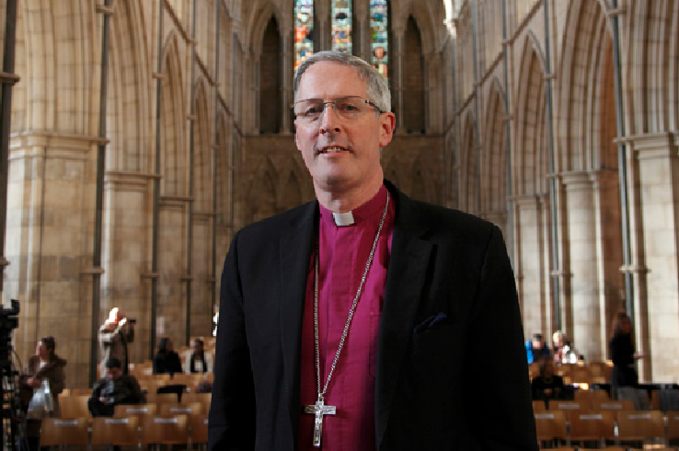

**Welcoming Children & Young People: Spirituality and Relationship with God**

**Bishop Christopher writes…**

*Dear Brothers and Sisters in Christ,*

Our vision in this Diocese is for our children and young people (CYP) to grow in faith, hope and love, with hearts on fire for Jesus, contributing joyfully, happily and confidently to the life of the Church and its mission at every level.

The whole Church has a role to play in walking alongside CYP and supporting households to grow in faith together. Our schools are an essential part of this outreach as we seek to welcome and listen well to the

voice of all children and young people in all their glorious and rich God-given diversity.

During 2020-21, the COVID-19 pandemic has impacted dramatically on the ways in which we gather as a church community as well as our mission and ministry with children and young people. It has presented a number of exciting new opportunities and possibilities. We are now able to reimagine the way in which we welcome children and young people, walk alongside them and encourage them to grow in their faith.

The Welcoming Children and Young People toolkit series, which I commend to you, provides a framework to enable churches to begin, re-start or reimagine their welcome and inclusion of children and young people.

Whether you are just starting out or have an established ministry with children, young people and their families, I hope you find working through this toolkit a constructive way to reflect on all that you do.

May it inspire your vision and celebrate what is going well, whilst challenging what may need to be changed or added so that children and young people can take a full place in the life of the Church.

The Lord blesses us through the children and young people He entrusts to our care. We are all God’s children and beloved in His sight. May we make the most of this new resource and the opportunities we have to be joyful and active as fellow members of the family and household of God.

**Bishop Christopher**

*The Diocese of Southwark*

Walking

Welcoming

Growing

3

**Welcoming Children & Young People: Spirituality and Relationship with God**

**Introduction**

This *Welcoming Children and Young People: Spirituality and Relationship with God* toolkit has been developed to enable parishes to take a fresh look at the welcome and community on offer to children, young people and their households. It is aimed at churches who seek to enrich the spiritual lives of children and young people, equip them to think theologically and develop their relationship with God.

The pack will take you through four stages of reflection, examining the opportunities your church has to enable children and young people to encounter and deepen their relationship with God. The toolkit invites you to reflect on what you are already doing, and where you have ideas and opportunities to develop or improve this area of ministry.

When your team is ready, you can go around the reflective cycle again and look at other areas within the Welcoming Children and Young People toolkit series: *First Steps*; *Mission and Outreach*; and *Decision- making and Inclusion*.

We encourage you to gather a group (in person or online) to look through this evaluation and pray together, ideally including your CYP Parish Rep, Incumbent or Churchwarden. Even if your church has only a few children and young people, it would be ideal to include them and their parents in your discussion, to enable you to see things through their eyes. This will provide greater relevance and integrity to any developments and changes that may come out of this process.

We recommend that you:

•

•

•

read through the *Spirituality and Relationship with God* booklet

work out your process for gathering information and ideas, and decide on your team

fill out this booklet together and keep a record, to enable your team to share your thinking and next steps with your PCC and wider church community

complete the contact details in Appendix 2 in order to access the support available to your team

outlined in Appendix 1

e-mail the completed form to [CYPAdmin@southwark.anglican.org](mailto:CYPAdmin@southwark.anglican.org) or post it to Kim Jeffal, Mission Team Administrator, Trinity House, 4 Chapel Court, Borough High Street, London SE1 1HW.

•

•

•

If you require additional support and would like an Accompanier to walk alongside you as you complete the process, please complete and return the request form in Appendix 2 or get in touch with Mission Support Officers Aike Kennett-Brown or Keli Bolton.

We hope that you will progress onto the other areas of the *Welcoming Children and Young People* toolkit series: *First Steps*; *Mission and Outreach*; and *Decision-making and Inclusion*.

**Aike Kennett-Brown**

[aike.kennett-brown@southwark.anglican.org](mailto:aike.kennett-brown@southwark.anglican.org)

**Keli Bolton**

[keli.bolton@southwark.anglican.org](mailto:keli.bolton@southwark.anglican.org)

4

Walking

Welcoming

Growing

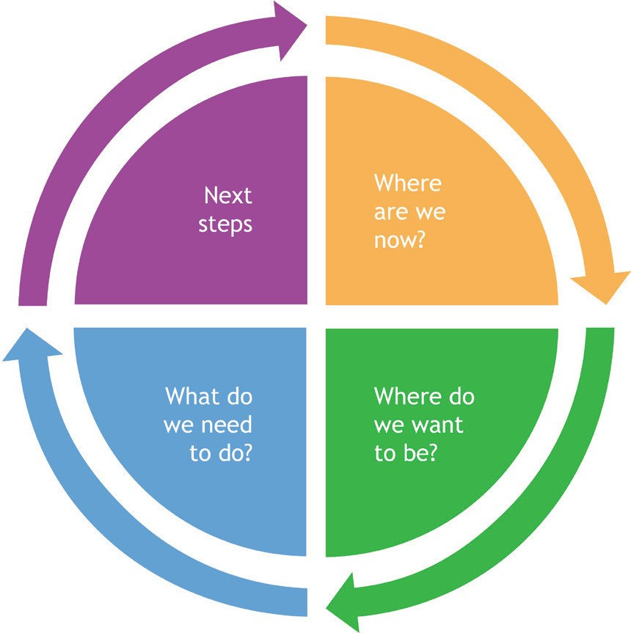

**Welcoming Children & Young People: Spirituality and Relationship with God**

**The Reflective Cycle**

The Reflective Cycle is a learning tool that will help you to reflect systematically on your circumstances. Each section of the *Spirituality and Relationship with God* toolkit is colour-coded according to which stage of the Reflective Cycle it relates. Once you have completed all the sections, you will have an action plan to strengthen the opportunities that enable children and young people to encounter God

at church, home and school. When you are ready, we hope that you will revisit the reflective cycle and consider another area of the *Welcoming Children and Young People* toolkit series (see [southwark.anglican.org/mission-ministry/mission/children-youth/welcoming-cyp-toolkit](https://southwark.anglican.org/mission-ministry/mission/children-youth/welcoming-cyp-toolkit/))

Walking

Welcoming

Growing

5

**Welcoming Children & Young People: Spirituality and Relationship with God** Where are we now?

**Section 1: Where are we now?**

**Question A**

In what ways do we create opportunities that enable children and young people (CYP) to encounter and grow their relationship with God? What, when and who do we already have in place?

**Areas to consider**

•

What provision is there for CYP to learn about Christian faith, the Bible, prayer and worship (for example, small groups for Bible study/prayer; First Communion preparation; confirmation class; mentoring, school lunch club, etc)?

How do we make opportunities (either gathered or online) for CYP to express their prayers, gifts of the Spirit, and sense of awe and wonder?

•

◊

◊

◊

◊

◊

◊

in our worship services? group activities?

trips or residentials? in local schools?

in the local community or environment? alongside other CYP?

alongside other generations?

•

•

Do we regularly pray for the CYP and households of our church and local community in this area?

Do we equip and resource parents, carers, grandparents and godparents to share their faith with children and young people in the home? If so, how?

What resources and leadership do we have in place?

Do we have leaders/helpers who reflect the ethnicity and gender of our CYP?

•

•

6

Walking

Welcoming

Growing

**Welcoming Children & Young People: Spirituality and Relationship with God** Where are we now?

**Question B**

What do children and young people (CYP) say about what helps them to connect with God?

**Suggested questions to ask children and young people**

•

•

•

•

•

•

•

•

•

What has made you go “wow” recently?

If Jesus came to spend the day with you, what would you choose to do with him? What is your favourite way to worship God?

What is your favourite Bible story? Would you rather read, watch or listen to a Bible story? What is your favourite Christian song and why?

Tell me about how and when you pray?

What helps you to connect with God?

What issues in your community, environment or world concern you? Do you think they concern God? In what ways do you or would you like to serve others in your church?

Walking

Welcoming

Growing

7

**Welcoming Children & Young People: Spirituality and Relationship with God** Where do we want to be?

**Section 2: Where do we want to be?**

**Question A**

What is our vision for enabling children and young people (CYP) both within our church and in our community to encounter and grow in relationship with God?

**Areas to consider**

•

How do we hope to enrich the spiritual lives of CYP in our church and in our local community? It might help to imagine a child you know and consider how you hope their relationship with God may start or develop over the next year, or the next five years.

•

Is there a particular target need or group in our community?

•

Have we considered our links with local schools (the places CYP inhabit Monday-Friday)?

•

Do we have a shared understanding within our church of the roles and responsibilities of parents/ carers and the church in supporting the faith formation of children? Visit [parentingforfaith.org/](https://parentingforfaith.org/churches) [churches](https://parentingforfaith.org/churches) to find out more.

•

Have we considered CYP with additional needs? For example, do we have key “befrienders” for families with CYP with additional needs while they are in church? Do we have trained volunteers who can provide one-to-one support for CYP with additional needs in groups?

•

How might we connect with CYP and families who are unable to attend in person?

•

How can we make use of digital and social media?

8

Walking

Welcoming

Growing

**Welcoming Children & Young People: Spirituality and Relationship with God** Where do we want to be?

**Question B**

What values are the foundation for our work alongside children, young people (CYP) and their

households?

**Areas to consider**

•

How will CYP know they are welcome? For example, do we greet them by name?

•

How do we imagine CYP will participate in church life and worship services?

•

How will we nurture and encourage the gifts and talents of CYP?

•

What leadership opportunities will we give CYP?

•

What opportunities are there to celebrate and listen to CYP?

•

How will we act on what CYP have shared?

•

What does it look like to include CYP in the sacraments? Is this reflected in our policy on communion, baptism and confirmation?

•

How do we demonstrate and adhere to our parish safeguarding policy?

•

Other values might include: praying regularly for CYP; including CYP of all abilities and backgrounds; Christ-centred; fun, etc.

Walking

Welcoming

Growing

9

**Welcoming Children & Young People: Spirituality and Relationship with God** What do we need to do?

**Section 3: What do we need to do?**

**Question A**

How can we improve our practice or begin to support our vision for enabling children and young people (CYP) to encounter and develop their relationship with God over the next year? The next five years?

**Areas to consider**

•

Can we evaluate existing and new activities to ensure that there is a balance of spiritually focused activities (building relationship with God) with those that build relationships with others?

•

How do we improve opportunities for CYP to express their prayers, gifts of the Spirit, and sense of awe and wonder and service to God in our groups, or main worship services, or online or at school?

•

How can our church community develop strategies to strengthen the relationships of CYP within their groups, with group leaders and with the wider church community, so that CYP are more fully integrated into church life?

•

Can we identify and facilitate role models of faith within the faith community that reflect the ethnicity of our CYP?

•

What intergenerational activities will enable families to engage with faith experiences together?

10

Walking

Welcoming

Growing

**Welcoming Children & Young People: Spirituality and Relationship with God** What do we need to do?

**Question B**

What do we need to change to support the faith development of children and young people (CYP) of differing ages, spiritual styles, ethnicities, and abilities?

**Areas to consider**

•

CYP make meaningful connections with God in different ways (through word, emotion, symbol and action). How can we improve the ways we explore the Bible, prayer and Christian faith with our CYP? Does our team need training in the area of spiritual styles (see [www.rootsontheweb.com/](https://www.rootsontheweb.com/discover-roots/spiritual-styles) [discover-roots/spiritual-styles](https://www.rootsontheweb.com/discover-roots/spiritual-styles))?

•

CYP learn through what is modelled to them. Do our resources reflect an appropriate gender balance and cater for CYP of different ethnicities and abilities?

•

Are we prepared to welcome visiting families with CYP outside our regular age groups?

•

Are we looking ahead to the key transition moments for CYP? What adaptations will we need to make and how can we prepare for this?

•

How do we connect with CYP and their families when we are unable to meet in person?

•

Are we prepared to welcome a family with a CYP with additional needs? For example, do we have key “befrienders” for families with CYP with additional needs while they are in church? Do we have volunteers who can provide one-to-one support for CYP with additional needs in groups? Does our church need some training in this area?

Walking

Welcoming

Growing

11

**Welcoming Children & Young People: Spirituality and Relationship with God** What do we need to do?

**Question C**

How do we improve or begin to support parents, carers or grandparents in growing faith at home?

**Areas to consider**

•

Do we have a shared understanding within our church of the roles and responsibilities of parents/ carers and the church in supporting the faith formation of children? Visit [parentingforfaith.org/](https://parentingforfaith.org/churches) [churches](https://parentingforfaith.org/churches) to find out more.

•

How can we care for, listen to, communicate and collaborate with parents/carers within our church and in the wider community?

•

How do we build community and enable our parents/carers to communicate and support with each other (for example, a WhatsApp group, prayer group, or a coffee morning after school drop-off)?

•

How do we encourage parents/carers to find confidence in sharing their faith at home with their children? For example, could we run a Parenting for Faith course? Could this be done in conjunction with a local Church of England school?

•

Are there resources or materials we could provide families with to support faith at home? (For example: Bibles, activity packs, discussion questions, etc. See [www.churchofengland.org/our-faith/](https://www.churchofengland.org/our-faith/faith-home) [faith-home](https://www.churchofengland.org/our-faith/faith-home) for more ideas.) Remember that a bespoke approach is more effective than a vast array of resources that are not specific to household needs.

12

Walking

Welcoming

Growing

**We support them in the following ways...**

**We could improve or begin this by...**

Our volunteers have First Aid training, and those working with under-11s have paediatric First Aid.

**Welcoming Children & Young People: Spirituality and Relationship with God** What do we need to do?

**Question D**

What safeguarding measures do we have or need to put in place?

Walking

Welcoming

Growing

13

**Areas to consider**

**Yes**

**No**

**Not sure**

**Action required**

We regularly review our safeguarding practice and policy with the PCC.

We implement and include updates to *A Safe Church* (see [southwark.](https://southwark.anglican.org/safeguarding/diocesan-policies-and-procedures) [anglican.org/safeguarding/diocesan-policies-and-procedures](https://southwark.anglican.org/safeguarding/diocesan-policies-and-procedures))

We have a Parish Safeguarding Officer.

Our safeguarding policy is displayed in the church and on our website.

All CYP volunteers and paid workers have enhanced DBS certificates and have gone through a safe recruitment process following the guidelines in *A Safe Church*.

All adults in contact with CYP have completed C1 Foundation safeguarding training.

CYP leaders have completed the C2 Leadership module.

The buildings and rooms are safe, accessible to all and appropriate for use.

Risk assessments are updated regularly.

We update CYP contact details and parental consent forms annually and store them securely.

We have considered online safety.

Other...

**Welcoming Children & Young People: Spirituality and Relationship with God** What do we need to do?

**Question E**

Do we have suitable facilities and materials in place for children of all ages and abilities?

14

Walking

Welcoming

Growing

**Questions to consider**

**Yes**

**No**

**Not sure**

**Action required**

Is there an area for parents/carers to feel comfortable with babies and very young children?

Is there clear signage for facilities and are users asked for feedback?

Are toilets and baby change facilities clean and accessible for all ages?

Do we need to replace/update/clean any furniture, carpet or curtains with CYP in mind?

Is the lighting conducive to activities?

Is there access to easily cleanable quality toys, books and activities for young children during a worship service, for example in pew bags/boxes?

Is there equipment and storage for creative and reflective activity for a

range of ages and abilities?

If there are groups for CYP, is the amount of space available appropriate

to the age group?

Is the space safe with a risk assessment completed?

Is the room a comfortable temperature in all seasons?

With regard to noise levels, are CYP distracted or distracting to others?

Are there suitable refreshments for CYP?

Have we asked CYP what they think?

Have we considered what we can learn from schools and nurseries with regard to the physical space that appeals to CYP?

Do we use resources that have images displaying a range of ethnicities?

**Our current practice...**

**We could improve or begin this by...**

**Welcoming Children & Young People: Spirituality and Relationship with God** What do we need to do?

**Question F**

How do we encourage, support and equip those working directly with children and young people (CYP) in the area of spiritual formation?

**Areas to consider**

•

How are parents/carers and leaders/helpers encouraged and given space to explore their own

spirituality and relationship with God?

•

Are parents/carers, leaders/helpers aware of their own spiritual styles (see [www.rootsontheweb.](https://www.rootsontheweb.com/discover-roots/spiritual-styles) [com/discover-roots/spiritual-styles](https://www.rootsontheweb.com/discover-roots/spiritual-styles))?

•

What resources and training do we provide in this area?

•

How do our parents/carers, leaders/helpers access encouragement and feedback in this area?

•

Is our church budget sufficient for resources, training and supervision?

•

Are there “praying friends” available to support those who work alongside CYP both within church and in the wider community?

•

How do we communicate to the wider church the work we are doing to improve the opportunities that CYP have to encounter God at church, school, within the local community and in households?

Walking

Welcoming

Growing

15

**We do this in the following ways...**

**We could improve or begin this by...**

**Welcoming Children & Young People: Spirituality and Relationship with God** Next steps

**Section 4: Next steps**

**Question A**

Based on our responses from previous sections, on which three areas is God calling us to focus, in order to strengthen the opportunities that enable children and young people to encounter God at church, home and school?

16

Walking

Welcoming

Growing

**ACTION:**

**Aim and description**

**Person responsible for progressing action**

**Timescale**

**Resources required**

**Person who can give support**

**Welcoming Children & Young People: Spirituality and Relationship with God**

Next steps

**Question B**

What training do we need?

Walking

Welcoming

Growing

17

**Actions**

**Timescale**

**Welcoming Children & Young People: Spirituality and Relationship with God** How we can help

**Appendix 1: How we can help**

1. **Fortnightly e-newsletter and social media**

Sign up for our e-newsletter signposting training, events and resources at: [bit.ly/3mL80TU](http://bit.ly/3mL80TU)

1. **Training**

•

•

Safeguarding: find details of courses and how to register at: [southwark.anglican.org/safeguarding/](https://southwark.anglican.org/safeguarding/) The Diocese of London offers a free online Academy course in both children’s ministry and youth ministry, available course to those working with CYP in Southwark. Find more information and details of how to sign up here: <https://learning.london.anglican.org/>

Bespoke training for your church or deanery. E-mail Aike Kennett-Brown ([aike.kennett-brown@](mailto:aike.kennett-brown@southwark.anglican.org) [southwark.anglican.org](mailto:aike.kennett-brown@southwark.anglican.org)) or Keli Bolton ([keli.bolton@southwark.anglican.org](mailto:keli.bolton@southwark.anglican.org)) for information. Webinars: topics and sign-up details are available on the website at [southwark.anglican.org/news-](https://southwark.anglican.org/news-events/events/whats-on/) [events/events/whats-on/](https://southwark.anglican.org/news-events/events/whats-on/) and in the e-newsletter.

•

•

**3. Small grants of up to £300**

The Mission Team offers small grants for CYP projects. Parishes can apply once per calendar year. E-mail Kim Jeffal on [CYPAdmin@southwark.anglican.org](mailto:CYPAdmin@southwark.anglican.org) for eligibility criteria and an application form. We fund:

•

•

•

local training fund

individual training grants

mission grants for new CYP projects.

**4. Resource Exchange**

The CYP team offers a free lending library of equipment for parishes and Church of England schools, including Godly Play sets and two large floor labyrinths. Download the catalogue at: [southwark.anglican.](https://southwark.anglican.org/wp-content/uploads/2020/12/cyp_lending_catalogue_sept_2020.pdf) [org/wp-content/uploads/2020/12/cyp_lending_catalogue_sept_2020.pdf](https://southwark.anglican.org/wp-content/uploads/2020/12/cyp_lending_catalogue_sept_2020.pdf); further information on how

to become a member can be found at [southwark.anglican.org/mission-ministry/mission/children-youth/](https://southwark.anglican.org/mission-ministry/mission/children-youth/resource-exchange/) [resource-exchange/](https://southwark.anglican.org/mission-ministry/mission/children-youth/resource-exchange/) or e-mail the CYP Team at [CYPAdmin@southwark.anglican.org](mailto:CYPAdmin@southwark.anglican.org)

1. **Ministry and Training library at Trinity House**

If you would like to apply for a library card and access the library, please contact [CYPAdmin@southwark.](mailto:CYPAdmin@southwark.anglican.org) [anglican.org](mailto:CYPAdmin@southwark.anglican.org).

1. **Support for paid and volunteer workers**

Get connected through our joint Southwark/London Zooms and webinars; WhatsApp group; and Facebook or Twitter feeds. Contact [keli.bolton@southwark.anglican.org](mailto:keli.bolton@southwark.anglican.org) for more information.

1. **Support for Messy Church**

Contact [aike.kennett-brown@southwark.anglican.org](mailto:aike.kennett-brown@southwark.anglican.org) or [david.cundill@southwark.anglican.org](mailto:david.cundill@southwark.anglican.org)

1. **Episcopal Area Celebration Events for those who work with children and young people**

We host events in each Episcopal area once every 18 months to two years. Details will be advertised via the e-newsletter, Facebook and Twitter.

Want to find out more? E-mail **Aike Kennett-Brown** ([aike.kennett-brown@southwark.anglican.org](mailto:aike.kennett-brown@southwark.anglican.org)) or

**Keli Bolton** ([keli.bolton@southwark.anglican.org](mailto:keli.bolton@southwark.anglican.org))

18

Walking

Welcoming

Growing

**Welcoming Children & Young People: Spirituality and Relationship with God**

Your details

**Appendix 2: Your details**

If you would like support in the form of an Accompanier to help you with this process, please complete and return this form to the CYP Team at [CYPAdmin@southwark.anglican.org.uk](mailto:CYPAdmin@southwark.anglican.org.uk)

**Name of parish/benefice:**

**Church number:**

**Deanery:**

**Address:**

**Postcode:**

**Contact name:**

**Telephone number:**

**E-mail:**

**Number of people involved in the process:**

**Age range of the group (from x to y years):**

*(please try to include at least one young person in your group)*

**Accompanier:**

**Accompanier’s telephone number:**

**Signature of Incumbent/Priest-in-Charge/PCC Secretary:**

**Date:**

Walking

Welcoming

Growing

19

**Welcoming Children & Young People: Spirituality and Relationship with God** Your details

**Appendix 2: Your details**

Please help us support your ministry with children and young people by providing the contact details of

your **CYP Parish Rep** and key **Children/Youth/Family Leaders**.

**1. CYP Parish Rep(s)**

**Name:**

**E-mail:**

**Telephone:**

**2. Children/Youth/Family Leader(s)**

**Name:**

**E-mail:**

**Role title:**

**Please circle whether this person is: Voluntary or Employed**

**3. Children/Youth/Family Leader(s)**

**Name:**

**E-mail:**

**Role title:**

**Please circle whether this person is: Voluntary or Employed**

**4. Children/Youth/Family Leader(s)**

**Name:**

**E-mail:**

**Role title:**

**Please circle whether this person is: Voluntary or Employed**

**5. Children/Youth/Family Leader(s)**

**Name:**

**E-mail:**

**Role title:**

**Please circle whether this person is: Voluntary or Employed**

20

Walking

Welcoming

Growing

**Welcoming Children & Young People: Spirituality and Relationship with God**

Your notes

**Appendix 3: Your notes**

**Continued from Section**

**Continued from Question**

Walking

Welcoming

Growing

21

**Notes**

**Welcoming Children & Young People: Spirituality and Relationship with God** Your notes

**Appendix 3: Your notes**

**Continued from Section**

**Continued from Question**

22

Walking

Welcoming

Growing

**Notes**

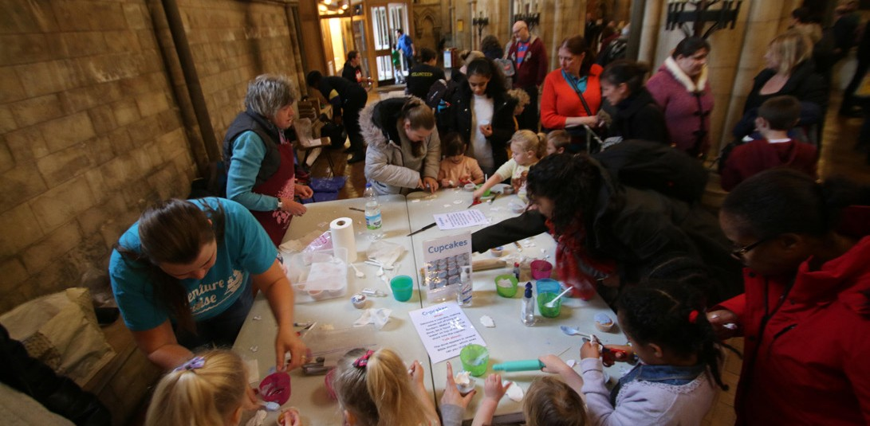

**Welcoming Children & Young People: Spirituality and Relationship with God**

Further reading

**Southwark**

**Splash in 2019.**

**Further reading**

*•*

*Children’s Ministry That Fits: Beyond One-Size-Fits-All Approaches to Nurturing Children’s Spirituality,* David M Csinos and Joyce E Bellous (Wipf and Stock, 2011).

*Little Theologians: Children, culture, and the making of theological meaning,* David M Csinos (McGill-Queen’s University Press, 2020).

*Faith in Children,* Ronni Lamont (Monarch Books, 2020).

*Children’s Spirituality: What it is and why it matters,* Rebecca Nye (Church House Publishing, 2009).

*Networks for Faith Formation: Relational Bonds and the Spiritual Growth of Youth,* Steven Emery- Wright and Ed Mackenzie (Wipf & Stock, 2017).

*•*

*•*

*•*

*•*

**Web resources**

•

[www.churchofengland.org/our-faith/faith-home](https://www.churchofengland.org/our-faith/faith-home) ― video resources to equip parents to talk about faith in the home.

[parentingforfaith.org](https://parentingforfaith.org/) ― equipping parents to raise God-connected children and teens.

[www.prayerspacesinschools.com](https://www.prayerspacesinschools.com/) ― resources to enable children and young people to explore life’s questions, spirituality and faith in a safe, creative and interactive way.

•

•

Walking

Welcoming

Growing

23

