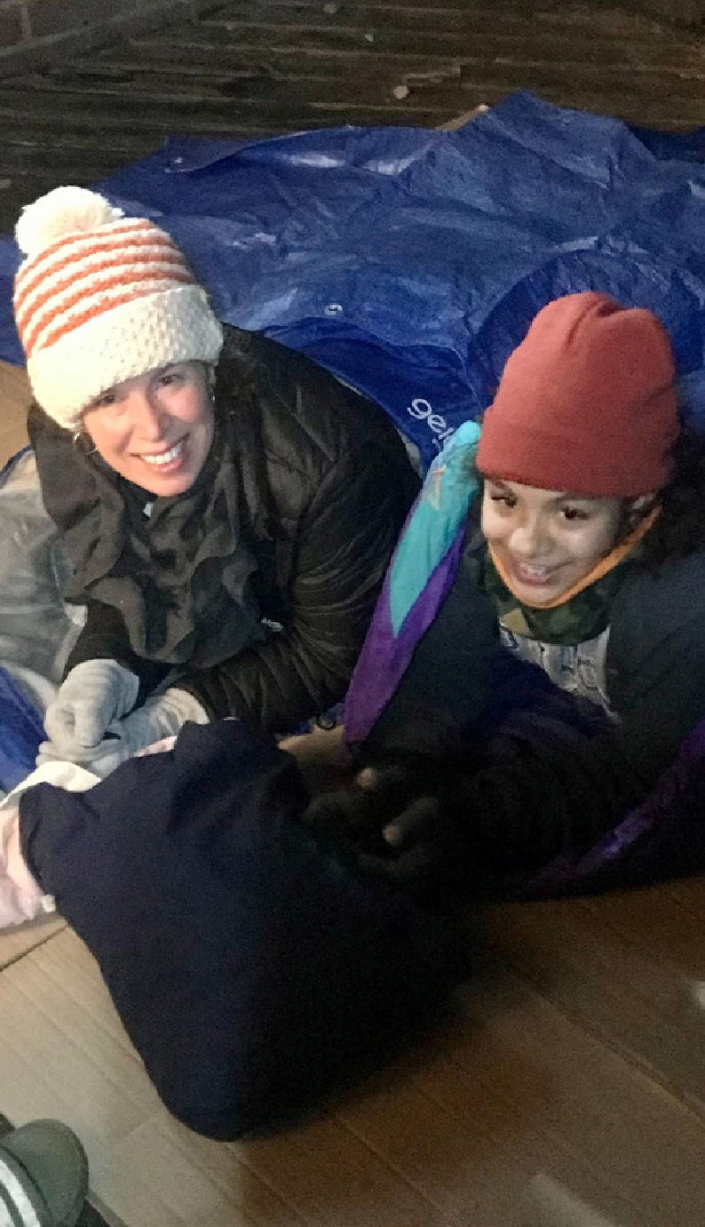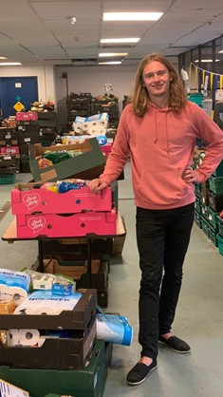

**Welcoming Children and Young People** Mission and outreach

***Walking Welcoming Growing***

**Welcoming Children & Young People: Mission and outreach**

**Contents**

Preface by The Bishop of Southwark

3

Introduction

4

The Reflective Cycle

5

Section 1: Where are we now?

6

Section 2: Where do we want to be?

8

Section 3: What do we need to do?

10

Section 4: Next steps

13

Appendix 1: How we can help

15

Appendix 2: Your details

16

Appendix 3: Five Marks of Mission

18

Appendix 4: Your notes

19

Further reading

23

**Cover images: Sarah and Kira from St John, Blackheath, sleep out to raise money for London City Mission homeless project; Morgan from St Mark, Wimbledon, volunteers at the Dons Local Action Food Group distribution centre.**

2

Walking

Welcoming

Growing

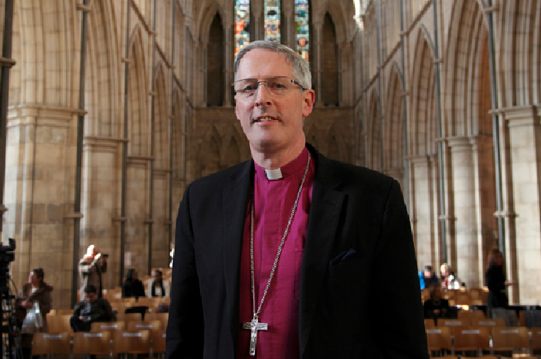

**Welcoming Children & Young People: Mission and outreach**

**Bishop Christopher writes…**

*Dear Brothers and Sisters in Christ,*

Our vision in this Diocese is for our children and young people (CYP) to grow in faith, hope and love, with hearts on fire for Jesus, contributing joyfully, happily and confidently to the life of the Church and its mission at every level.

The whole Church has a role to play in walking alongside CYP and supporting households to grow in faith together. Our schools are an essential part of this outreach as we seek to welcome and listen well to the

voice of all children and young people in all their glorious and rich God-given diversity.

During 2020-21, the COVID-19 pandemic has impacted dramatically on the ways in which we gather as a church community as well as our mission and ministry with children and young people. It has presented a number of exciting new opportunities and possibilities. We are now able to reimagine the way in which we welcome children and young people, walk alongside them and encourage them to grow in their faith.

The Welcoming Children and Young People toolkit series, which I commend to you, provides a framework to enable churches to begin, re-start or reimagine their welcome and inclusion of children and young people.

Whether you are just starting out or have an established ministry with children, young people and their families, I hope you find working through this toolkit a constructive way to reflect on all that you do.

May it inspire your vision and celebrate what is going well, whilst challenging what may need to be changed or added so that children and young people can take a full place in the life of the Church.

The Lord blesses us through the children and young people He entrusts to our care. We are all God’s children and beloved in His sight. May we make the most of this new resource and the opportunities we have to be joyful and active as fellow members of the family and household of God.

**Bishop Christopher**

*The Diocese of Southwark*

Walking

Welcoming

Growing

3

**Welcoming Children & Young People: Mission and outreach**

**Introduction**

This *Welcoming Children and Young People: Mission and Outreach* toolkit has been developed to enable parishes to take a fresh look at the welcome and community on offer to children, young people and their households.

The pack will take you through four stages of reflection, inviting you to reflect on what you are already doing, and where you have ideas to start or develop mission or outreach opportunities with children, young people and their families in your community.

We encourage you to gather a group (in person or online) to look through this evaluation and pray together, ideally including your CYP Parish Rep, Incumbent or Churchwarden. Even if your church has only a few children and young people, it would be ideal to include them and their parents in your discussion, to enable you to see things through their eyes. This will provide greater relevance and integrity to any developments and changes that may come out of this process.

We recommend that you:

•

•

•

read through the *Mission and Outreach* booklet

work out your process for gathering information and ideas, and decide on your team

fill out this booklet together and keep a record, to enable your team to share your thinking and next steps with your PCC and wider church community

complete the contact details in Appendix 2 in order to access the support available to your team outlined in Appendix 1

e-mail the completed form to [CYPAdmin@southwark.anglican.org](mailto:CYPAdmin@southwark.anglican.org) or post it to Kim Jeffal, Mission Team Administrator, Trinity House, 4 Chapel Court, Borough High Street, London SE1 1HW.

•

•

If you require additional support and would like an Accompanier to walk alongside you as you complete the process, please complete and return the request form in Appendix 2 or get in touch with Mission Support Officers Aike Kennett-Brown or Keli Bolton.

When your team is ready, you can go around the reflective cycle again and look at other areas within the *Welcoming Children and Young People* toolkit series: *First Steps*; *Spirituality and Relationship with God*; and *Decision-making and Inclusion*.

**Aike Kennett-Brown**

[aike.kennett-brown@southwark.anglican.org](mailto:aike.kennett-brown@southwark.anglican.org)

**Keli Bolton**

[keli.bolton@southwark.anglican.org](mailto:keli.bolton@southwark.anglican.org)

4

Walking

Welcoming

Growing

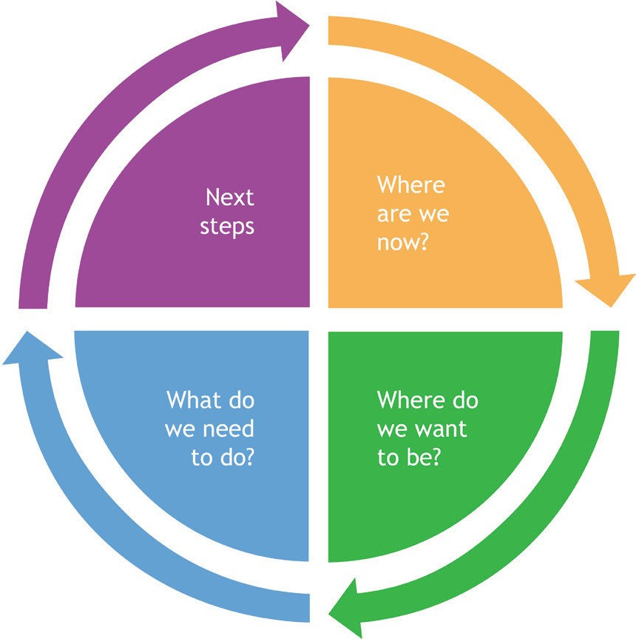

**Welcoming Children & Young People: Mission and outreach**

**The Reflective Cycle**

The Reflective Cycle is a learning tool that will help you to reflect systematically on your circumstances. Each section of the *Mission and Outreach* toolkit is colour-coded according to which stage of the Reflective Cycle it relates. Once you have completed all the sections, you will have decided your vision and values, and have an action plan. When you are ready, we hope that you will revisit the reflective cycle and consider another area of the *Welcoming Children and Young People* toolkit series.

Walking

Welcoming

Growing

5

**Welcoming Children & Young People: Mission and outreach** Where are we now?

**Section 1: Where are we now?**

**Question A**

What opportunities for mission and outreach with children, young people (CYP) and their families do we already have?

**Areas to consider**

•

Try this mapping exercise: make a list of all the activities throughout the week/month/year where the church has contact with CYP and their families. What, when and with whom do we already connect?

•

Who are the people in our church that build these connections?

•

What partnerships do we already have? For example, which other organisations make use of our church buildings and how do we engage with them? Think about uniformed groups, toddler groups, local schools and nurseries, food banks etc.

•

What other areas of mission does our church engage with, for example overseas or local mission partners, care for the elderly, homelessness, work with schools/the community? How do the CYP and families of our church get involved?

•

Does our community have a particular need?

•

How do we make use of digital media to reach our community?

•

How accessible and affordable are our children, youth and family activities?

6

Walking

Welcoming

Growing

**Welcoming Children & Young People: Mission and outreach** Where are we now?

**Question B**

What areas of mission are important to the children and young people (CYP) of our church?

**Suggested questions to ask children and young people**

•

What issues concern you:

◊

◊

◊

◊

◊

in our church?

in your school?

in our local community? in our world?

about our environment?

•

What issues concern your friends?

•

Do you already support any charities or campaigns? Tell us more…

Walking

Welcoming

Growing

7

**Welcoming Children & Young People: Mission and outreach**

Where do we want to be?

**Section 2: Where do we want to be?**

**Question A**

What is our vision for enabling children, young people (CYP) and their families, both within our church and in our community, to engage in God’s mission locally and globally?

**Have we considered the Five Marks of Mission (see Appendix 3)?**

**•**

**Tell:** How do we support CYP and their families to talk to their friends about their faith? How will we share the gospel with families who do not yet come to our church?

**Teach:** How do we equip CYP to teach others about faith, for example in a Sunday group or with their friends at school?

**Tend:** How do we encourage and equip CYP and their families to serve our church or local community?

**Transform:** How do we enable CYP and their families to instigate and participate in ways of challenging injustice?

**Treasure:** How do we enable CYP and their families to care for creation?

**•**

**•**

**•**

**•**

•

Is there a particular need in our community where we could offer support? Which of the Five Marks of Mission is the best place to start?

•

How might we connect with CYP and families who are physically unable to come to our church?

•

How can we improve our use of digital and social media?

8

Walking

Welcoming

Growing

**Welcoming Children & Young People: Mission and outreach**

Where do we want to be?

**Question B**

Have we considered our links with local schools (the places CYP inhabit Monday-Friday)?

**Areas to consider**

•

What relationships within schools already exist?

•

Which schools (either community, private or Church of England) are within our parish? Who are our

key contacts?

•

Where do the children and young people in our church go to school/college?

•

Do we have any teachers/school staff in our church? Which schools do they work in?

•

Have we asked the school what sort of support they would like from our church?

•

Which of the Five Marks of Mission would be most appropriate to develop with the school(s) in our context? Here are some suggestions:

◊

◊

◊

Tell: support assemblies/collective worship; key Christian festivals Teach: RE support; set up a reflective prayer space

Tend: chaplaincy/mentoring; school gate ministry; food bank or holiday lunch provision for at-risk families; befriend overseas families; volunteer to read with children

Transform: pray for schools; provide a safe space after school; campaign on local issues of injustice, for example food poverty; become a school governor

Treasure creation: organise a litter sweep around the school; create a reflective garden.

◊

◊

Walking

Welcoming

Growing

9

**Welcoming Children & Young People: Mission and outreach**

What do we need to do?

**Section 3: What do we need to do?**

**Question A**

How can we improve our practice or begin to support our vision for mission and outreach with children, young people (CYP) and their families and schools over the next year? The next five years?

**Areas to consider**

•

What research do we need to do to enable our vision? For example, talk with the local school, find out the needs of local families, find out about other local organisations/churches with whom we could partner, etc.

•

Who are the people within our church that have good relationships or expertise in our area of vision?

•

Who else is appropriate and available to inform or carry out our vision?

•

Do we need to stop or change anything in order to start something new?

•

How can we pray about this as a church?

10

Walking

Welcoming

Growing

**Welcoming Children & Young People: Mission and outreach** What do we need to do?

**Question B**

What safeguarding measures do we have or need to put in place?

Walking

Welcoming

Growing

11

**Areas to consider**

**Yes**

**No**

**Not sure**

**Action required**

We regularly review our safeguarding practice and policy with the PCC.

We implement and include updates to *A Safe Church* (see [southwark.](https://southwark.anglican.org/safeguarding/diocesan-policies-and-procedures) [anglican.org/safeguarding/diocesan-policies-and-procedures](https://southwark.anglican.org/safeguarding/diocesan-policies-and-procedures))

We have a Parish Safeguarding Officer.

Our safeguarding policy is displayed in the church and on our website.

All CYP volunteers and paid workers have enhanced DBS certificates and have gone through a safe recruitment process following the guidelines in *A Safe Church*.

All adults in contact with CYP have completed C1 Foundation safeguarding training.

CYP leaders have completed the C2 Leadership module.

Our volunteers have First Aid training, and those working with under-11s have paediatric First Aid.

The buildings and rooms are safe, accessible to all and appropriate for use.

Risk assessments are updated regularly.

We update CYP contact details and parental consent forms annually and store them securely.

We have considered online safety.

Other...

**Welcoming Children & Young People: Mission and outreach**

What do we need to do?

**Question C**

How do we encourage, support and equip CYP, parents/carers and volunteers to get involved in God’s mission, both locally and globally?

**Areas to consider**

•

What training do we provide in this area?

•

Is our church budget sufficient for resources, training and supervision?

•

Are there “praying friends” available to support those who work alongside CYP, both within church and in the wider community?

•

How will we communicate to the wider church our vision for mission and outreach with CYP, their households and schools?

12

Walking

Welcoming

Growing

**We support them in the following ways...**

**We could improve or begin this by...**

**Welcoming Children & Young People: Mission and outreach**

Next steps

**Section 4: Next steps**

**Question A**

Based on our responses from previous sections, on which three areas is God calling us to focus, in order to strengthen the opportunities we have for mission and outreach with children and young people (CYP), their households and schools?

Walking

Welcoming

Growing

13

**ACTION:**

**Aim and description**

**Person responsible for progressing action**

**Timescale**

**Resources required**

**Person who can give support**

**Welcoming Children & Young People: Mission and outreach** Next steps

**Question B**

What training do we need?

14

Walking

Welcoming

Growing

**Actions**

**Timescale**

**Welcoming Children & Young People: Mission and outreach** How we can help

**Appendix 1: How we can help**

1. **Fortnightly e-newsletter and social media**

Sign up for our e-newsletter signposting training, events and resources at: [bit.ly/3mL80TU](http://bit.ly/3mL80TU)

1. **Training**

•

•

Safeguarding: find details of courses and how to register at: [southwark.anglican.org/safeguarding/](https://southwark.anglican.org/safeguarding/) The Diocese of London offers a free online Academy course in both children’s ministry and youth ministry, available course to those working with CYP in Southwark. Find more information and details of how to sign up here: <https://learning.london.anglican.org/>

Bespoke training for your church or deanery. E-mail Aike Kennett-Brown ([aike.kennett-brown@](mailto:aike.kennett-brown@southwark.anglican.org) [southwark.anglican.org](mailto:aike.kennett-brown@southwark.anglican.org)) or Keli Bolton ([keli.bolton@southwark.anglican.org](mailto:keli.bolton@southwark.anglican.org)) for information. Webinars: topics and sign-up details are available on the website at [southwark.anglican.org/news-](https://southwark.anglican.org/news-events/events/whats-on/) [events/events/whats-on/](https://southwark.anglican.org/news-events/events/whats-on/) and in the e-newsletter.

•

•

**3. Small grants of up to £300**

The Mission Team offers small grants for CYP projects. Parishes can apply once per calendar year. E-mail Kim Jeffal on [CYPAdmin@southwark.anglican.org](mailto:CYPAdmin@southwark.anglican.org) for eligibility criteria and an application form. We fund:

•

•

•

local training fund individual training grants

mission grants for new CYP projects.

**4. Resource Exchange**

The CYP team offers a free lending library of equipment for parishes and Church of England schools, including Godly Play sets and two large floor labyrinths. Download the catalogue at: [southwark.anglican.](https://southwark.anglican.org/wp-content/uploads/2020/12/cyp_lending_catalogue_sept_2020.pdf) [org/wp-content/uploads/2020/12/cyp_lending_catalogue_sept_2020.pdf](https://southwark.anglican.org/wp-content/uploads/2020/12/cyp_lending_catalogue_sept_2020.pdf); further information on how

to become a member can be found at [southwark.anglican.org/mission-ministry/mission/children-youth/](https://southwark.anglican.org/mission-ministry/mission/children-youth/resource-exchange/) [resource-exchange/](https://southwark.anglican.org/mission-ministry/mission/children-youth/resource-exchange/) or e-mail the CYP Team at [CYPAdmin@southwark.anglican.org](mailto:CYPAdmin@southwark.anglican.org)

1. **Ministry and Training library at Trinity House**

If you would like to apply for a library card and access the library, please contact [CYPAdmin@southwark.](mailto:CYPAdmin@southwark.anglican.org) [anglican.org](mailto:CYPAdmin@southwark.anglican.org).

1. **Support for paid and volunteer workers**

Get connected through our joint Southwark/London Zooms and webinars; WhatsApp group; and Facebook or Twitter feeds. Contact [keli.bolton@southwark.anglican.org](mailto:keli.bolton@southwark.anglican.org) for more information.

1. **Support for Messy Church**

Contact [aike.kennett-brown@southwark.anglican.org](mailto:aike.kennett-brown@southwark.anglican.org) or [david.cundill@southwark.anglican.org](mailto:david.cundill@southwark.anglican.org)

1. **Episcopal Area Celebration Events for those who work with children and young people**

We host events in each Episcopal area once every 18 months to two years. Details will be advertised via the e-newsletter, Facebook and Twitter.

Want to find out more? E-mail **Aike Kennett-Brown** ([aike.kennett-brown@southwark.anglican.org](mailto:aike.kennett-brown@southwark.anglican.org)) or

**Keli Bolton** ([keli.bolton@southwark.anglican.org](mailto:keli.bolton@southwark.anglican.org))

Walking

Welcoming

Growing

15

**Welcoming Children & Young People: Mission and outreach**

Your details

**Appendix 2: Your details**

If you would like support in the form of an Accompanier to help you with this process, please complete and return this form to the CYP Team at [CYPAdmin@southwark.anglican.org.uk](mailto:CYPAdmin@southwark.anglican.org.uk)

**Name of parish/benefice:**

**Church number:**

**Deanery:**

**Address:**

**Postcode:**

**Contact name:**

**Telephone number:**

**E-mail:**

**Number of people involved in the process:**

**Age range of the group (from x to y years):**

*(please try to include at least one young person in your group)*

**Accompanier:**

**Accompanier’s telephone number:**

**Signature of Incumbent/Priest-in-Charge/PCC Secretary:**

**Date:**

16

Walking

Welcoming

Growing

**Welcoming Children & Young People: Mission**

**and outreach**

Your details

**Appendix 2: Your details**

Please help us support your ministry with children and young people by providing the contact details of

your **CYP Parish Rep** and key **Children/Youth/Family Leaders**.

**1. CYP Parish Rep(s)**

**Name:**

**E-mail:**

**Telephone:**

**2. Children/Youth/Family Leader(s)**

**Name:**

**E-mail:**

**Role title:**

**Please circle whether this person is: Voluntary or Employed**

**3. Children/Youth/Family Leader(s)**

**Name:**

**E-mail:**

**Role title:**

**Please circle whether this person is: Voluntary or Employed**

**4. Children/Youth/Family Leader(s)**

**Name:**

**E-mail:**

**Role title:**

**Please circle whether this person is: Voluntary or Employed**

**5. Children/Youth/Family Leader(s)**

**Name:**

**E-mail:**

**Role title:**

**Please circle whether this person is: Voluntary or Employed**

Walking

Welcoming

Growing

17

**Welcoming Children & Young People: Mission and outreach**

**Appendix 3:**

**The Five Marks of Mission**

According to the Mission Theology Advisory Group of the Church of England, “the Five Marks of Mission have been developed by the Anglican Consultative Council since 1984. Since then, they have been widely adopted as an understanding of what contemporary mission is about. The Marks were adopted by the General Synod of the Church of England in 1996 and many Dioceses and other denominations used them as the basis of action plans and creative mission ideas”.

Some churches abbreviate the Five Marks to five words:

•

•

•

•

•

Tell Teach Tend

Transform

Treasure

In 2012, the ACC added wording to the Fourth Mark, to include the need for Christians to challenge violence and work for peace.

**The Five Marks of Mission**

•

•

•

•

To proclaim the good news of the Kingdom. To teach, baptise and nurture new believers. To respond to human need by loving service.

To seek to transform unjust structures of society, to challenge violence of every kind, and to pursue peace and reconciliation.

To strive to safeguard the integrity of creation and sustain and renew the life of the Earth.

•

18

Walking

Welcoming

Growing

**Welcoming Children & Young People: Mission and outreach**

Your notes

**Appendix 4: Your notes**

**Continued from Section**

**Continued from Question**

Walking

Welcoming

Growing

19

**Notes**

**Welcoming Children & Young People: Mission and outreach** Your notes

**Appendix 4: Your notes**

**Continued from Section**

**Continued from Question**

20

Walking

Welcoming

Growing

**Notes**

**Welcoming Children & Young People: Mission and outreach**

Your notes

**Appendix 4: Your notes**

**Continued from Section**

**Continued from Question**

Walking

Welcoming

Growing

21

**Notes**

**Welcoming Children & Young People: Mission and outreach** Your notes

**Appendix 4: Your notes**

**Continued from Section**

**Continued from Question**

22

Walking

Welcoming

Growing

**Notes**

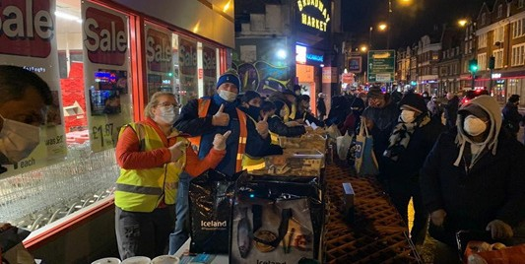

**Welcoming Children & Young People: Mission and outreach** Further reading

**Dons Local Action Group.**

**Further reading**

*•*

*Mission-Shaped Children: Moving towards a child-centred church*, Margaret Withers (Church House Publishing, 2010).

*Messy Church: Fresh ideas for building a Christ-centred community*, Lucy Moore (BRF, 2015).

*Starting Your Messy Church: A beginners’ guide for churches*, Lucy Moore and Jane Leadbetter (BRF, 2015).

*Youthwork from Scratch: How to launch or revitalize a church youth ministry*, Martin Saunders (Monarch Books, 2013).

*Beginning Unlimited: The Diary of a Church Plant*, Liz Grier (Instant Apostle, 2018).

*•*

*•*

*•*

*•*

**Web resources**

•

[www.churchofengland.org/our-faith/faith-home](https://www.churchofengland.org/our-faith/faith-home) ― resources to support faith development and pastoral care of children and young people at church, home and school.

[www.biblesociety.org.uk/get-involved/open-the-book/](https://www.biblesociety.org.uk/get-involved/open-the-book/) ― a project which offers primary school children an opportunity to hear key Bible stories, from a team of Christians from local churches.

[www.prayerspacesinschools.com](https://www.prayerspacesinschools.com/) ― resources to enable children and young people to explore life’s questions, spirituality and faith in a safe, creative and interactive way.

[ecochurch.arocha.org.uk](https://ecochurch.arocha.org.uk/) ― resources to equip your church to express your care for God’s world.

•

•

•

Walking

Welcoming

Growing

23

