

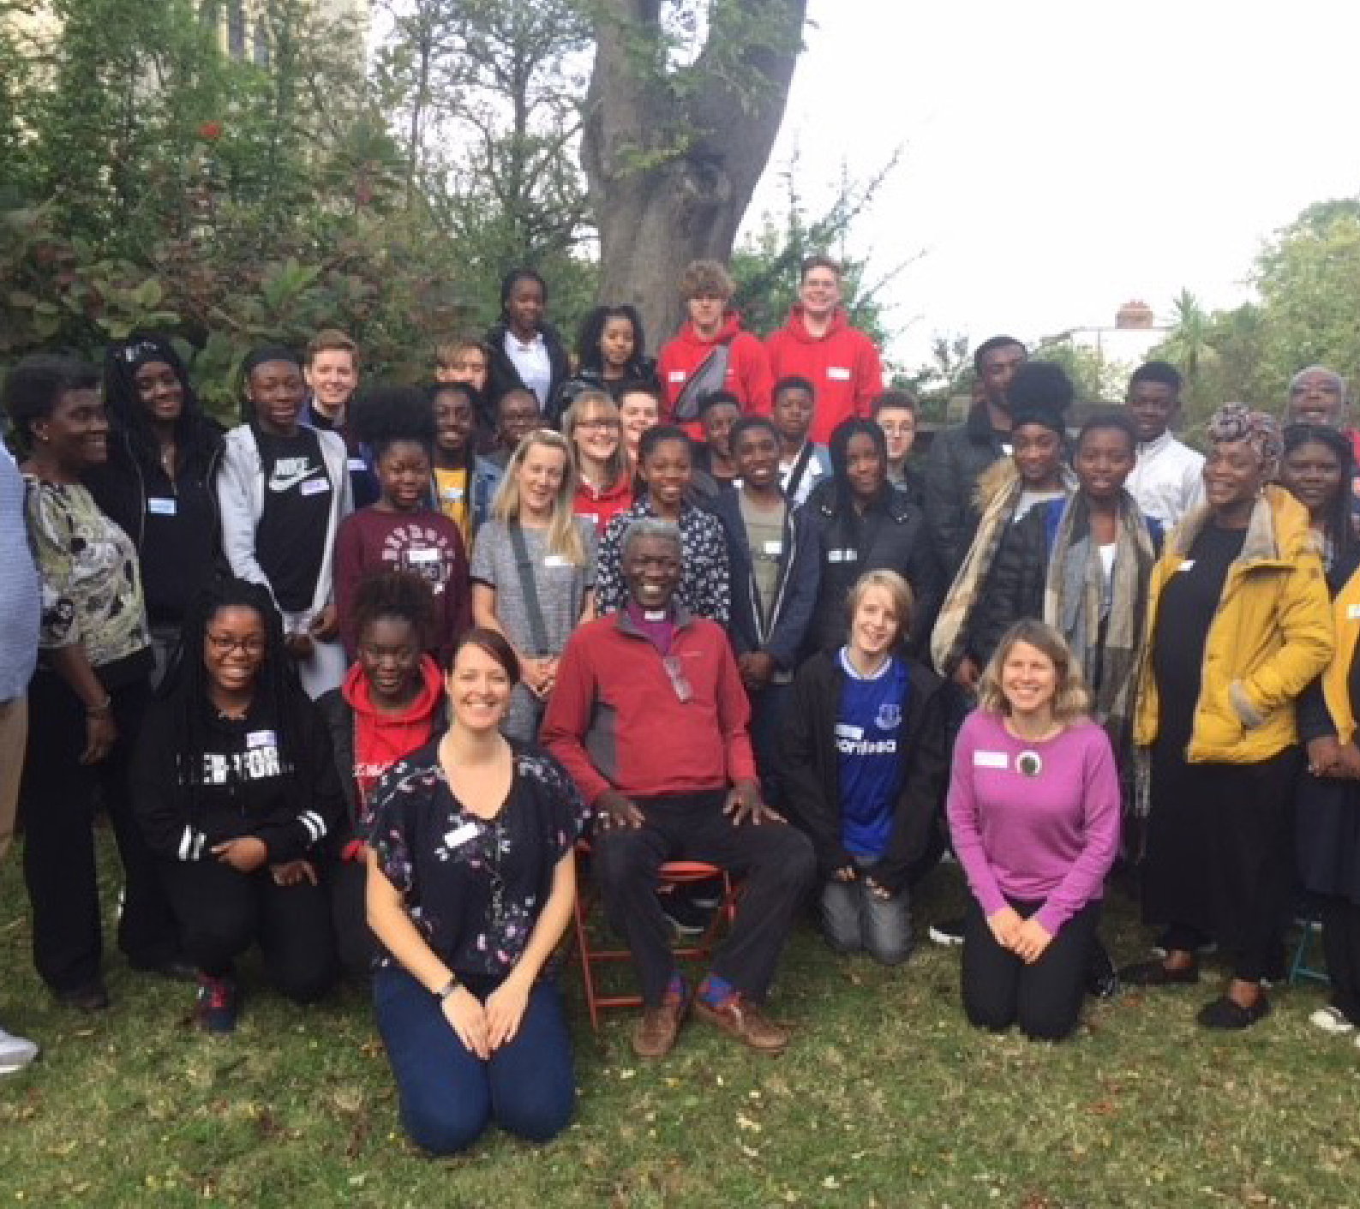

**Welcoming Children and Young People** Decision-making

and inclusion

***Walking Welcoming Growing***

**Welcoming Children & Young People:**

**Decision-making and inclusion**

**Contents**

Preface by The Bishop of Southwark

3

Introduction

4

The Reflective Cycle

5

Section 1: Where are we now?

6

Section 2: Where do we want to be?

9

Section 3: What do we need to do?

11

Section 4: Next steps

13

Appendix 1: How we can help

14

Appendix 2: Your details

15

Appendix 3: Parish Rep role description

17

Appendix 4: Your notes

18

Further resources

19

**Cover image: Woolwich Episcopal Area Youth Forum with Bishop Karowei, 2019**

2

Walking

Welcoming

Growing

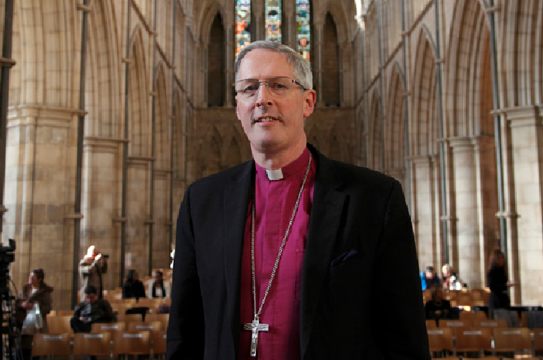

**Welcoming Children & Young People:**

**Decision-making and inclusion**

**Bishop Christopher writes…**

*Dear Brothers and Sisters in Christ,*

Our vision in this Diocese is for our children and young people (CYP) to grow in faith, hope and love, with hearts on fire for Jesus, contributing joyfully, happily and confidently to the life of the Church and its mission at every level.

The whole Church has a role to play in walking alongside CYP and supporting households to grow in faith together. Our schools are an essential part of this outreach as we seek to welcome and listen well to the

voice of all children and young people in all their glorious and rich God-given diversity.

During 2020-21, the COVID-19 pandemic has impacted dramatically on the ways in which we gather as a church community as well as our mission and ministry with children and young people. It has presented a number of exciting new opportunities and possibilities. We are now able to reimagine the way in which we welcome children and young people, walk alongside them and encourage them to grow in their faith.

The Welcoming Children and Young People toolkit series, which I commend to you, provides a framework to enable churches to begin, re-start or reimagine their welcome and inclusion of children and young people.

Whether you are just starting out or have an established ministry with children, young people and their families, I hope you find working through this toolkit a constructive way to reflect on all that you do.

May it inspire your vision and celebrate what is going well, whilst challenging what may need to be changed or added so that children and young people can take a full place in the life of the Church.

The Lord blesses us through the children and young people He entrusts to our care. We are all God’s children and beloved in His sight. May we make the most of this new resource and the opportunities we have to be joyful and active as fellow members of the family and household of God.

**Bishop Christopher**

*The Diocese of Southwark*

Walking

Welcoming

Growing

3

**Welcoming Children & Young People:**

**Decision-making and inclusion**

**Introduction**

This *Welcoming Children and Young People: Decision-Making & Inclusion* toolkit has been developed to enable parishes to take a fresh look at how decisions are made regarding their work with children and young people and how to include them within this process.

In church, we are often very good at deciding what children and young people need, telling them what

to do, and making decisions on their behalf. We can sometimes forget that children and young people are the Church of today. They have a wealth of ideas, suggestions and insights which can shape, challenge and change the Church in exciting ways, whilst enabling them to have a greater sense of ownership and belonging.

For example, one eight-year-old girl had a profound effect on her parish vision. At a Mission Action Planning day, the children were asked to make Lego models representing what they liked about their church. Sonia made a model of her church, but without a door. She was able to explain that although she loved coming to church, it was always shut. This insight helped the parish to rethink their use of their building and how they could open it up and create missional opportunities with their local community throughout the week.

We encourage you to gather a group (in person or online) to look through this evaluation and pray together, ideally including your CYP Parish Rep, Incumbent or Churchwarden. Even if your church has only a few children and young people, it would be ideal to include them and their parents in your discussion, to enable you to see things through their eyes. This will provide greater relevance and integrity to any developments and changes that may come out of this process.

We recommend that you:

•

•

•

read through the *Decision-Making & Inclusion* booklet

work out your process for gathering information and ideas, and decide on your team

fill out this booklet together and keep a record, to enable your team to share your thinking and next steps with your PCC and wider church community

complete the contact details in Appendix 2 in order to access the support available to your team

outlined in Appendix 1

e-mail the completed form to [CYPAdmin@southwark.anglican.org](mailto:CYPAdmin@southwark.anglican.org) or post it to Kim Jeffal, Mission Team Administrator, Trinity House, 4 Chapel Court, Borough High Street, London SE1 1HW.

•

•

If you require additional support and would like an Accompanier to walk alongside you as you go through the process, please complete and return the request form in Appendix 2 or get in touch with Mission Support Officers Aike Kennett-Brown or Keli Bolton.

**Aike Kennett-Brown**

[aike.kennett-brown@southwark.anglican.org](mailto:aike.kennett-brown@southwark.anglican.org)

**Keli Bolton**

[keli.bolton@southwark.anglican.org](mailto:keli.bolton@southwark.anglican.org)

4

Walking

Welcoming

Growing

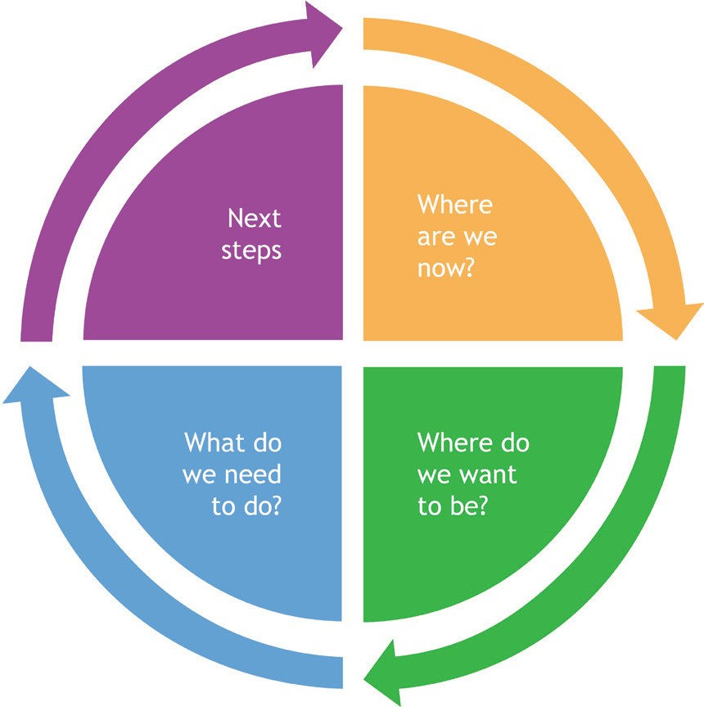

**Welcoming Children & Young People:**

**Decision-making and inclusion**

**The Reflective Cycle**

The Reflective Cycle is a learning tool that will help you to reflect systematically on your circumstances. Each section of the *Decision-Making & Inclusion* toolkit is colour-coded according to which stage of the Reflective Cycle it relates. Once you have completed all the sections, have considered how to evaluate and make decisions around your work with children and young people, and how to include them within this process. When you are ready, we hope that you will revisit the reflective cycle and consider another area of the *Welcoming Children and Young People* toolkit series.

Walking

Welcoming

Growing

5

**Welcoming Children & Young People:**

**Decision-making and inclusion**

Where are we now?

**Section 1: Where are we now?**

**Question A**

In what ways do we currently review, evaluate and hold ourselves accountable for our work with children, young people (CYP) and their families?

**Areas to consider**

•

What is our church vision and objectives for work alongside CYP and their households?

•

How is mission and ministry with CYP reflected in our church vision statement/parish profile/ website/Mission Action Plan?

•

How and when do we evaluate our work alongside CYP?

•

Who is involved in this evaluation?

•

How often does mission and ministry with CYP appear on our PCC agenda, so that there is a shared understanding and proper financial provision?

6

Walking

Welcoming

Growing

**Welcoming Children & Young People:**

**Decision-making and inclusion**

Where are we now?

**Question B**

How do we encourage and include parents/carers and our CYP leaders to be involved in evaluation and making decisions about our work alongside CYP?

**Areas to consider**

•

•

•

•

How is the vision for ministry with CYP communicated with CYP leaders and parents? Do our CYP leaders feel part of a team?

How does our church communicate with parents/carers?

What opportunities are there for parents/carers and CYP leaders to offer comments or recommendations on existing activities or when the church makes plans for the future?

How is this followed up and acted on?

Who is our CYP Parish Rep (see Appendix 3 for role description)?

Which adults on the PCC or staff team will advocate for issues concerning CYP? For example, is the CYP Parish Rep on the PCC?

•

•

•

Walking

Welcoming

Growing

7

**Welcoming Children & Young People:**

**Decision-making and inclusion**

Where are we now?

**Question C**

How do we listen to and learn from our children and young people (CYP) and enable them to participate

in decision-making?

**Areas to consider**

•

•

What opportunities are there for CYP to offer feedback or make decisions on existing activities?

What opportunities are there for CYP to make recommendations when the church makes future plans? For example, choosing a new vicar, helping with the church vision, planning services.

How is this followed up and acted on?

How does the PCC hear the views and opinions of CYP? In other words, are CYP invited to be on the PCC, or is there a CYP council or advocate that feeds into PCC meetings?

Each Episcopal Area has a termly youth forum for those aged 13-18 years. It is an opportunity for young people to express their concerns and pray with senior Diocesan clergy. Do we have two or three young people who could represent our parish?

•

•

•

8

Walking

Welcoming

Growing

**Welcoming Children & Young People:**

**Decision-making and inclusion**

Where do we want to be?

**Section 2: Where do we want to be?**

**Question A**

How shall we review and evaluate our work alongside children and young people (CYP) going forward? How shall we start or improve our current practice?

**Areas to consider**

•

What role could CYP, their parents/carers and other members of the CYP team take as we evaluate and make decisions about our ministry with CYP?

Walking

Welcoming

Growing

9

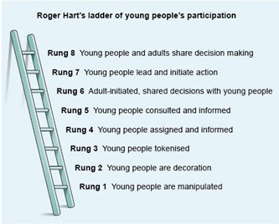

**Welcoming Children & Young People:**

**Decision-making and inclusion**

Where do we want to be?

**Question B**

What is our vision for including children and young people (CYP) in our church decision-making processes?

Using Roger Hart’s ladder of CYP participation, decide which rung of the ladder your parish is on now and where you would like to get to over the next year, and over the next two years. What needs to change for this to happen?

**Areas to consider**

•

Does anything need to change if we want to include CYP on our PCC?

10

Walking

Welcoming

Growing

**Welcoming Children & Young People:**

**Decision-making and inclusion**

What do we need to do?

**Section 3: What do we need to do?**

Many age-appropriate creative ideas of how to listen to children and young people (CYP) on a variety of issues, such as how to involve them in appointing a new vicar or social worker, can be found at [https://www.learn-to-listen.org.uk](https://www.learn-to-listen.org.uk/)

However, listening to CYP is only the start. It is also important to feed back what is happening. Where it is not possible (or appropriate) to implement everything CYP suggest, it is important that they understand how any decisions are made.

CYP can be included in decision-making by following these five steps: listen, reflect, respond, review and monitor.

**1.**

**Listen**

What do you want to know about? When will the listening happen?

Who will be involved?

Who will facilitate?

What method will you use?

**2.**

**Reflect**

What have you learned from listening?

What are the main points the CYP want to be taken forward?

Who needs to hear what has been said (for example, PCC, youth leaders, worship group)?

**3.**

**Respond**

What needs to happen/change?

Who will take the lead on this?

Who will feed back the response to the CYP?

**4.**

**Review**

Who/which group is taking the actions/decisions forward?

What needs to happen next?

Has a date been agreed to review what’s happened?

**5.**

**Monitor**

What has changed as a result of implementing the agreed action(s)? Who will feed this back to the CYP?

What (if anything) needs to happen next?

Walking

Welcoming

Growing

11

**Welcoming Children & Young People:**

**Decision-making and inclusion**

What do we need to do?

**Question B**

What safeguarding measures do we have or need to put in place in order to be able to include CYP in our

decision-making processes?

12

Walking

Welcoming

Growing

**Areas to consider**

**Yes**

**No**

**Not sure**

**Action required**

We regularly review our safeguarding practice and policy with the PCC.

We implement and include updates to *A Safe Church* (see [southwark.](https://southwark.anglican.org/safeguarding/diocesan-policies-and-procedures) [anglican.org/safeguarding/diocesan-policies-and-procedures](https://southwark.anglican.org/safeguarding/diocesan-policies-and-procedures))

We have a Parish Safeguarding Officer.

Our safeguarding policy is displayed in the church and on our website.

All CYP volunteers and paid workers have enhanced DBS certificates and have gone through a safe recruitment process following the guidelines in *A Safe Church*.

All adults in contact with CYP have completed C1 Foundation safeguarding training.

CYP leaders have completed the C2 Leadership module.

Our volunteers have First Aid training, and those working with under-11s have paediatric First Aid.

The buildings and rooms are safe, accessible to all and appropriate for use.

Risk assessments are updated regularly.

We update CYP contact details and parental consent forms annually and store them securely.

We have considered online safety.

Other...

**Welcoming Children & Young People:**

**Decision-making and inclusion**

Next steps

**Section 4: Next steps**

**Question A**

Based on our responses from previous sections, on which three areas is God calling us to focus, in order to start, improve or develop further our ministry with children, young people and their families?

**Question B**

What training do we need?

Walking

Welcoming

Growing

13

**Actions**

**Timescale**

**ACTION:**

**Aim and description**

**Person responsible for progressing action**

**Timescale**

**Resources required**

**Person who can give support**

**Welcoming Children & Young People:**

**Decision-making and inclusion**

How we can help

**Appendix 1: How we can help**

1. **Fortnightly e-newsletter and social media**

Sign up for our e-newsletter signposting training, events and resources at: [bit.ly/3mL80TU](http://bit.ly/3mL80TU)

1. **Training**

•

•

Safeguarding: find details of courses and how to register at: [southwark.anglican.org/safeguarding/](https://southwark.anglican.org/safeguarding/) The Diocese of London offers a free online Academy course in both children’s ministry and youth ministry, available course to those working with CYP in Southwark. Find more information and details of how to sign up here: <https://learning.london.anglican.org/>

Bespoke training for your church or deanery. E-mail Aike Kennett-Brown ([aike.kennett-brown@](mailto:aike.kennett-brown@southwark.anglican.org) [southwark.anglican.org](mailto:aike.kennett-brown@southwark.anglican.org)) or Keli Bolton ([keli.bolton@southwark.anglican.org](mailto:keli.bolton@southwark.anglican.org)) for information. Webinars: topics and sign-up details are available on the website at [southwark.anglican.org/news-](https://southwark.anglican.org/news-events/events/whats-on/) [events/events/whats-on/](https://southwark.anglican.org/news-events/events/whats-on/) and in the e-newsletter.

•

•

**3. Small grants of up to £300**

The Mission Team offers small grants for CYP projects. Parishes can apply once per calendar year. E-mail Kim Jeffal on [CYPAdmin@southwark.anglican.org](mailto:CYPAdmin@southwark.anglican.org) for eligibility criteria and an application form. We fund:

•

•

•

local training fund

individual training grants

mission grants for new CYP projects.

1. **Resource Exchange**

The CYP team offers a free lending library of equipment for parishes and Church of England schools, including Godly Play sets and two large floor labyrinths. Download the catalogue at: [bit.ly/](http://bit.ly/ResourceExchange1) [ResourceExchange1](http://bit.ly/ResourceExchange1); further information on how to become a member can be found at [southwark.](https://southwark.anglican.org/mission-ministry/mission/children-youth/resource-exchange/)

[anglican.org/mission-ministry/mission/children-youth/resource-exchange/](https://southwark.anglican.org/mission-ministry/mission/children-youth/resource-exchange/) or e-mail the CYP Team at [CYPAdmin@southwark.anglican.org](mailto:CYPAdmin@southwark.anglican.org)

1. **Ministry and Training library at Trinity House**

If you would like apply for a library card and access the library, please contact [CYPAdmin@southwark.](mailto:CYPAdmin@southwark.anglican.org) [anglican.org](mailto:CYPAdmin@southwark.anglican.org).

1. **Support for paid and volunteer workers**

Get connected through our joint Southwark/London Zooms and webinars; WhatsApp group; and Facebook or Twitter feeds. Contact [keli.bolton@southwark.anglican.org](mailto:keli.bolton@southwark.anglican.org) for more information.

1. **Support for Messy Church**

Contact [aike.kennett-brown@southwark.anglican.org](mailto:aike.kennett-brown@southwark.anglican.org) or [david.cundill@southwark.anglican.org](mailto:david.cundill@southwark.anglican.org)

1. **Episcopal Area Celebration Events for those who work with children and young people**

We host events in each Episcopal area once every 18 months to two years. Details will be advertised via the e-newsletter, Facebook and Twitter.

Want to find out more? E-mail **Aike Kennett-Brown** ([aike.kennett-brown@southwark.anglican.org](mailto:aike.kennett-brown@southwark.anglican.org)) or

**Keli Bolton** ([keli.bolton@southwark.anglican.org](mailto:keli.bolton@southwark.anglican.org))

14

Walking

Welcoming

Growing

**Welcoming Children & Young People:**

**Decision-making and inclusion**

Your details

**Appendix 2: Your details**

If you would like support in the form of an Accompanier to help you with this process, please complete and return this form to the CYP Team at [CYPAdmin@southwark.anglican.org.uk](mailto:CYPAdmin@southwark.anglican.org.uk)

**Name of parish/benefice:**

**Church number:**

**Deanery:**

**Address:**

**Postcode:**

**Contact name:**

**Telephone number:**

**E-mail:**

**Number of people involved in the process:**

**Age range of the group (from x to y years):**

*(please try to include at least one young person in your group)*

**Accompanier:**

**Accompanier’s telephone number:**

**Signature of Incumbent/Priest-in-Charge/PCC Secretary:**

**Date:**

Walking

Welcoming

Growing

15

**Welcoming Children & Young People:**

**Decision-making and inclusion**

Your details

**Appendix 2: Your details**

Please help us support your ministry with children and young people by providing the contact details of

your **CYP Parish Rep** and key **Children/Youth/Family Leaders**.

**1. CYP Parish Rep(s)**

**Name: E-mail: Telephone:**

**2. Children/Youth/Family Leader(s)**

**Name: E-mail: Role title: Please circle whether this person is: Voluntary or Employed**

**3. Children/Youth/Family Leader(s)**

**Name: E-mail: Role title: Please circle whether this person is: Voluntary or Employed**

**4. Children/Youth/Family Leader(s)**

**Name: E-mail: Role title: Please circle whether this person is: Voluntary or Employed**

**5. Children/Youth/Family Leader(s)**

**Name: E-mail: Role title: Please circle whether this person is: Voluntary or Employed**

16

Walking

Welcoming

Growing

**Welcoming Children & Young People:**

**Decision-making and inclusion**

**Appendix 3:**

**Parish Representatives for Children & Young People’s Mission & Ministry (CYPM&M)**

The purpose of the Children and Young People’s (CYP) Parish Rep is to ensure there is effective communication between parishes and Southwark Diocese; to understand the Diocesan vision of “Walking, Welcoming, Growing”; and to champion the voice of CYP at parish level.

Each parish can appoint its own CYP parish rep and organise this role to fit the context. For example, the role can be shared, particularly in larger parishes or where there is more than one church, and could be a young person, volunteer, paid-worker or clergy. This is a time-limited role, to be reviewed by the parish (for example, every two years).

**Role description**

1.

To understand the Diocesan vision and strategy for CYP, and connect with the Mission Support Officers (Children and Young People) via e-newsletter, e-mail and social media platforms.

To provide a point of contact within the parish for all involved in CYPM&M and be proactive at involving others.

To champion CYP voices within the parish.

To assist Churchwardens with accurate information regarding numbers of under-16s in the annual October count.

To undertake a parish audit (at least biannually) of CYP activities to help determine priorities on the Mission Action Plan (MAP), for example training, resourcing, events. The *Welcoming Children and Young People* toolkit series can be used as a framework for this process.

To disseminate information (mostly by e-mail) coming through the deanery, Episcopal Area and Diocesan networks to the right people in the church.

To represent the parish CYPM&M and liaise with the Deanery Champion and Deanery Leadership team on joint CYPM&M projects.

To actively participate in other gatherings of people in similar roles (for example, deanery gatherings for parish representatives or wider Episcopal Area events).

2.

3.

4.

5.

6.

7.

8.

**Person specification**

1. Committed Christian with experience of mission and ministry with CYP.
2. Active involvement with children and young people’s mission and ministry within the parish.
3. Able to engage with CYP and be proactive in advocating for them to be included and involved in the whole life of the church.

Walking

Welcoming

Growing

17

**Welcoming Children & Young People:**

**Decision-making and inclusion**

Your notes

**Appendix 4: Your notes**

**Continued from Section**

**Continued from Question**

18

Walking

Welcoming

Growing

**Notes**



**Welcoming Children & Young People:**

**Decision-making and inclusion**

Further resources

**Young people from Holy Trinity, Clapham discuss ideas**

**Further resources**

•

Roger Hart (1992), *Children’s Participation: from Tokenism to Citizenship*. Florence: Unicef Innocenti Research Centre

Listening to young people in a church context: [https://www.learn-to-listen.org.uk](https://www.learn-to-listen.org.uk/) Examples of youth participation:

•

•

◊

Woolwich Episcopal Area Youth Forum video featured at Diocesan Synod in November 2020,

What helps grow my faith? (watch at: [www.youtube.com/watch?v=W3-q7QcPKVM](https://www.youtube.com/watch?v=W3-q7QcPKVM))

Video from Woolwich and Croydon Episcopal Area Youth Forums featured at Diocesan Synod in March 2021, Anti-Racism Charter (watch at: [www.youtube.com/watch?v=GJo4Wt_IoL4](https://www.youtube.com/watch?v=GJo4Wt_IoL4))

◊

*•*

*We are… Burning Down the House*, 2020 Tearfund & Youthscape research with young Christians from the UK about their thoughts on the climate, the Church and their faith. Download the research and watch the video here: [wearetearfund.org/burningdownthehouse/](https://wearetearfund.org/burningdownthehouse/)

Walking

Welcoming

Growing

19

