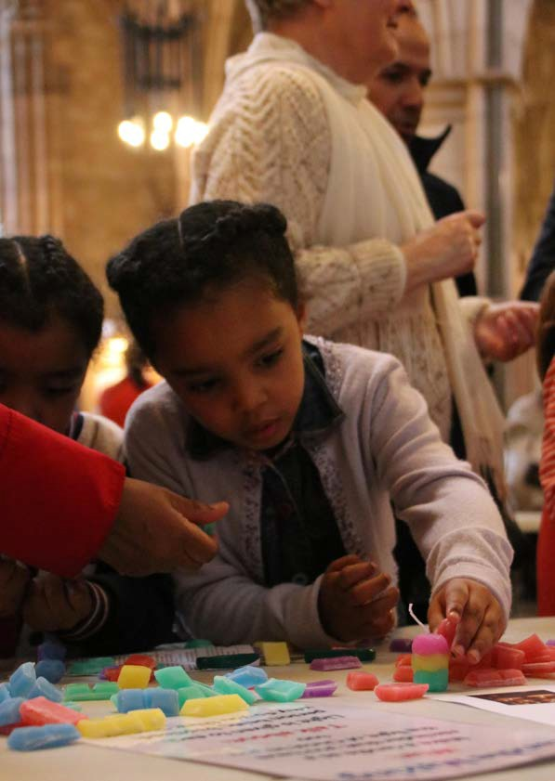

**Welcoming Children and Young People** First Steps

***Walking Welcoming Growing***

**Welcoming Children & Young People: First Steps**

**Contents**

Preface by The Bishop of Southwark

3

Introduction

4

The Reflective Cycle

5

Section 1: Where are we now?

6

Section 2: Vision and values

8

Section 3: Equipping and supporting

10

Section 4: Next steps

15

Appendix 1: How we can help

16

Appendix 2: Your details

17

Appendix 3: Your notes

19

Further reading

23

2

Walking

Welcoming

Growing

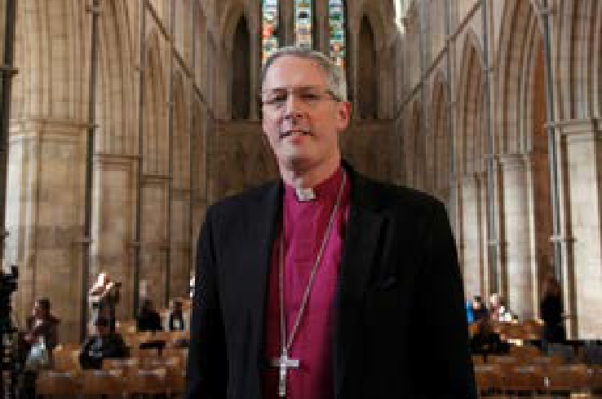

**Welcoming Children & Young People: First Steps**

**Bishop Christopher writes…**

*Dear Brothers and Sisters in Christ,*

Our vision in this Diocese is for our children and young people (CYP) to grow in faith, hope and love, with hearts on fire for Jesus, contributing joyfully, happily and confidently to the life of the Church and its mission at every level.

The whole Church has a role to play in walking alongside CYP and supporting households to grow in faith together. Our schools are an essential part of this outreach as we seek to welcome and listen well to the

voice of all children and young people in all their glorious and rich God-given diversity.

During 2020-21, the COVID-19 pandemic has impacted dramatically on the ways in which we gather as a church community as well as our mission and ministry with children and young people. It has presented a number of exciting new opportunities and possibilities. We are now able to reimagine the way in which we welcome children and young people, walk alongside them and encourage them to grow in their faith.

The Welcoming Children and Young People toolkit series, which I commend to you, provides a framework to enable churches to begin, re-start or reimagine their welcome and inclusion of children and young people.

Whether you are just starting out or have an established ministry with children, young people and their families, I hope you find working through this toolkit a constructive way to reflect on all that you do.

May it inspire your vision and celebrate what is going well, whilst challenging what may need to be changed or added so that children and young people can take a full place in the life of the Church.

The Lord blesses us through the children and young people He entrusts to our care. We are all God’s children and beloved in His sight. May we make the most of this new resource and the opportunities we have to be joyful and active as fellow members of the family and household of God.

**Bishop Christopher**

*The Diocese of Southwark*

Walking

Welcoming

Growing

3

**Welcoming Children & Young People: First Steps**

**Introduction**

This Welcoming Children and Young People: First Steps toolkit has been developed to enable parishes to take a fresh look at the welcome and community on offer to children.

It is aimed at churches who are just at the start of this journey, who may have few or no children or young people in their fellowship either prior to the pandemic or as a result of it. It can also be used by churches with established ministries who may seek a fresh vision or new project.

The pack will take you through four stages of reflection which will form the foundation for your work alongside children and young people. On completion, you will have formulated a vision document and action plan. When your team is ready, you can go around the reflective cycle again and look at other areas within the Welcoming Children and Young People toolkit series: Spirituality and Relationship with God; Mission and Outreach; and Decision-making and Inclusion (downloadable from the website [add link]).

We encourage you to gather a group (in person or online) to look through this evaluation and pray together, ideally including your CYP Parish Rep, Incumbent or Churchwarden. Even if your church has only a few children and young people, it would be ideal to include them and their parents in your discussion, to enable you to see things through their eyes. This will provide greater relevance and integrity to any developments and changes that may come out of this process.

We recommend that you:

•

•

•

read through the *First Steps* booklet

work out your process for gathering information and ideas, and decide on your team

fill out this booklet together and keep a record, to enable your team to share your vision and goals with your PCC and wider church community

complete the contact details in Appendix 2 in order to access the support available to your team outlined in Appendix 1

e-mail the completed form to [CYPAdmin@southwark.anglican.org](mailto:CYPAdmin@southwark.anglican.org) or post it to Kim Jeffal, Mission Team Administrator, Trinity House, 4 Chapel Court, Borough High Street, London SE1 1HW.

•

•

If you require additional support and would like an Accompanier to walk alongside you as you complete the process, please complete and return the request form in Appendix 2 or get in touch with Mission Support Officers Aike Kennett-Brown or Keli Bolton.

We hope that you will progress onto the other areas of the Welcoming Children and Young People toolkit series: Spirituality and Relationship with God; Mission and Outreach; and Decision-making and Inclusion.

**Aike Kennett-Brown**

[aike.kennett-brown@southwark.anglican.org](mailto:aike.kennett-brown@southwark.anglican.org)

**Keli Bolton**

[keli.bolton@southwark.anglican.org](mailto:keli.bolton@southwark.anglican.org)

4

Walking

Welcoming

Growing

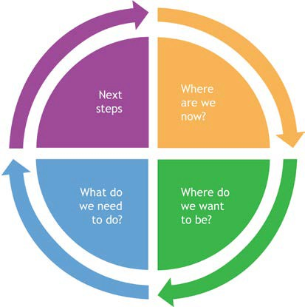

**Welcoming Children & Young People: First Steps**

**The Reflective Cycle**

The Reflective Cycle is a learning tool that will help you to reflect systematically on your circumstances.

Each section of the *First Steps* toolkit is colour-coded according to which stage of the Reflective Cycle it relates. Once you have completed all the sections, you will have decided your vision and values, and have an action plan. When you are ready, we hope that you will revisit the reflective cycle and consider another area of the *Welcoming Children and Young People* toolkit series.

Walking

Welcoming

Growing

5

**Welcoming Children & Young People: First Steps** Where are we now?

**Section 1: Where are we now?**

**Question A**

Where are we now (before we begin the process) regarding our welcome and connection with children, young people (CYP) and their households within our church and local community? What and who do we already have in place?

6

Walking

Welcoming

Growing

**Areas to consider**

**Yes**

**No**

**Not sure**

There is a parish safeguarding policy in place to which we adhere.

The church has a vision and specific objectives for its work alongside CYP and their households.

We regularly pray for the CYP and households of our church and local community.

The buildings and rooms are safe, accessible and appropriate for use.

Suitable facilities and materials are in place for CYP of all ages and abilities.

There are opportunities for CYP to meet either gathered or online in order to develop their relationship with God.

CYP are welcomed at church services and have a valued role.

CYP are listened to and responded to appropriately.

There is provision for CYP to learn about Christian faith, the Bible, prayer and worship. Appropriate resources & leadership are in place.

CYP are recognised as members of the church and encouraged to contribute to, and participate in, the life of the church.

We encourage CYP to develop leadership skills and give them opportunities to lead.

CYP leaders and volunteers are enabled, equipped, supported and accountable within the whole church.

CYP are encouraged to be active in God’s mission in the community and the world.

Parents, carers, grandparents, godparents are encouraged and enabled to share their faith with children and young people in the home.

The church has good links and prays for the schools within the parish.

**Welcoming Children & Young People: First Steps** Where are we now?

**Question B**

What do children and young people (CYP) say about how they are welcomed and where they belong in church? If you have no CYP in your fellowship, ask those in your community what they think about your church.

**Suggested questions to ask children and young people**

•

•

•

•

•

•

•

•

•

Do people outside your family know your name and talk to you at church? Does someone say hello to you when you arrive at church?

What helps you feel welcome in church?

What do you like best/least about church (in person or online)? Do you have a role/job to do at church?

How does your church support you?

What could be better at your church?

Are there people who look like you (role models) in leadership roles?

Do you have the opportunity to be involved in leadership (i.e. preaching, serving, leading prayers, sung worship, leading the service, leading children’s groups, decision making on the PCC etc)?

Walking

Welcoming

Growing

7

**Welcoming Children & Young People: First Steps** Vision and values

**Section 2: Vision and values**

**Question A**

What is our vision for welcoming children, young people (CYP) and their households?

**Areas to consider**

•

Why do we want mission and ministry with CYP in our parish?

•

What are we seeking to achieve with the work?

•

Is there a particular target group or need in our community?

•

Have we considered our links with local schools (the places CYP inhabit Monday-Friday)?

•

How might we reach CYP who are unable to attend in person?

•

How can we make use of digital media?

8

Walking

Welcoming

Growing

**Welcoming Children & Young People: First Steps**

Vision and values

**Question B**

What values are the foundation for our work alongside children, young people and their households?

**Areas to consider**

•

How will children and young people (CYP) know they are welcome? For example, do we greet them by name?

•

How do we imagine CYP will participate in church life and worship services?

•

How will we nurture and encourage the gifts and talents of CYP?

•

What leadership opportunities will we give CYP?

•

What opportunities are there to celebrate and listen to CYP?

•

What does it look like to include children and young people in the sacraments? Have we considered our policy on Communion, Baptism and Confirmation and if it provides for all ages?

•

How do we demonstrate and adhere to our parish safeguarding policy?

•

Other values might include: praying regularly for CYP; including CYP of all abilities and backgrounds; Christ-centred; fun etc.

Walking

Welcoming

Growing

9

**Welcoming Children & Young People: First Steps** Vision and values

**Question C**

How is our vision for children, young people and families shared with and owned by the whole church?

**Areas to consider**

•

How is this vision reflected in our church vision statement, church profile or Mission Action Plan?

•

Are church members aware of their part in giving support to the vision?

•

Is mission and ministry with CYP on our PCC agenda at least once a year to ensure shared

understanding?

•

Does the allocated funding reflect what is needed to meet the vision?

•

How will we review our work and know if we are fulfilling our vision?

10

Walking

Welcoming

Growing

**We share vision in the following ways...**

**We could improve or begin this by...**

**Welcoming Children & Young People: First Steps** Equipping and supporting

**Section 3: Equipping and supporting**

**Question A**

How will we recruit volunteers?

**Areas to consider**

•

What character qualities are we looking for in volunteers for the CYP team?

•

Who are the appropriate people in our fellowship that relate well to CYP? What gifts do they bring?

•

Are they available and have we invited them personally to join the team?

•

Do we have leaders who reflect the ethnicity of our CYP?

•

Have we prepared role descriptions, with a clear time frame, for CYP helpers and leaders?

Walking

Welcoming

Growing

11

**Our current practice...**

**We could improve or begin this by...**

**Welcoming Children & Young People: First Steps** Equipping and supporting

**Question B**

What safeguarding measures do we have or need to put in place?

12

Walking

Welcoming

Growing

**Areas to consider**

**Yes**

**No**

**Not sure**

**Action required**

We regularly review our safeguarding practice and policy with the PCC.

We implement and include updates to *A Safe Church* (see [southwark.](https://southwark.anglican.org/safeguarding/diocesan-policies-and-procedures) [anglican.org/safeguarding/diocesan-policies-and-procedures](https://southwark.anglican.org/safeguarding/diocesan-policies-and-procedures))

We have a Parish Safeguarding Officer.

Our safeguarding policy is displayed in the church and on our website.

All CYP volunteers and paid workers have enhanced DBS certificates and have gone through a safe recruitment process following the guidelines in *A Safe Church*.

All adults in contact with CYP have completed C1 Foundation safeguarding training.

CYP leaders have completed the C2 Leadership module.

Our volunteers have First Aid training, and those working with under-11s have paedatric First Aid.

The buildings and rooms are safe, accessible to all and appropriate for use.

Risk assessments are updated regularly.

We update CYP contact details and parental consent forms annually and store them securely.

We have considered online safety.

Other...

**Welcoming Children & Young People: First Steps** Equipping and supporting

**Question C**

Do we have suitable facilities and materials in place for children of all ages and abilities?

Walking

Welcoming

Growing

13

**Questions to consider**

**Yes**

**No**

**Not sure**

**Action required**

Is there an area for parents/carers to feel comfortable with babies and very young children?

Is there clear signage for facilities and are users asked for feedback?

Are toilets and baby change facilities clean and accessible for all ages?

Do you need to replace/update/clean any furniture, carpet or curtains with CYP in mind?

Is the lighting conducive to activities?

Is there access to easily cleanable quality toys, books and activities for young children during a worship service, for example in pew bags/boxes?

Is there equipment and storage for creative and reflective activity for a range of ages and abilities?

If there are groups for CYP, is the amount of space and environment

appropriate for the age group?

Is the space safe with a risk assessment completed?

Is the room a comfortable temperature in all seasons?

With regard to noise levels, are CYP distracted or distracting to others?

Are there suitable refreshments for CYP?

Have we asked CYP what they think?

What can we learn from schools and nurseries with regard to the physical space that appeals to CYP?

Do we use resources that have images displaying a range of ethnicities?

**Our current practice...**

**We could improve or begin this by...**

**Welcoming Children & Young People: First Steps** Equipping and supporting

**Question D**

How will we encourage, recognise, support and equip volunteers to work alongside children, young people and their households?

**Areas to consider**

•

How are CYP helpers and leaders (paid or volunteer) encouraged and given space to explore their own spirituality and relationship with God?

What resources and training do we provide for CYP helpers and leaders. For example, has everyone completed a CYP Basics course or equivalent (see How we can help, Appendix 1, page 16)?

How do our leaders access pastoral support and supervision?

Is our church budget sufficient for resources, training and supervision?

Are there ‘praying friends’ available to support those who work alongside CYP both within and

outside the church?

How will we communicate to the wider church what is happening in CYP work?

How will we affirm people who have roles supporting CYP both within the church (Junior Church leaders, choir leader etc) and outside the church (school governors, parents, teachers, social workers etc)? For example, does our church hold an annual service of affirmation for all areas of CYP mission and ministry?

•

•

•

•

•

•

14

Walking

Welcoming

Growing

**Our current practice...**

**We could improve or begin this by...**

**Welcoming Children & Young People: First Steps**

Next steps

**Section 4: Next steps**

**Question A**

Based on our responses from previous sections, on which three areas is God calling us to focus, in order to start, improve or develop further our ministry with children, young people and their families?

**Question B**

What training do we need?

Walking

Welcoming

Growing

15

**Actions**

**Timescale**

**ACTION:**

**Aim and description**

**Person responsible for progressing action**

**Timescale**

**Resources required**

**Person who can give support**

**Welcoming Children & Young People: First Steps** How we can help

**Appendix 1: How we can help**

1. **Fortnightly e-newsletter and social media**

Sign up for our e-newsletter signposting training, events and resources at: [bit.ly/3mL80TU](http://bit.ly/3mL80TU)

1. **Training**

•

•

Safeguarding: find details of courses and how to register at: [southwark.anglican.org/safeguarding/](https://southwark.anglican.org/safeguarding/) The Diocese of London offers a free online Academy course in both children’s ministry and youth ministry, available course to those working with CYP in Southwark. Find more information and details of how to sign up here: <https://learning.london.anglican.org/>

Bespoke training for your church or deanery. E-mail Aike Kennett-Brown ([aike.kennett-brown@](mailto:aike.kennett-brown@southwark.anglican.org) [southwark.anglican.org](mailto:aike.kennett-brown@southwark.anglican.org)) or Keli Bolton ([keli.bolton@southwark.anglican.org](mailto:keli.bolton@southwark.anglican.org)) for information. Webinars: topics and sign-up details are available on the website at [southwark.anglican.org/news-](https://southwark.anglican.org/news-events/events/whats-on/) [events/events/whats-on/](https://southwark.anglican.org/news-events/events/whats-on/) and in the e-newsletter.

•

•

**3. Small grants of up to £300**

The Mission Team offers small grants for CYP projects. Parishes can apply once per calendar year. E-mail Kim Jeffal on [CYPAdmin@southwark.anglican.org](mailto:CYPAdmin@southwark.anglican.org) for eligibility criteria and an application form. We fund:

•

•

•

local training fund individual training grants

mission grants for new CYP projects.

1. **Resource Exchange**

The CYP team offers a free lending library of equipment for parishes and Church of England schools, including Godly Play sets and two large floor labyrinths. Download the catalogue at: [bit.ly/](http://bit.ly/ResourceExchange1) [ResourceExchange1](http://bit.ly/ResourceExchange1); further information on how to become a member can be found at [southwark.](https://southwark.anglican.org/mission-ministry/mission/children-youth/resource-exchange/)

[anglican.org/mission-ministry/mission/children-youth/resource-exchange/](https://southwark.anglican.org/mission-ministry/mission/children-youth/resource-exchange/) or e-mail the CYP Team at [CYPAdmin@southwark.anglican.org](mailto:CYPAdmin@southwark.anglican.org)

1. **Ministry and Training library at Trinity House**

If you would like apply for a library card and access the library, please contact [CYPAdmin@southwark.](mailto:CYPAdmin@southwark.anglican.org) [anglican.org](mailto:CYPAdmin@southwark.anglican.org).

1. **Support for paid and volunteer workers**

Get connected through our joint Southwark/London Zooms and webinars; WhatsApp group; and Facebook or Twitter feeds. Contact [keli.bolton@southwark.anglican.org](mailto:keli.bolton@southwark.anglican.org) for more information.

1. **Support for Messy Church**

Contact [aike.kennett-brown@southwark.anglican.org](mailto:aike.kennett-brown@southwark.anglican.org) or [david.cundill@southwark.anglican.org](mailto:david.cundill@southwark.anglican.org)

1. **Episcopal Area Celebration Events for those who work with children and young people**

We host events in each Episcopal area once every 18 months to two years. Details will be advertised via the e-newsletter, Facebook and Twitter.

Want to find out more? E-mail **Aike Kennett-Brown** ([aike.kennett-brown@southwark.anglican.org](mailto:aike.kennett-brown@southwark.anglican.org)) or

**Keli Bolton** ([keli.bolton@southwark.anglican.org](mailto:keli.bolton@southwark.anglican.org))

16

Walking

Welcoming

Growing

**Welcoming Children & Young People: First Steps**

Your details

**Appendix 2: Your details**

If you would like support in the form of an Accompanier to help you with this process, please complete and return this form to the CYP Team at [CYPAdmin@southwark.anglican.org.uk](mailto:CYPAdmin@southwark.anglican.org.uk)

**Name of parish/benefice:**

**Church number:**

**Deanery:**

**Address:**

**Postcode:**

**Contact name:**

**Telephone number:**

**E-mail:**

**Number of people involved in the process:**

**Age range of the group (from x to y years):**

*(please try to include at least one young person in your group)*

**Accompanier:**

**Accompanier’s telephone number:**

**Signature of Incumbent/Priest-in-Charge/PCC Secretary:**

**Date:**

Walking

Welcoming

Growing

17

**Welcoming Children & Young People: First Steps** Your details

**Appendix 2: Your details**

Please help us support your ministry with children and young people by providing the contact details of

your **CYP Parish Rep** and key **Children/Youth/Family Leaders**.

**1. CYP Parish Rep(s)**

**Name:**

**E-mail:**

**Telephone:**

**2. Children/Youth/Family Leader(s)**

**Name:**

**E-mail:**

**Role title:**

**Please circle whether this person is: Voluntary or Employed**

**3. Children/Youth/Family Leader(s)**

**Name:**

**E-mail:**

**Role title:**

**Please circle whether this person is: Voluntary or Employed**

**4. Children/Youth/Family Leader(s)**

**Name:**

**E-mail:**

**Role title:**

**Please circle whether this person is: Voluntary or Employed**

**5. Children/Youth/Family Leader(s)**

**Name:**

**E-mail:**

**Role title:**

**Please circle whether this person is: Voluntary or Employed**

18

Walking

Welcoming

Growing

**Welcoming Children & Young People: First Steps**

Your notes

**Appendix 3: Your notes**

**Continued from Section**

**Continued from Question**

Walking

Welcoming

Growing

19

**Notes**

**Welcoming Children & Young People: First Steps** Your notes

**Appendix 3: Your notes**

**Continued from Section**

**Continued from Question**

20

Walking

Welcoming

Growing

**Notes**

**Welcoming Children & Young People: First Steps**

Your notes

**Appendix 3: Your notes**

**Continued from Section**

**Continued from Question**

Walking

Welcoming

Growing

21

**Notes**

**Welcoming Children & Young People: First Steps** Your notes

**Appendix 3: Your notes**

**Continued from Section**

**Continued from Question**

22

Walking

Welcoming

Growing

**Notes**

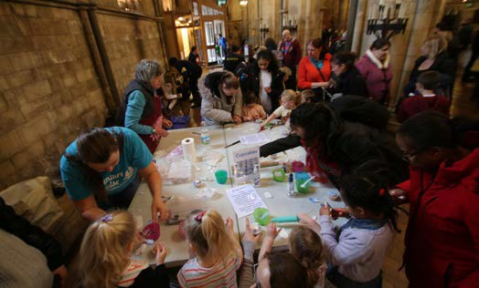

**Welcoming Children & Young People: First Steps**

Further reading

**Southwark**

**Splash in 2019.**

**Further reading**

*•*

*Beyond the Children’s Corner: Creating a culture of welcome for all ages*, Margaret Pritchard Houston (Church House Publishing, 2020).

*The Essential Guide to Family Ministry*, Gail Adcock (BRF, 2020).

*Re-thinking Children’s Work in Churches*, Carolyn Edwards, Sian Hancock and Sally Nash (Jessica Kingsley Publishers, 2019).

*Youth Work from Scratch: How to launch or revitalise a church youth ministry*, Martin Saunders (Monarch Books, 2013).

*•*

*•*

*•*

Walking

Welcoming

Growing

23



Hea ts

**t, on** F1re

*�*

n, Diocese of

Southwark