Stations of
the Cross

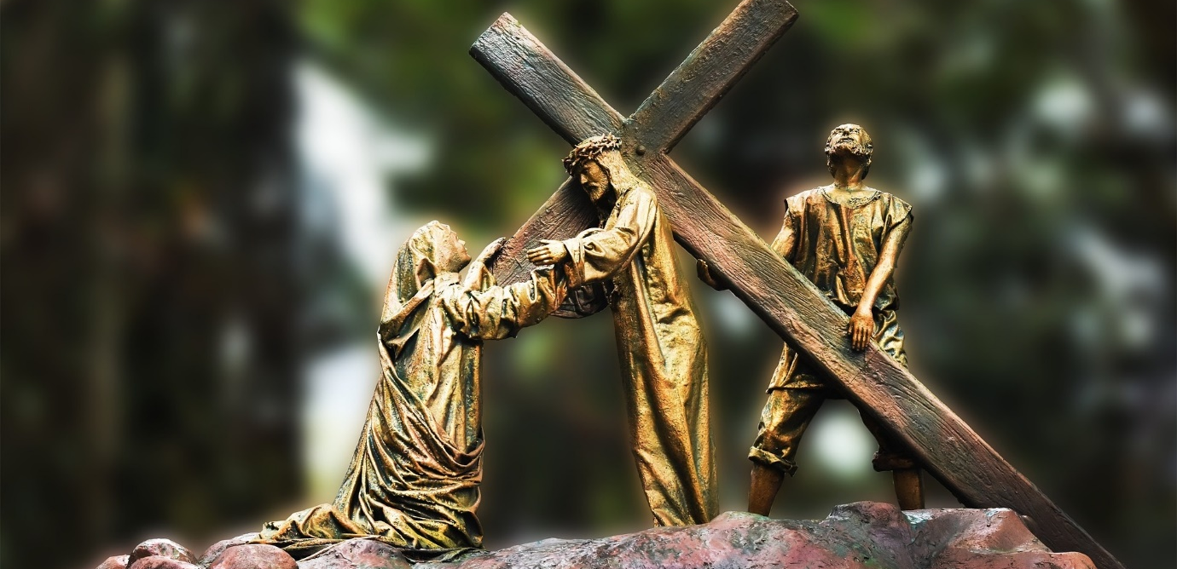

This range of resources is compiled by the Bishop’s Advisory Group for Liturgy. Here you will find a range of ways for individuals or congregations to pray through the Stations of the Cross online, as part of a journey through Lent.

Stations and accompanying liturgy using images from St John the Divine Church, Richmond
PowerPoint format
https://1drv.ms/p/s!AgHqLkAppV3Mg7Jmxim1gNSxQoOA8Q?e=CHhIlv

Stations and accompanying liturgy using images by the 20th century Scottish artist Loris Rey
PowerPoint format
https://1drv.ms/p/s!AgHqLkAppV3Mg7Ju-4UzPHKXrv25uw?e=5a3LQf

Stations and accompanying liturgy by Bp Christopher Chessun, using photographs of Jerusalem and recreating the experience of walking the Via Dolorosa
Prezi format
https://prezi.com/view/u9ahVD7USMFCCqW5by7N/

Photographs of the Stations from the sculpture garden of the Wintershall Estate, Surrey
PDF format
https://1drv.ms/b/s!AgHqLkAppV3Mg7Jxo94dT_s608-Rpw?e=f3wAUI

Photographs of the Wintershall Passion Play, relating to the Stations, accompanied by reflections as if by characters in the Good Friday story
PDF format
https://1drv.ms/b/s!AgHqLkAppV3Mg7JvjiTghJUVOHDwEA?e=3RvWn8

Stations for older children adapted by Catherine Odell from the Kids Book of Everyday Prayers (Loyola Press)
PDF format
https://1drv.ms/b/s!AgHqLkAppV3Mg7JwOO5637hrZJb-AA?e=ae2dvL

Stations accompanied by reflections on and prayers for the climate crisis, written by the Revd David Stephenson, with images of the Earth
PowerPoint format
https://1drv.ms/p/s!AgHqLkAppV3Mg7Jkk2YsldGfFcKN5Q?e=blktQz

Stations using images by Köder Sieger accompanied by organ music and reflective readings by Cicelyn Hinds, from St Mark’s Church South Norwood, in two parts
YouTube video format (about 90 minutes in total)
Part 1: https://youtu.be/oBILR1LpqPg
Part 2: https://youtu.be/O5Wctls-LPw

Stations using paintings by Gerry Scott from York Minister accompanied by organ music, reflective readings and prayers
YouTube video format (about 60 minutes)
https://www.youtube.com/playlist?list=PLpuXEsgzQReNQF-0fuamXVjBtlTyRwriM –

Photograph by Boshakti / Pixabay

