## Personal prayer in a newly re-opened church building

*Prayer resources* *commended by the   
Bishop of Southwark   
during the COVID-19 Pandemic,   
Trinity 2020*



One thing have I asked of the Lord and that alone I seek:  
that I may dwell in the house of the Lord all the days of my life  
*Psalm 27.4*

*Some material is taken or adapted from Common Worship, © The Archbishops’ Council of the Church of England. Biblical texts are from the New Revised Standard Version (Anglicised)*

## Introduction

Aim

This form of prayer is intended for use by individuals when they are once again able to go into their Parish Church from which they have had to be absent for several months.

It provides a repeated cycle for use at different points in the building. You can pray at just one point or at several. There is no reason not to repeat the cycle from time to time, as the building comes back to life – under the circumstances, this will happen slowly.

The hope is that people who love this place and who have met with the Risen Lord through his Holy Spirit here, will be able to give thanks and to pray that this place may continue to be holy and blessed.

Structure

A cycle of prayers is provided for use in the following places (of course not all Churches will have all of these):

* On Entering
* Font
* Nave
* Communion Rail and Altar
* Pulpit and Lectern
* Choir Stalls or Band Area
* Children’s Area
* On Leaving

Each set of prayers within the overall cycle follows this pattern:

* Opening sentence
* Short reading from Scripture
* Time for silent reflection or extemporary prayer with a focus for reflection
* Collect (short prayer)
* Conclusion

Use

These materials are intended as a resource, not as a constraint, so please use them as works best. It may be helpful to vary between speaking the words out loud and reading them in silence, and to change posture, standing, sitting or kneeling as seems right.

It may also be good to allow time for silent prayer. There are different forms of silent prayer, but it is worth allowing at least five minutes whatever approach you take. One way is as follows:

* get comfortable
* focus on your breath to bring attention away from your thinking
* when you are ready start repeating the word ‘Mar-ra-na-tha’ to yourself repeatedly as an anchor word (an Aramaic word, which St Paul uses in 1Co 16.22, meaning roughly “Come, Lord”)
* when thoughts and feelings come into your conscious mind, acknowledge them and let them go, coming back to the anchor word

However you choose to use the words and the silence offered in this booklet, what is perhaps most important is your presence in the building as a willing vessel of the Holy Spirit.

Necessary precautions / restrictions

In these difficult times we must of course adhere scrupulously to the rules put in place to prevent the spread of the coronavirus. These rules will vary from time to time, and the way they operate will be specific to each Church building, so please take care to observe local instructions.

Quite often this may mean that you have to pray *for* a part of a Church without being *in* that place. Many, perhaps all, Churches will have to prevent people going to the Altar, Choir Stalls and so on.

Again, it is up to individual Churches to prescribe the conditions for using the building, within the parameters set by the Diocese and the National Church. Nothing in this booklet is to be taken as permitting anything beyond the prescribed conditions.

You may be viewing this booklet in PDF form on your phone, but if you have it in hard copy, please do not leave it behind as it may transmit COVID. Instead, please take it home and continue to pray for the re-opening of our Church buildings in the weeks and months ahead.

## A Returning to Church Prayer

O God from whom all blessings flow,  
I turn to you in gratitude for this place [or name of church];  
for every faithful footstep taken within its walls,  
and every petition prayed,  
for every story shared,   
the ordinary and the extraordinary  
from generation to generation.

Thank you that in the silence of our absence  
You were still here, as well as with your people.  
As we begin to return, grant to us all the wisdom to stay safe, the comfort of your peace  
and joy in coming home.

Now these doors are opened once again  
let your Spirit flow out of me and all who come here,  
bringing life, hope and healing   
to our community.   
Amen.

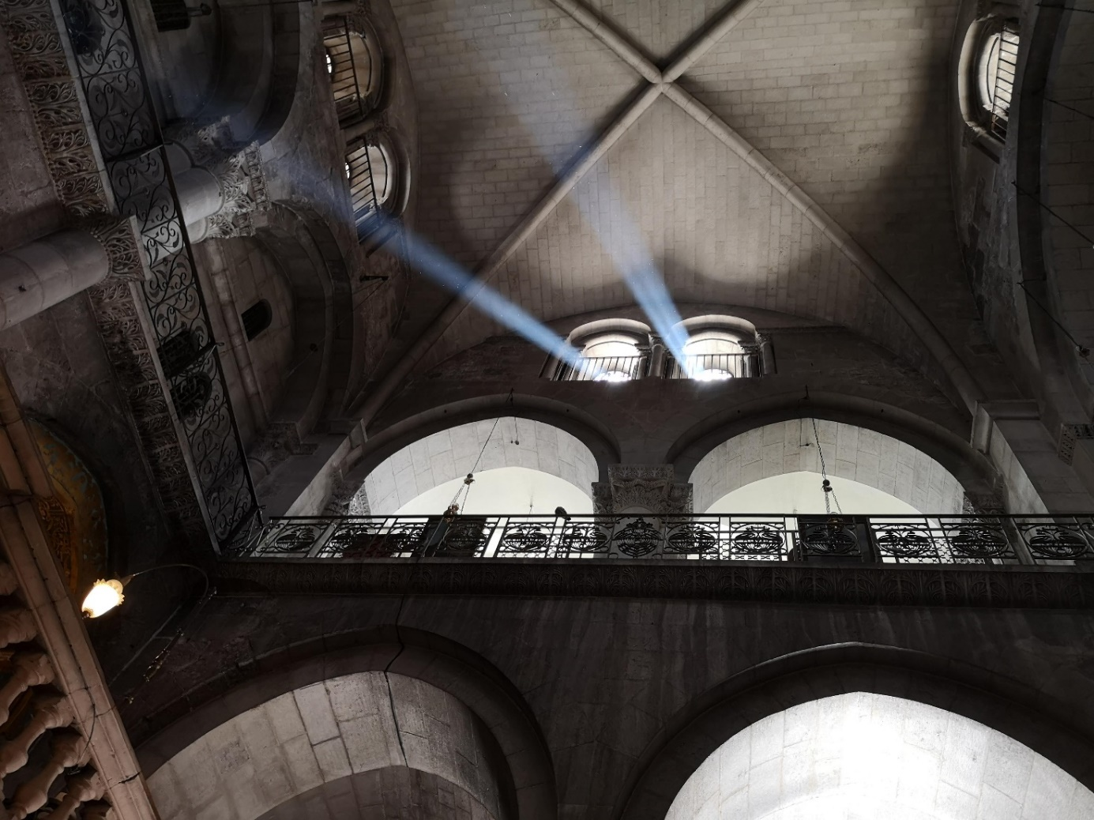  
 Church of the Holy Sepulchre, Jerusalem, Lent 2019

## On Entering

Opening Sentence:

How awesome is this place! This is none other than the house of God, and this is the gate of heaven

Genesis 28.17

Passage from Scripture:

19 Consequently, you are no longer foreigners and strangers, but fellow citizens with God’s people and also members of his household, 20 built on the foundation of the apostles and prophets, with Christ Jesus himself as the chief cornerstone. 21 In him the whole building is joined together and rises to become a holy temple in the Lord. 22 And in him you too are being built together to become a dwelling in which God lives by his Spirit.

Ephesians 2:19-22

At this point there is space to pause for reflection, silence or extemporary prayer, seated or kneeling. You may wish to begin with the question “What does this building mean to me, and to the others who have worshipped here and will do so in future?”

The Collect:

Almighty God,to whose glory this house of prayer is dedicated:we praise you for the many blessingsyou have given to those who worship you here:and we pray that all who seek you in this place may find you,and, being filled with the Holy Spirit,may become a living temple acceptable to you;through Jesus Christ your Son our Lord,who is alive and reigns with you,in the unity of the Holy Spirit,one God, now and for ever. Amen.

Concluding Sentence:

I was glad when they said to me, “Let us go to the house of the Lord!”

Ps 122.1

## Font

Opening Sentence:

Repent and be baptised every one of you in the name of Jesus Christ for the forgiveness of your sins; and you shall receive the gift of the Holy Spirit

Acts 2.38

Passage from Scripture:

13 Then Jesus came from Galilee to John at the Jordan, to be baptized by him. 14 John would have prevented him, saying, “I need to be baptized by you, and do you come to me?” 15 But Jesus answered him, “Let it be so now; for it is proper for us in this way to fulfil all righteousness.” Then he consented. 16 And when Jesus had been baptized, just as he came up from the water, suddenly the heavens were opened to him and he saw the Spirit of God descending like a dove and alighting on him. 17 And a voice from heaven said, “This is my Son, the Beloved, with whom I am well pleased.”

Matthew 3.13-17

At this point there is space to pause for reflection, silence or extemporary prayer, seated or kneeling. You may wish to begin with the question “How does the gift of the Holy Spirit which we received at Baptism equip us to live well in these times?”

The Collect:

Heavenly Father,  
by the power of your Holy Spirit  
you give your faithful people new life in the water of baptism.  
As your people return to this place of worship,  
as we gather again to minister your Baptism:  
guide and strengthen us by the same Spirit,  
that we who are born again may serve you in faith and love,  
and grow into the full stature of your Son, Jesus Christ,  
who is alive and reigns with you in the unity of the Holy Spirit  
now and for ever. Amen.

Concluding Sentence:

Praise God who made heaven and earth, who keeps his promise for ever

cf Psalm 146

## Nave

Opening Sentence:

Now you are the body of Christ and individually members of it

1 Corinthians 12:27

Passage from Scripture:

23 And when he got into the boat, his disciples followed him. 24 A gale arose on the lake, so great that the boat was being swamped by the waves; but he was asleep. 25 And they went and woke him up, saying, “Lord, save us! We are perishing!” 26 And he said to them, “Why are you afraid, you of little faith?” Then he got up and rebuked the winds and the sea; and there was a dead calm. 27 They were amazed, saying, “What sort of man is this, that even the winds and the sea obey him?”

Matthew 8.23-27

At this point there is space to pause for reflection, silence or extemporary prayer, seated or kneeling. You may wish to begin with the question “What unique gift do I bring to the body of Christ, here in this place?”

The Collect:

O God our creator,  
you have called us to be one in your Son, Jesus Christ:  
may we gather once again in this place in peace and safety:  
pour upon us your blessings of unity and fellowship,  
like the dew falling on the mountains of Zion,  
that we may be one, as you are one,  
Father, Son, and Holy Spirit,  
now and forever. Amen.

Concluding Sentence:

Then all the people said “Amen” and “Praise the Lord”

1 Chronicles 16.36

## Communion Rail and Altar

Opening Sentence:

The bread of God is that which comes down from Heaven and gives life to the world

John 6:33

Passage from Scripture:

23 For I received from the Lord what I also handed on to you, that the Lord Jesus on the night when he was betrayed took a loaf of bread, 24 and when he had given thanks, he broke it and said, “This is my body that is for you. Do this in remembrance of me.” 25 In the same way he took the cup also, after supper, saying, “This cup is the new covenant in my blood. Do this, as often as you drink it, in remembrance of me.” 26 For as often as you eat this bread and drink the cup, you proclaim the Lord’s death until he comes.

1 Corinthians 11.23-26

At this point there is space to pause for reflection, silence or extemporary prayer, seated or kneeling. You may wish to begin with the question “How will the bread of life, broken and shared here, give life to the world?”

The Collect:

Lord Jesus Christ,we thank you that in this wonderful sacramentyou have given us the memorial of your passion:grant us so to reverence the sacred mysteriesof your body and bloodthat we may know within ourselvesand show forth in our livesthe fruits of your redemption;for you are alive and reign with the Fatherin the unity of the Holy Spirit,one God, now and for ever. Amen.

Concluding Sentence:

O taste and see that the Lord is good

Psalm 34.8a

## Pulpit and Lectern

Opening Sentence:

Make me to know your ways, O Lord;   
teach me your paths

Psalm 25:4

Passage from Scripture:

2 Ezra brought the law before the assembly, both men and women and all who could hear with understanding. This was on the first day of the seventh month. 3 He read from it facing the square before the Water Gate from early morning until midday, in the presence of the men and the women and those who could understand; and the ears of all the people were attentive to the book of the law... 5 And Ezra opened the book in the sight of all the people, for he was standing above all the people; and when he opened it, all the people stood up. 6 Then Ezra blessed the Lord, the great God, and all the people answered, “Amen, Amen”, lifting up their hands. Then they bowed their heads and worshipped the Lord with their faces to the ground.

Nehemiah 8.2-6

At this point there is space to pause for reflection, silence or extemporary prayer, seated or kneeling. You may wish to begin with the question “What happens when the Bible is proclaimed in the Church?”

The Collect:

Blessed Lord,who caused all holy Scriptures to be written for our learning:help us so to hear them,to read, mark, learn and inwardly digest themthat, through patience, and the comfort of your holy word,we may embrace and for ever hold fastthe hope of everlasting life,which you have given us in our Saviour Jesus Christ,who is alive and reigns with you,in the unity of the Holy Spirit,one God, now and for ever.

Concluding Sentence:

The words that I have spoken to you are spirit and life

John 6:63

## Choir Stalls or Band Space

Opening Sentence:

Sing to God, sing praises to his name;   
lift up a song to him who rides upon the clouds

Psalm 68.4

Passage from Scripture:

1 Praise the Lord!  
Praise God in his sanctuary;  
 praise him in his mighty firmament!  
2 Praise him for his mighty deeds;  
 praise him according to his surpassing greatness!  
3 Praise him with trumpet sound;  
 praise him with lute and harp!  
4 Praise him with tambourine and dance;  
 praise him with strings and pipe!  
5 Praise him with clanging cymbals;  
 praise him with loud clashing cymbals!  
6 Let everything that breathes praise the Lord!   
 Praise the Lord!

Psalm 150

At this point there is space to pause for reflection, silence or extemporary prayer, seated or kneeling. You may wish to begin with the question “When and how do I sing to God?”

The Collect:

O God, in whose presence the morning stars sang together  
and all the heavenly beings shouted for joy  
on the first day of creation,  
and to whom every creature in heaven and on earth   
and under the earth and in the sea  
will sing at the end of all time:  
give us breath in this place  
to join in your worship once again,  
through the Grace of the Lamb seated on the throne  
who is worthy of all praise. Amen.

Concluding Sentence:

With gratitude in your hearts sing psalms, hymns, and spiritual songs to God

Colossians 3.16

## Children’s Area

Opening Sentence:

Let the little children come to me, and do not stop them; for it is to such as these that the kingdom of heaven belongs

Matthew 19.14

Passage from Scripture:

42 When Jesus was twelve years old, they went up as usual for the festival. 43 When the festival was ended and they started to return, the boy Jesus stayed behind in Jerusalem, but his parents did not know it. 44 Assuming that he was in the group of travellers, they went a day’s journey. Then they started to look for him among their relatives and friends. 45 When they did not find him, they returned to Jerusalem to search for him. 46 After three days they found him in the temple, sitting among the teachers, listening to them and asking them questions. 47 And all who heard him were amazed at his understanding and his answers. 48 When his parents saw him they were astonished; and his mother said to him, “Child, why have you treated us like this? Look, your father and I have been searching for you in great anxiety.” 49 He said to them, “Why were you searching for me? Did you not know that I must be in my Father’s house?”

Luke 3.42-43

At this point there is space to pause for reflection, silence or extemporary prayer, seated or kneeling. You may wish to begin with the question “How do we become like little children and receive the kingdom of God?”

The Collect:

God our Father,  
thank you for entrusting your Church   
with a share in nurturing your children.  
May we be patient and understanding guide,  
so that through the love of this community  
they may come to know your love;  
and may your Church learn from the children in our midst  
to welcome you with innocence and hope:  
through Jesus Christ our Lord. Amen.

Concluding Sentence:

The leopard shall lie down with the kid, the calf and the lion and the fatling together, and a little child shall lead them

Isaiah 11.6

## On Leaving

Opening Sentence:

‘Go into all the world and proclaim the good news to the whole creation’

Mark 16.15

Passage from Scripture:

7 Jesus said, “Very truly, I tell you, I am the gate for the sheep. 8 All who came before me are thieves and bandits; but the sheep did not listen to them. 9 I am the gate. Whoever enters by me will be saved, and will come in and go out and find pasture. 10 The thief comes only to steal and kill and destroy. I came that they may have life, and have it abundantly.”

John 10.7-10

At this point there is space to pause for reflection, silence or extemporary prayer, seated or kneeling. You may wish to begin with the question “How does this Church building nurture us to be the Church in the world today?”

The Collect:

Almighty God,  
who calls us to worship in this place,  
and is willing to meet us here in your Son Jesus Christ:  
through him we offer you our souls and bodies  
to be a living sacrifice.  
Send us out in the power of your Spirit  
to live and work to your praise and glory. Amen.

Concluding Sentence:

The word is very near to you; it is in your mouth and in your heart

Deuteronomy 30.14

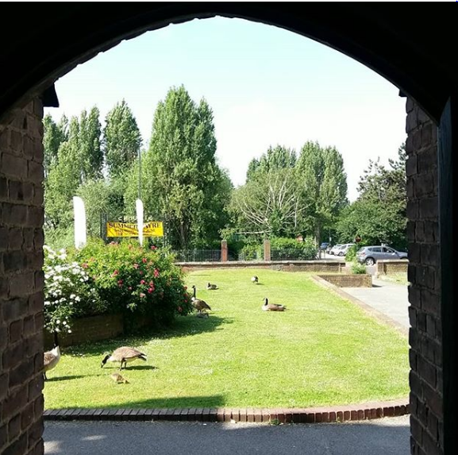

*St John’s Catford, 2 Trinity 2018*