Hymn while waiting and praying for the ‘New Shepherd’ [8686D]
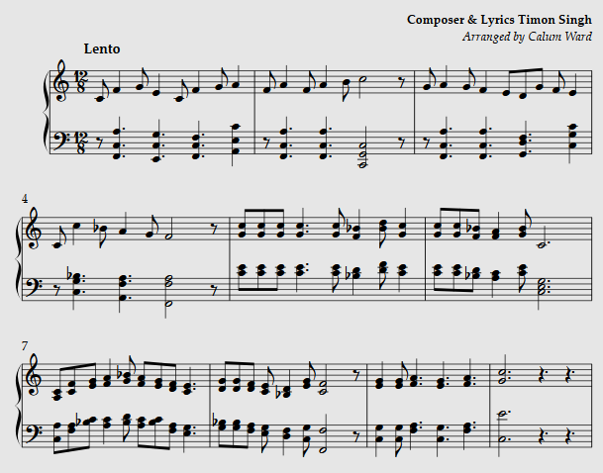
The shepherd’s crook is laid to rest,
Until appointed new.
We pray to God with this our quest,
Bless us in season due.
And on our knees with this request;
We ask to bless us through,
And keep us safe from every test,
O’ Lord we ask of you.
Send us the one who like yourself
Good shepherd can be called
That they may lead us in our land
To praise and to be bold
With loving heart and gentle soul
Bring fresh and vision new
And meet the needs of everyone
O’ Lord we ask of you.
Grant unto us a prayerful heart
That we may seek your will
continue working as thou art
Who’s never at stand still
Be fervent in our daily prayer
And do what you would do
Be patient in the time of need
O’ Lord we ask of you.
Give eyes to see and ears to hear,
And wisdom to who seek.
Their way be from confusion clear,
Who will in future meet.
Your shepherd whom you’ll send to steer,
Your sheep along this creek.
May they and we to them be dear,
Gentle, Humble and meek.
O’ Father in this vacancy,
Hear us as we all pray.
And keep us as one flock of sheep,
Till Sheperd comes our way.
May we remain one church one fold,
Be firm in faith and true.
Then at the end your praises sing, O’ Lord we ask of you. Alleluia! Amen!
[Revd Timon Singh]

