Creationtide 2026 Prayers (Word Editable Version)
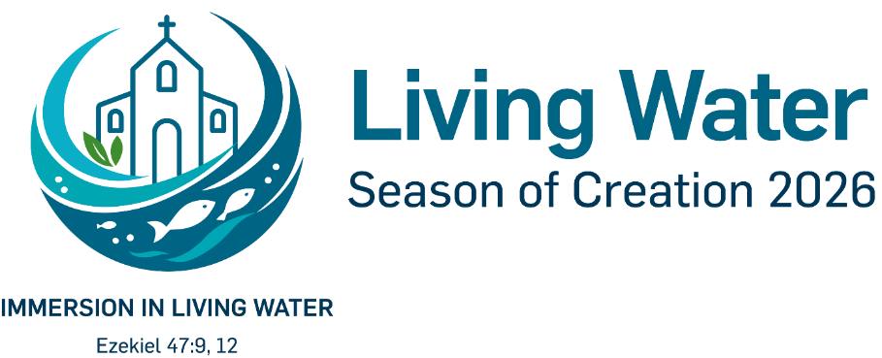
A Prayer of Praise
Inspired by Psalm 147
Great are you, Lord; how good it is to sing your praise. Your ways are not our ways, and your understanding has no limit.
Creation proclaims your glory. You set the number of the stars and call each one by name. You cover the heavens with clouds, send rain upon the earth, and make grass grow upon the hills.
You spread the snow like wool and scatter the frost like ashes. At your command they melt; you send forth your wind, and the waters flow.
Open our eyes to behold your majesty in all that you have made, and give us hearts to cherish and protect your vast creation; through Jesus Christ our Lord.
Amen.

A Prayer for Waters
Inspired by Ezekiel 47:1-12

Creator God,
We praise you, for you set the waters in place, and gave the sea its boundary.
You established the clouds above and fixed the fountains of the deep.

Forgive us Lord, for treating your waters as our own;
for the harm done to rivers, lakes, and seas,
for our pollution, our wastefulness, and our carelessness.

We pray for all who thirst:
for those without reliable access to clean water, for communities facing drought, and for all whose lives depend upon waters that are polluted or depleted.
Bring refreshment to the weary, and hope to those in need.

Turn us back to your ways Lord, and transform our hearts; that by your Holy Spirit, we may serve in your work of restoration.
May your living waters flow through dry and desolate places, bringing healing, renewal, and abundant life;
and may swarms of living creatures live wherever your river flows.
Amen.

A Prayer for those Impacted by Extreme Weather
God of Mercy and Compassion,
We lift before you all those affected by extreme weather, both near and far;
those facing droughts, storms, heatwaves, and floods.

Bring healing to hearts who have experienced loss;
of loved ones, homes, and livelihoods.
Where there is fear, bring peace.
Where there is despair, bring hope.

Grant us and our leaders courage and wisdom to act;
to tackle climate change and nature loss,
to protect those most at risk,
and to seek a more just and peaceful world.
Amen.

A Prayer for Action
Lord,
Help us to be the hands and feet of Christ in the communities where you have placed us.
By your Holy Spirit, enable us to bring signs of healing and resurrection life through care for your world;
to plant and nurture, to restore and protect, and to bring hope where there is despair.

Make your Church a lighthouse in stormy times, faithful in word and deed.
May we seek the good of our neighbours, and bear witness to your love in a hurting world;
in our daily actions, both great and small,
through Jesus Christ our Lord.
Amen.

A Prayer for Earth Justice
Lord, we pray for the state of the world,
for the injustice we see on our doorsteps, and across the globe.
Lord in your mercy,
Hear our prayer.

We know the impacts of climate change and nature loss are not felt equally…
We lift up the poorest who suffer most, despite doing the least to contribute.
Lord in your mercy,
Hear our prayer.

We pray for those unjustly facing greater pollution, sea level rise, droughts, and storms.
We grieve the loss of species and habitats that have been destroyed.
Lord in your mercy,
Hear our prayer.

Equip us through your Spirit to be agents of transformation,
giving voice to the voiceless and courageously seeking change.
Lord in your mercy,
Hear our prayer.

Help us as the Body of Christ,
to act justly, love mercy, and walk humbly with you all of our days.
Lord in your mercy,
Hear our prayer.

Image Credit: Season of Creation 2026 logo. Source: seasonofcreation.org.

