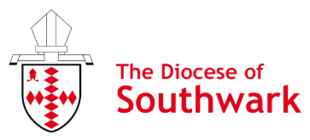

Diocese of Southwark: Mission Department
Justice, Peace and Integrity of Creation Grant Application Form

Before completing the form, please read the criteria for the allocation of grants.
This application must have been discussed and agreed with the incumbent.

1. Name of church/organisation:
Address:

2. Your contact details

Name:

Phone:

Email:

3. The proposal:
a. Please provide a brief outline of how this grant will be used:

b. When will this happen? Please provide the dates:

c. Which mark/s of mission does this grant cover, how and why?

    - To respond to human need by loving service
    - To seek to transform unjust structures of society, to challenge violence of every kind and to pursue peace and reconciliation
    - To strive to safeguard the integrity of creation and sustain and renew the life of the earth?

d. What would you give thanks to God for in your ministry as a result of receiving this grant? What outcomes do you hope to achieve? How might receiving this grant support your growth?

4. Total cost of what you would like to do:

5. Please provide a breakdown of costs:

6. Amount of grant requested to carry out your plans:

7. Bank account details (must be church/organisation):

Name of bank:
Exact name on account:
Account Number:
Sort Code:

8. Endorsement:

Name of applicant:

Position in organisation:

Incumbent’s name and signature:

Date:

9. Diocese of Southwark Approval: Date:

Please return a signed and scanned version of this form to the Mission Team Administrator by email: Mission@southwark.anglican.org

