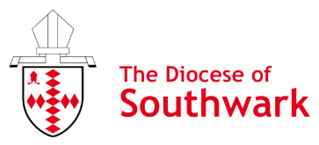

Diocese of Southwark: Mission Department
Children and Young People’s Mission and Ministry Grant Application Form

Before completing the form, please read the criteria for the allocation of grants.
This application must have been discussed and agreed with the incumbent.

1. Name of church/organisation:
Address:

2. Your contact details

Name:

Phone:

Email:

3. The proposal:

a. Please provide a brief outline of how this grant will be used to grow or restart your children, youth or families ministry. How does this grant help you to grow your ministry through gathering children, young people and/or their families, sharing Jesus and/or discipling children, young people and their families?

b. When will this happen? Please give dates:

c. Which ministry/ ministries is the grant for?
For example: Children, youth and/or families?

d. What are the planned outcomes that you would give thanks to God for in your ministry with children, youth or families as a result of receiving the grant?
How might receiving this grant help you to grow younger and more diverse?

4. Total cost of what you would like to do:

5. Please provide a breakdown of costs:

6. Amount of grant requested to carry out your plans:

7. Bank account details (must be church/organisation):

Name of bank:
Exact name on account:
Account Number:
Sort Code:

8. Endorsement:

Name of applicant:

Position in organisation:

Incumbent’s name and signature:

Date:

9. Diocese of Southwark Approval: Date:

Please return a signed and scanned version of this form to the Mission Team Administrator by email: Mission@southwark.anglican.org

