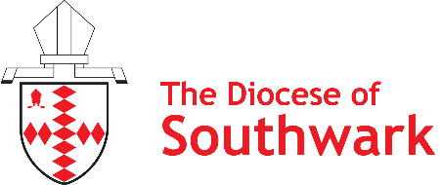
March 2026
Consultation on the next Bishop of Southwark

Our Diocesan Bishop - The Rt Revd Bishop Christopher Chessun - will be retiring this summer, after many years of faithful leadership in our diocese. We’ll miss him greatly – and there’ll be an opportunity to give thanks for his ministry in due course.
Because of this, as a diocesan family, we are preparing to begin our search for the next Bishop of Southwark – and in doing so, we want to ensure that we hear the views of as many people as possible across our communities.
So we’ve created this simple anonymous survey - we’d love you and those in your parish to fill it out. The whole thing should take no more than 5-7 minutes to complete and is completely anonymous - check out our Privacy Statement to find out more www.southwark.anglican.org/privacy.
Please email completed surveys to newbishop@southwark.anglican.org – or send them by post to:
Vacancy-in-See Consultation
Trinity House
4 Chapel Court
Borough High Street
London SE1 1HW
The consultation will close at noon on 1 April 2026 – it will not be possible for us to accept responses received after this time will not be accepted.
We especially want to hear from people who feel their voices don’t get heard very often. If that’s you, please do fill out the survey – if it’s someone you know, please help and encourage them to do so. Resources to support parishes in helping people to contribute to the survey can be found online here: www.southwark.anglican.org/newbishop.
In all of this, let’s pray for ourselves, our communities – and for the person God is calling to serve Him in this role.
Thank you for playing your part in this vital process - may God bless us and guide us as we seek the next Bishop of Southwark.
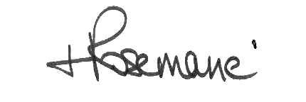
The Rt Revd Dr Rosemarie Mallett
Bishop of Croydon & Chair of the Vacancy-in-See Committee
Survey for children & young people

- Are you responding on behalf of yourself as an individual - or on behalf of a group?
Just me
On behalf of a group

- In no more than 5 words, please describe what you hope your new Bishop will be like.

- What do you think will be the most difficult thing the new Bishop will have to do? Please name just one thing.

- What do you think the new Bishop's most important first jobs might be? Please just tell us three things.

- What else would you like to tell us about your hopes for the new Bishop of what they can do for young people?

Thank you so much for adding your voice to the search for our next diocesan Bishop. Please email completed surveys to newbishop@southwark.anglican.org or send them by post to Vacancy-in-See Consultation, Trinity House, 4 Chapel Court, Borough High Street, London SE1 1HW.
Please do encourage others to contribute their thoughts, too - the survey will close at noon on 1 April 2026. Please also continue to pray for our churches, communities and schools - and for the person that God is calling to serve him in this role.
We offer the following prayer, which has been specially written for this season:
God of all times and places,
send us a Bishop who will
lead us faithfully through
days of rejoicing and
nights of challenge,
with prayer and Scripture,
with love and laughter,
with bread and wine.
Send your Holy Spirit to
guide those entrusted with
this process.
May they recognise the person of your
choice, with ears that are open
and hearts that are wise.
Make us thankful for all that has gone before,
ready and hopeful for all that lies ahead,
led by a Bishop whose ministry is a blessing
to everyone in Southwark Diocese,
as we hear the good news of Jesus
and delight in the love of God.
Amen

Find more resources and information online at www.southwark.anglican.org/newbishop

