**SOUTHWARK MOTHERS’ UNION**

**2024 ANNUAL REPORT**

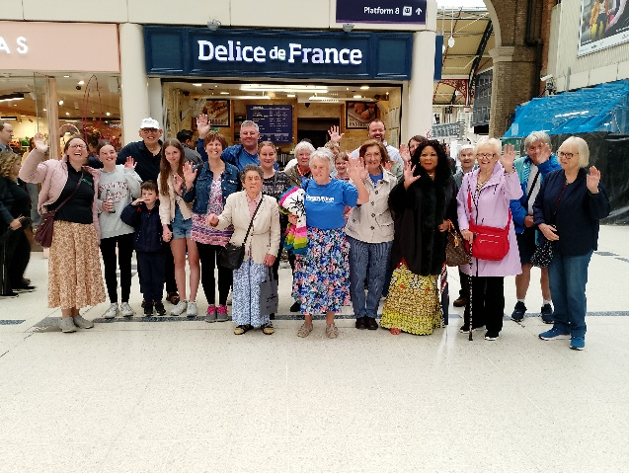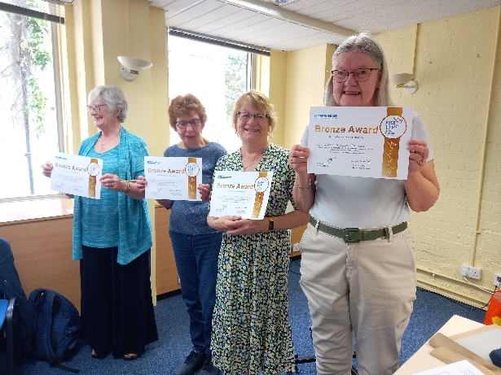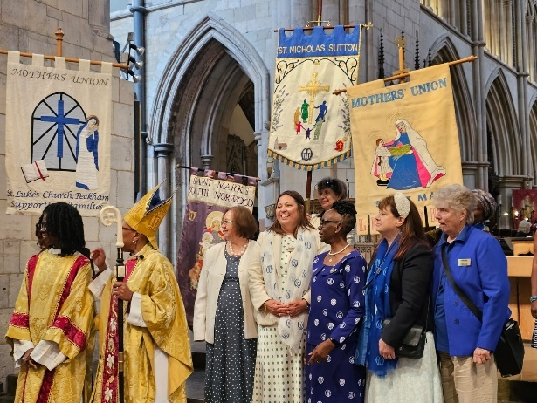

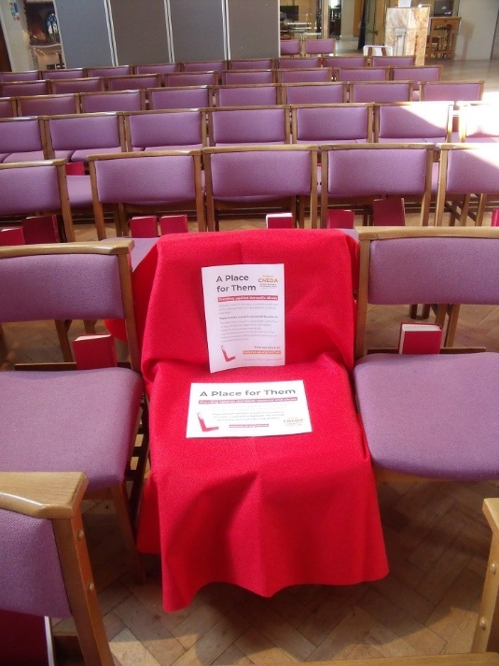

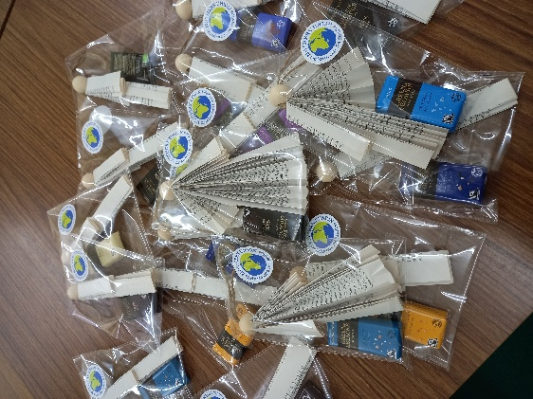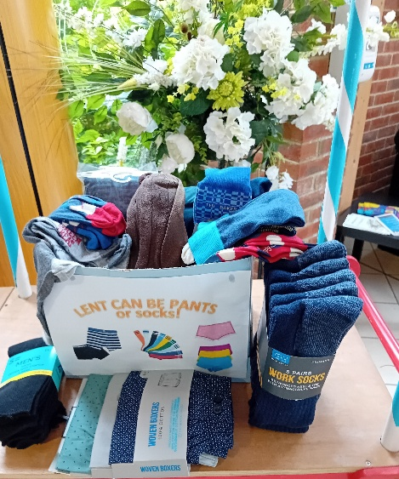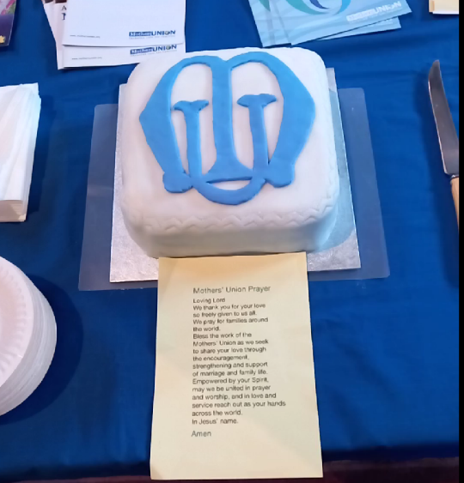

**Annual Report and Statement of Financial Activities**

**Year ended 31 December 2024**

**Vision**

Our vision is of a world where God’s love is shown through loving, respectful and flourishing relationships. This is not a vague hope, but a goal we actively pursue by praying, campaigning and enabling.

**Mission**

We aim to show our Christian faith by the transformation of communities worldwide. We can do this through supporting strong relationships within the family and promoting reconciliation at all levels.

**Values**

We are firmly rooted in voluntary ethos centred on mutual respect and collaboration. Our governance, leadership and programmes are driven by and undertaken through members within their own communities worldwide. We are inclusive and work with people of all faiths and none.

**Aim**

The Aim of the Mothers' Union is the advancement of the Christian religion in the sphere of marriage and family life. In particular we aim to:

* encourage parents to bring up their children in the faith and life of the Church;
* maintain a worldwide fellowship of Christians, united in prayer, worship and service;
* promote conditions in society favourable to stable family life and the protection of children;
* help those whose family life has met with adversity.
* uphold Christ's teaching on the nature of marriage and to promote its wider understanding;

**Objectives and Activities**

Together with members across the world, our objectives are:

* **Strengthen** communities all over the world
* **Help** the most disadvantaged at home
* **Shape** how we advocate for the rights of families
* **Build** supportive, loving relationships
* **Develop** our own relationship with God.

**Achievements & Challenges**

The MU theme in 2024 was Transformation in Action and this report reflects on how action in the MU in Southwark has had an impact.

**Growing the MU Community: *Inspiring others and showing the relevance of the MU***

Over 2024, branches continue to face challenges of securing membership and leaders. In some cases, these branches are in a church which itself is finding it difficult to grow. We continue to work on ways we can be more creative and imaginative in promoting our mission and increasing member engagement. Although some branches have closed a number of the residual members have joined neighbouring branches.

A large number of members attended the Provincial Gathering in Oxford providing insights into how others were working and what more could be done to help the MU grow. Some of these actions can be seen in action within our own MU community.

***Being a bridge between clergy and MU members***

Most branches have been actively engaging with their church and a number have been able to recruit new members.

It would appear having a strong relationship with the incumbent and regular contact with the congregation brings benefits and helps branches flourish. Clergy packs, previously circulated are still available for branches to share with new members and church leaders. As a Diocese we have also continued to provide information about the MU to clergy in training.

The actions we have taken appear to have the greatest impact where we can share the benefits of the MU underpinned by prayer and action. Many of the achievements we can see in the rest of the report show how the MU across Southwark has shone out in the ministry of the Church as a whole.

**Connecting with the Church Mission:**

***Strengthening our role within the wider church community***

Where MU branches have an active membership, we can see that they play a big part in the mission of their local church promoting the work of the MU widely. Members continue to support their churches in a range of lay ministry across their parish. Over the last year this includes:

* Supporting community projects: 20 bags of Love for families of new starters at the local Preschool (Horley); Church weekly coffee shop (Tadworth); Hear Here clinics supporting more than 40 people a month (Caterham); Supporting foodbanks (Redhill, South Norwood, Lewisham, New Malden); Collecting clothing for women in Zimbabwe (Lewisham);
* Taking part in worship: Participating and contributing and leading in Lady Day services, Mothering Sunday (cards and posies) and Mary Sumner Day as well as Christingles at Christmas; Supporting Bubble Church, Forest Church and Prayer Clubs supporting a local primary school.
* Pastoral care: Hospital and home visits (Tadworth)
* Helping with church fundraising: As strong supporters of Church Summer and Autumn / Christmas Fairs, coffee mornings as well as Church Lent lunches.
* Welcoming people into the Church family: Supporting baptism families, distributing cards, gifts and arranging events including Pre-Easter parties, Bible themed workshops.
* Engaging with Diocesan links with Zimbabwe: Currently working in the Croydon Episcopal area and Central Zimbabwe Diocese developing links to the Mothers’ Union.

**Having an impact: *Meeting the needs of families facing injustice and adversity***

In line with our aims and objectives members continue to be active in wider diocesan outreach projects. Members have given of their time and talents in supporting:

***Tea @ 2***: Thanks go to Hilary Richardson for coordinatingTea at 2 at the Evelina Children’s Hospital. This initiative includes a small but dedicated team of 11 volunteers who provide support to parents whose children are supported in the neo natal unit.

***Other Hospital Links***: The MU also support neo natal intensive care units and other hospital units by knitting, crocheting and stitching including 150 blankets for the Happy Baby community in Thornton Heath. Members in Horley also provided 64 bags of toiletries for vulnerable patients on Emergency hospital wards.

***Prison Links:*** Links between Prisons and Southwark MU are also now expanding. The links with Belmarsh continue to be strong, facilitated by Jan Gosling. Links with Wandsworth prison have also developed with MU members in Horley making a total of 70 Christmas cards, members in Caterham made 25 angel Christmas decorations. A number of other branches have also been active in making socks and hats for prisoners.

***Tea and Talk:*** This initiative led by Cynthia Smith and continues in South Croydon. The outreach to refugee families in the local community builds strong connections strengthened with examples of generosity.

***AFIA (Away from it All) Holidays***:

As our flagship Diocesan outreach project, we thank Sally Steele for continuing to organise and manage holidays and trips for some very needy and vulnerable families in the Diocese. We have seen 14 families sent on a 4-night caravan holiday to a Haven caravan park on the South coast, near Chichester. There were also day trips for 3 refuges in the Diocese; Croydon, Sutton and Redhill. 2 groups went to Butlin’s at Bognor by coach; and the 3rd group went to Bockett’s Farm in Surrey, also by coach.

*“I’d like to send a huge thank you to the amazing people that made this holiday possible for me, my son and my mum. It brought us together. This wouldn’t have happened without your kindness. My son came out of his shell and experienced things he wouldn’t have as we come from a busy town”,*

*“Our holiday was great; the children had a ball too. It was very much needed; you can never really comprehend how much a holiday is needed until you are actually living it”.*

Feedback from these holidays has been entirely positive, with the families enjoying being together and enjoying the caravan and facilities on the park. These are families who mostly, have never had a holiday and who cope with all manner of adversities, including, being single mothers, having children with autism and other disabilities.

Thanks are sent to all the members who have fund-raised and donated to the AFIA fund. This programme has made a difference to 60 adults and 71 children; 131 people in total.

We are also so grateful for the wonderful generosity of our “unknown” benefactor, who has really boosted our AFIA fund over many years, ensuring many more families could take advantage of your kindness.

**Developing members: *In faith, confidence and understanding through***

***Worship and Prayer***

Prayer is the bedrock of the Mothers’ Union and this is evident in the various events that have taken place at both branch and diocesan level as well as in our participation in national events and programmes.

At branch level members are involved in leading and supporting:

* Mid-day prayers in the Harvard Chapel each month
* Lady Day services: with services held at across our Deaneries;
* Carol services: welcoming neighbouring branch members
* 16 days of activism: with services and prayers held across the Diocese
* World Day of Prayer: Strengthening links with other churches
* Lent and Advent meditations: across the Diocese
* Regular Communion Services: followed by fellowship e.g. in Caterham, New Malden, Tadworth
* Bible Study: Weekly and monthly sessions held in South Lambeth and Sutton and bible stories for children on Sunday mornings
* Community outreach: Leading services in Care Homes; Providing bibles to schools

At a Diocesan and National level, events include:

* Festival service at Southwark Cathedral held on the 8th June.
* Wave of Prayer which took place at the beginning of September with many branches participating.
* The retreat at Wychroft in October which was well attended and ably led by led by the Venerable Carol Coslett.
* The Diocesan Advent service held at St Johns, Caterham Valley with preacher Venerable Moira Astin, Archdeacon for Reigate
* Prayer network has been led by Olu Akitoye
* Provincial Meeting: Attendance at the event in Oxford.

***Campaigning against social injustice***

***16 days of activism:*** Although campaigning against gender-based violence is a ‘365 days a year’ programme many MU branches in Southwark took the opportunity once more to promote this more actively during the 16 days of activism at the end of November.

During this period a number of branches engaged with the Red Chair project promoted by Restored <https://www.restored-uk.org/partner/cneda/red-chair/> . It involved reserving an empty chair in a public place, alongside information about domestic abuse and violence against women. The empty chair acted as a powerful symbol of the many women who have been killed through gender-based violence - women who should still be with us today.

***Responding to those in women’s Refuges***: There continues to be active engagement by branches with their wider parish community, in providing gifts and equipment to local refuges in Croydon, Sutton and Redhill. Hundreds of items and gifts have been supplied to these vulnerable women and their children. This includes support for charities such as ‘I choose Freedom’ who support those escaping Domestic abuse with donations of toiletries twice a year from members in Tadworth.

***RiseUp Campaign***: Mothers’ Union campaign against Domestic abuse continues to flourish. Known as RiseUp it stands for Respond, Inform, Support, Empower, Unite and Pray. A number of branches have been successful in achieving their bronze award and now working for their silver award. The campaign is significantly raising awareness of the issue, providing support to those who are suffering and strengthening MU links with their wider church leaders (PCC and clergy). Congratulations to all those who are active in this area.

***Celebrating and Connecting***

The Mothers’ Union members in Southwark continue to show enormous energy and enthusiasm for arranging events that bring joy and interest to members lives. Examples of this focus on:

***Keeping connected***: Although a number of faithful members have passed away during 2024 it is great to see how branches are keeping in touch with more vulnerable members. Branch members also meet regularly in fellowship for food and friendship as well as connecting with neighbouring members for events. A number have also spent time reflecting on how they can use their talents and strengthen their membership in line with the mission of the MU through the use of the Metamorphosis programme.

***Learning from others***: A wide range of topics have been the focus for meeting, raising awareness of individuals’ experiences, their faith and their work as well as how to support the most vulnerable in our community. Examples include AFIA; RiseUP; Julian of Norwich; The Shrine at Lourdes (Surbiton); Textile creations (Motspur Park); Dementia (Lambeth); Reading St Andrew’s Church through its Art (Ham); RBL (Horley); Women Prisoners (Tadworth); Girls’ education and empowerment in South Sudan (Cheam); Faith liaison in the Police (Coulsdon); Air Ambulance (Riddlesdown); Leprosy Mission (Merton).

***Community events***: This includes organising family games afternoon and evenings in Mitcham and Lambeth. Running stalls at Church fairs, and displays at Heritage Open days and other parish events.

***Being active and creative***: Connecting with the arts and creativity continues to be important building on the skills of members. Examples of activities that have taken place includes Knit and Natter groups (Lewisham); Crafted cards and gifts for MU sales (Tadworth); Christmas decorations from recycled materials (Merton), painting and making Christmas wreathes (Hook); keep fit classes (Eltham Park).

***Outings***: MU members have been active in getting out and about. This includes a walk around the local parks, visit to the Lumley Chapel, a trip to Buckingham Palace, an Art exhibition at Bethlem Hospital, visit to Eltham Palace, The Horton Chapel in Epsom and to Southwark Cathedral to see the ‘Threads through Creation’ exhibition.

***Celebrating***: It has also been great to see branches celebrating anniversaries and the legacy of members with long service as well as significant birthdays.

***Fundraising***

Thanks are given to all branches who continue to be active in fundraising for AFIA, Summer of Hope and the Mothers’ Union worldwide. Activities to support these campaigns have taken place across the diocese including:

***Sales and stalls***: Bring and buy sales; Cake and Mothering Sunday sales; Church event; Bible Object Auction and Craft and artwork sales.

***Entertainment & Refreshment***: Barn Dances, Quiz nights; Christmas festive lunch; Garden parties Afternoon and Strawberry teas; Coffee mornings; Cheese and wine events.

The impact of all these events this has allowed us to maintain our outreach through AFIA, provide grants to branches that are trying new initiatives and support the wider work of the MU.

**Moving forward in 2025**

The 2024 theme of *Transformation- in Action!* now shifts to *Join Us, Join In****.*** The emphasis over the next three years is to promote growing and flourishing and considering how the MU can be relevant within the 21st Century. We would like to aim to build our membership by 150 over the next three years.

In doing so we will need to continue to:

* Consider strategies as to how the MU can grow in confidence by developing membership and build connections through shared stories with those at home and across the world.
* Having an Impact by responding to Social Injustice and supporting vulnerable communities through RiseUP, Prison strategy, Modern Slavery, AFIA and MU overseas.
* Strengthening our connection with the wider Church Mission through, Lay ministry, Synods, Family work / Parenting, Gender based violence and the Climate Crisis

**Safeguarding**

As an organisation concerned with Christian principles and ministry in family life, the nurture and protection of children, young people and vulnerable adults is at the heart of Mothers’ Union. Both individually as members and collectively as an organisation, Mothers’ Union fulfils its duty to protect children, young people and vulnerable adults, doing everything possible to ensure that they are safe when involved in Mothers’ Union activities.

Safeguarding policies and practices issued by the Anglican Church, and the Anglican Consultative Council (ACC) charter for the safety of people within the churches of the Anglican Communion are used as the basis for the MU in Southwark. In line with the duties of the Board the trustees have:

* reviewed safeguarding policies and procedures at the first meeting of the year.
* completed DBS checks on new Trustees using a DBS service from Thirtyone:eight.
* nominated a member to have an overview of the safeguarding aspects of the Mothers’ Union activities across the diocese (Susan Gibbin)
* reviewed the roles in Mothers’ Union and ensure that recruitment is in line with good safeguarding practice.

As well as ensuring Trustees are aware of policy and practice, guidance continues to be shared with all members to help establish strong practice at a local level. Strong links are encouraged with local Parish Safeguarding officers and training is made available through the Church of England and Southwark Diocesan Safeguarding teams:

* <http://southwark.anglican.org/safeguarding/safeguarding-training-events/>
* <https://www.churchofengland.org/more/safeguarding/training>

**Data Protection**

As an organisation the Diocese of Southwark Mothers’ Union takes its duties under the relevant Data protection legislation seriously. Its actions are guided by Diocesan policy and advice from Mary Sumner House. Work is underway to ensure access to privacy notices are available through the website and in hardcopy. Guidance to role holders has been circulated along with consent forms to be used in line with Diocesan and Central MU advice. The Trustees have made it a priority to maintain good Information Governance practice and provide support to all those responsible for holding personal data.

**Financial Review 2024**

Under the Charities Act 2011, the Trustees have prepared a statement of accounts for 2024 which gives a true and fair view of the state of affairs of the Mothers’ Union Southwark Diocese. Full details can be found in the Annual Accounts.

***Accounting Policies:*** The accounts have been prepared in accordance with applicable accounting standards and the Charities SORP.

The accounts include all transactions, assets and liabilities for which the Trustees are responsible in law.

***Financial performance – General and unrestricted funds***: General Funds represent the funds of the Trustees that are not subject to any restrictions regarding their use and are available for application on the general purposes of the Trustees. Funds designated for a particular purpose by the Trustees are also unrestricted. In 2024, £15,000 within the General Funds was held in the designated contingency fund.

In 2024 total income into unrestricted funds was £25,153. Of this income £26,492 was spent from unrestricted funds to support the administration and mission of the Southwark Diocesan Mothers’ Union. The net result for the year was an excess of expenditure over income of £1,339 on unrestricted funds. Unrestricted funds totalling £50,691 were carried forward at 31st December 2024.

***Financial performance - Restricted Funds***

Restricted funds are to be used for specified purposes as laid down by the donor. Expenditure which meets these criteria is charged to the fund.

There were restricted donations totalling £35,234 in the year (this includes money sent to MSH which contributes to the leadership, administration and mission of MU worldwide). These are given to support all the various Diocesan and Mothers’ Union Central funds (these are set out in the accounts). The total balance of restricted funds at 31st December was £18,496.

***Receipts:*** Collections, subscriptions, donations and interest are recognised when received. Income tax recoverable on Gift Aid donations is recognised when the income is recognised. Funds raised through any other sources, including through sales of literature purchased from Mothers’ Union Enterprises (MUe) are accounted for gross.

***Payments:*** Grants and donations are accounted for when paid over.

***Reserves Policy:*** Reserves are defined as income that becomes available and which is to be expended at the discretion of the Trustees in furtherance of their objects, but which has not yet been spent, committed or designated. The Trustees recognise the need to hold reserves to allow protection of the core activities in the event of income shortfalls and to promote balanced strategic planning. Through prudent housekeeping over a number of years, the reserves have been built up to the current level of £69,188 and include a residual legacy of £16,769 received in 2016.

The Trustee Board budgets and plans its expenditure and intends to maintain reserves that will protect the Charity against income shortfalls. A sum of £15,000 has also been set aside in a designated fund to rent and equip a Diocesan Mothers’ Union Office should the present premises become unavailable, and to cover the secretary’s salary for 6 months in an emergency.

***Investment Policy:*** The Trustees continue to invest in the Central Board of Finance of the Church of England.

**Communication**

The Southwark Mothers’ Union continues to use a range of tools for communicating with its members and the wider community.

***Digital tools***

This includes our allocated space on the Southwark Diocesan website where information about the organisation, services, the wave of prayer and projects and publications are posted <https://southwark.anglican.org/mission-ministry/faith-in-action/mothers-union/>.

There has been a steady flow of visitors, however we are unable to offer a facility for people to ask questions (other than by ‘contact us) or add comments.

During the year we had 276 views of our pages, split as follows:

* mothers-union: 117 views
* about-the-mu: 73 views
* mu-prayer: 64 views
* mu-projects: 22 views

The 2023 Annual Report was downloaded 134 times

The Facebook page continues to be a success - sharing information from the wider MU community - nationally and internationally - as well as events and activities within branches and the Diocese <https://www.facebook.com/MothersUnionSouthwarkDiocese> . During the year, there has been a steady flow of readers with a good proportion using the information in some way – liking, commenting or sharing - Project news is particularly popular as well as “issues”. We had 562 likes and 607 followers and a vast reach of many thousands.

We also have a You Tube channel: <https://www.youtube.com/@southwarkmu> which although still early in its development has had 769 views.

Thanks to Margaret Simmons for all she does to keep us connected and online.

***Publications***

In addition to our Southwark News (three times a year) which we thank Val Green for editing, we have had a number of articles published in The Bridge. This included articles on the work of the MU in supporting families and our campaigns around Gender Based violence, Domestic Abuse and AFIA, as well as the festival service. We have also been posting Blogs on the Diocesan website including one on Mary Sumner.

**Leadership and Governance**

***Leadership in Southwark***

The affairs of the Mothers’ Union in the diocese are managed by the Board of Trustees. Under the Diocesan Constitution and Handbook, revised 2005 and regularly reviewed, the Trustees are elected on a triennial basis. The new Trustee Board was appointed for three years from January 2022. This is the last year of the current triennial and so we will be welcoming new appointments from 2025. All are thanked for their commitment to the role.

All subscribing members of the MU in the diocese are entitled to vote for the Diocesan President and Unit Co-ordinators. Members from each geographical Area also vote for their own Vice President and two area representatives on the Trustee Board. To date no election has been held due to a lack of candidates and a number of vacancies were held open last year.

The Honorary Treasurer, appointed by the Trustees continues to keep a close eye on the MU’s financial governance. Jean Cartwright is thanked for her continued service. In addition to those trustees that represent the branches within the diocese and those that hold unit lead roles there is an opportunity to appoint three additional members on the Board. These individuals are co-opted onto the Trustee Board for the triennial because of their specific skills. In 2024 there were no additional co-opted members on the Board.

The Diocesan Chaplain is appointed after consultation between the Diocesan Bishop and the Southwark MU President. Also appointed by the Trustee Board are a number of officers listed in Annex 1. The Trustees also employ a part-time secretary, who manages the office and provides administrative support for the Trustee Board.

***Governance***

The Trustee Board met five times in 2024 and the Council twice (in addition to the AGM for 2023). During these times meetings were held in person with the opportunity for some members to join over zoom. Thanks to all those who helped manage the technology.

Within the Southwark Diocesan Mothers’ Union, the work of the four units continue to report to the Trustee Board and to Diocesan Council, coordinating diocesan activity and advising on policy and performance.

In order that Southwark MU is able to connect with and benefit from other members of MU across England as well as worldwide, members of the Board as well as those directly connected to the four units also participate in meetings facilitated by Mary Sumner House. These include, provincial conferences (we are within the Canterbury Province) and Community of Interest Groups. The areas covered and our local leads include:

|  |  |
| --- | --- |
| * AFIA (Sally Steele) | * Governance (Joy Morrall) |
| * Communications (Meg Simmons) | * Membership (Ursula Hodges) |
| * Craft (Norma McKnight) | * Member Directory and Database (MU Secretary) |
| * Diocesan Chaplains (Sandra Schloss) | * Prisons (Comfort Fearon) |
| * Faith (Penny Lochead) | * Policy (Rosaline Okiti) |
| * Finance / Treasurers (Jean Cartwright) | * RiseUp (Comfort Fearon) |
| * Fundraising (Vacancy) | * Safeguarding (Susan Gibbin) |

In addition, The Mothers’ Union (Southwark Diocese) Vice presidents and area representatives of the four geographical areas (Croydon, Kingston, Reigate and Woolwich) continued to link with their deaneries and branches (in line with the Church of England parish and synod structures). The challenges of maintaining branches continues to be difficult. Many members are happy to keep the connection with the MU but unwilling or unable to continue to take on leadership roles locally. Trustees continue to try and support their branch and diocesan members and try to help find new ways to work.

The Annual General Meeting (AGM) is arranged for July at which meeting the Annual Report and Accounts will be presented to the membership. The AGM is open to all members although voting rights at Diocesan Council are restricted.

***Membership / Volunteers***

In 2024, there were 50 branches in Southwark to which 834 branch members belong, in addition there are 37 diocesan members, giving a total of 871 known members across the diocese. Although some branches continue to grow, total numbers of members and branches are not yet seeing significant growth.

Enrolments include: St Mary Magdalene with St Michaels and All Angels, Woolwich; Cathedral with St Hugh's; St Mary the Virgin, Lewisham; St Alban's, South Norwood; St Andrew's, Coulsdon; St Barnabas, Sutton; St Peter, Norbiton; St Andrews and St Mark's, Surbiton; St Andrew's, Ham; St James, New Malden; St John the Baptist, Malden; The Good Shepherd, Tadworth; Holy Trinity, Redhill.

There have also been a number of people who have and continue to give of their time and talents to the MU. We celebrate these individuals and thank them for the service they have given.

We also thank God for the wonderful lives and service to the MU given by our members who have passed away this year.

***Indoor Members*** are also well supported by local Branches as well as the additional support of the Diocesan Indoor member correspondent, Jane Namurye. In 2024, we had 18 members however, one member sadly passed away, one moved out of the diocese.

***Member training and development***

During 2024 branches continued to be supported with information, policies and presentations at Council meetings.

Branch leader meetings with the Diocesan President have continued and have been well represented. In some areas of the Diocese, branches highlighted significant difficulties in securing leadership capacity to develop and grow their membership. As a result of this the branch guide was redesigned. Trustees do their best to keep members updated and informed of MU initiatives, local activities and good practice. This continues to be cascaded down through the work of the communications lead, VPs and area representatives.

***Feedback from local Branches***

The engagement of members at branch, deanery and area level is seen through regular reports to trustees as well as in the celebrating the years successes in the Annual Report. Each provides evidence of the hard work members have continued to do to find new ways of engaging with their local Church and its mission; in promoting the wider role of the MU in supporting families and in offering fellowship and prayer for those in need.

There is much we can be proud of as we all seek to meet the aims, purpose and mission of the MU. It has been wonderful to see the lasting legacy members work has had on families here in the Diocese and worldwide.

**Administrative Information**

The Mothers’ Union Southwark Diocese is under the patronage and sanction of the Bishop of the Diocese. It is affiliated to its parent charity, The Mothers’ Union (Reg. Charity No. 240531, headquarters at Mary Sumner House, Westminster), but is an autonomous organisation.

***Registered office:***

Mothers’ Union Office,

Trinity House, 4 Chapel Court,

Borough High Street,

London SE1 1HW.

Tel: 020 7939 9459

Email: [mu@southwark.anglican.org](mailto:mu@southwark.anglican.org)

***Bank:***

HSBC, 66 High Street, New Malden, Surrey KT3 4HD

***Independent Examiner***:

Mr A J Kett FCA, Little Dolby, Ifield Road, Charlwood, Surrey, RH6 0DR

Trustee Board members are appointed for three years from 1 January 2022. A list of Trustees and other officers up until December 2024 can be found in Annex 1.

**Report Approval**

This report was approved by the Trustees on 24 June 2025 and signed on their behalf by:

Penny Lochead

Diocesan President (Southwark MU)

**Annex 1**

**List of Trustees and officers for 2024**

|  |  |
| --- | --- |
| **Trustees (in post from 1 January 2022)** |  |
| Diocesan President | Comfort Idowu-Fearon |
| Vice President for Croydon | Sally Steele |
| Vice Presidents for Woolwich | Yemi Ojumu (From April 2023) |
| Vice President for Reigate | Susan Gibbin |
| Vice President for Kingston | Wendy Moss |
| Action and Outreach Unit Coordinator | Sally Steele |
| Fundraising and Communications Unit Coordinator | Susan Gibbin |
| Finance and Administration Unit Coordinator | Joy Morrall |
| Faith and Policy Unit Coordinator | Penny Lochead |
| Croydon Area Representative | Cathy Brown |
| Woolwich Area Representative | Roseline Okiti |
| Reigate Area Representative | Margaret Fitch |
| Kingston Area Representatives | Ursula Hodges |
|  |  |
| **Attendees (non-voting)** |  |
| Hon Treasurer | Jean Cartwright |
| Diocesan Secretary | Anne Love |
| Chaplain | Revd Sandra Schloss |
| Diocesan Safeguarding lead (co-opted) | Susan Gibbin |
|  |  |
| **Other Officers** |  |
| Away From It All (AFIA) Coordinator | Sally Steele |
| Newsletter Editor | Val Green |
| Training Officer | Vacancy |
| Indoor Member Coordinator | Jane Namurye |
| Social Media lead | Margaret Simmons |
| Gift Aid coordinator | Ann Squirrell |

