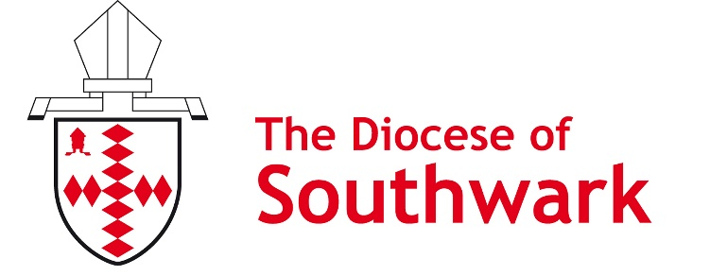
0

southwark.anglican.org/tkc

Thy Kingdom Come grant request form

Thy Kingdom Come grants
We can award £100 grants towards creating a prayer station or prayer space to celebrate Thy Kingdom Come. (We would really value any photographs of the resulting prayer stations/rooms.)

Date applied:

Parish name:

Bank Account Name:

Sort Code:

Account number:

A brief description of how the money will be used:

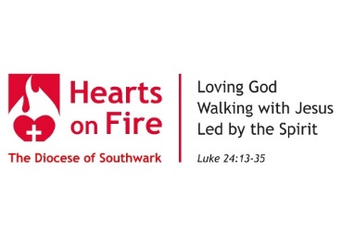
Please email this form to mission@southwark.anglican.org

Walking
Welcoming
Growing

